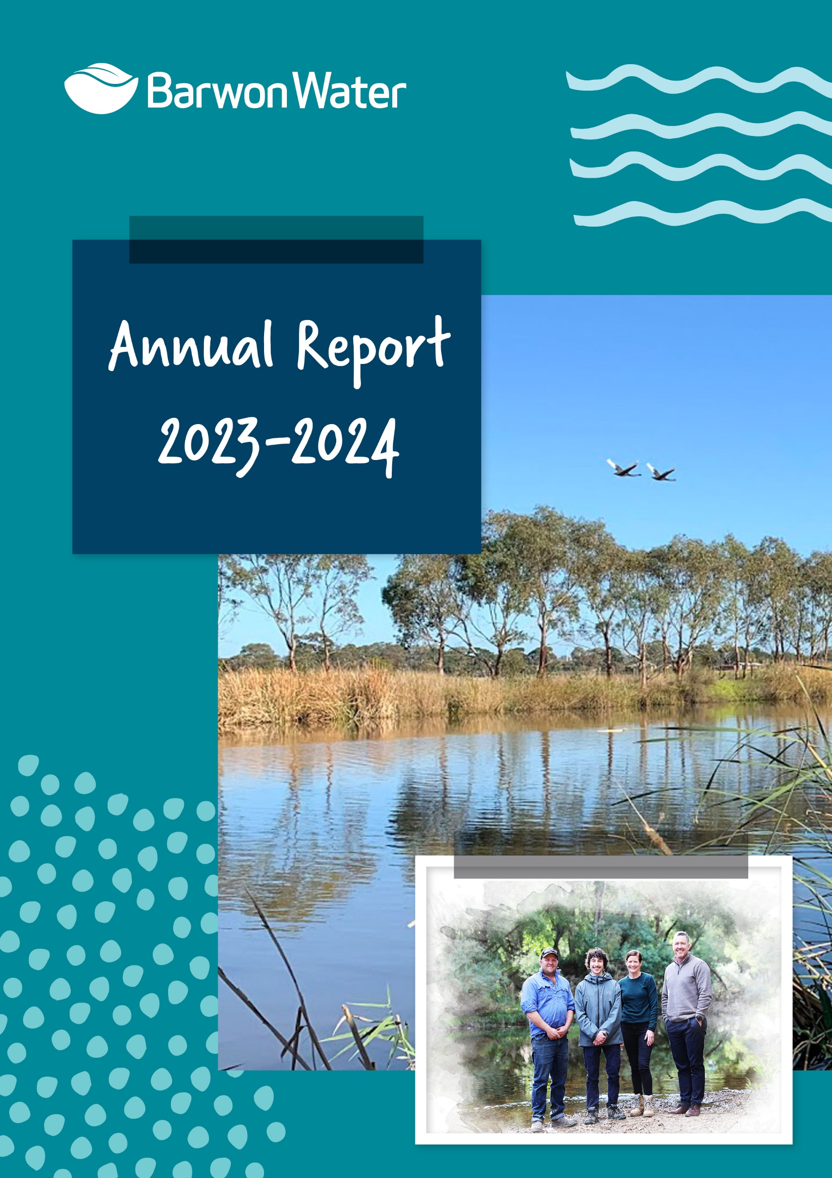
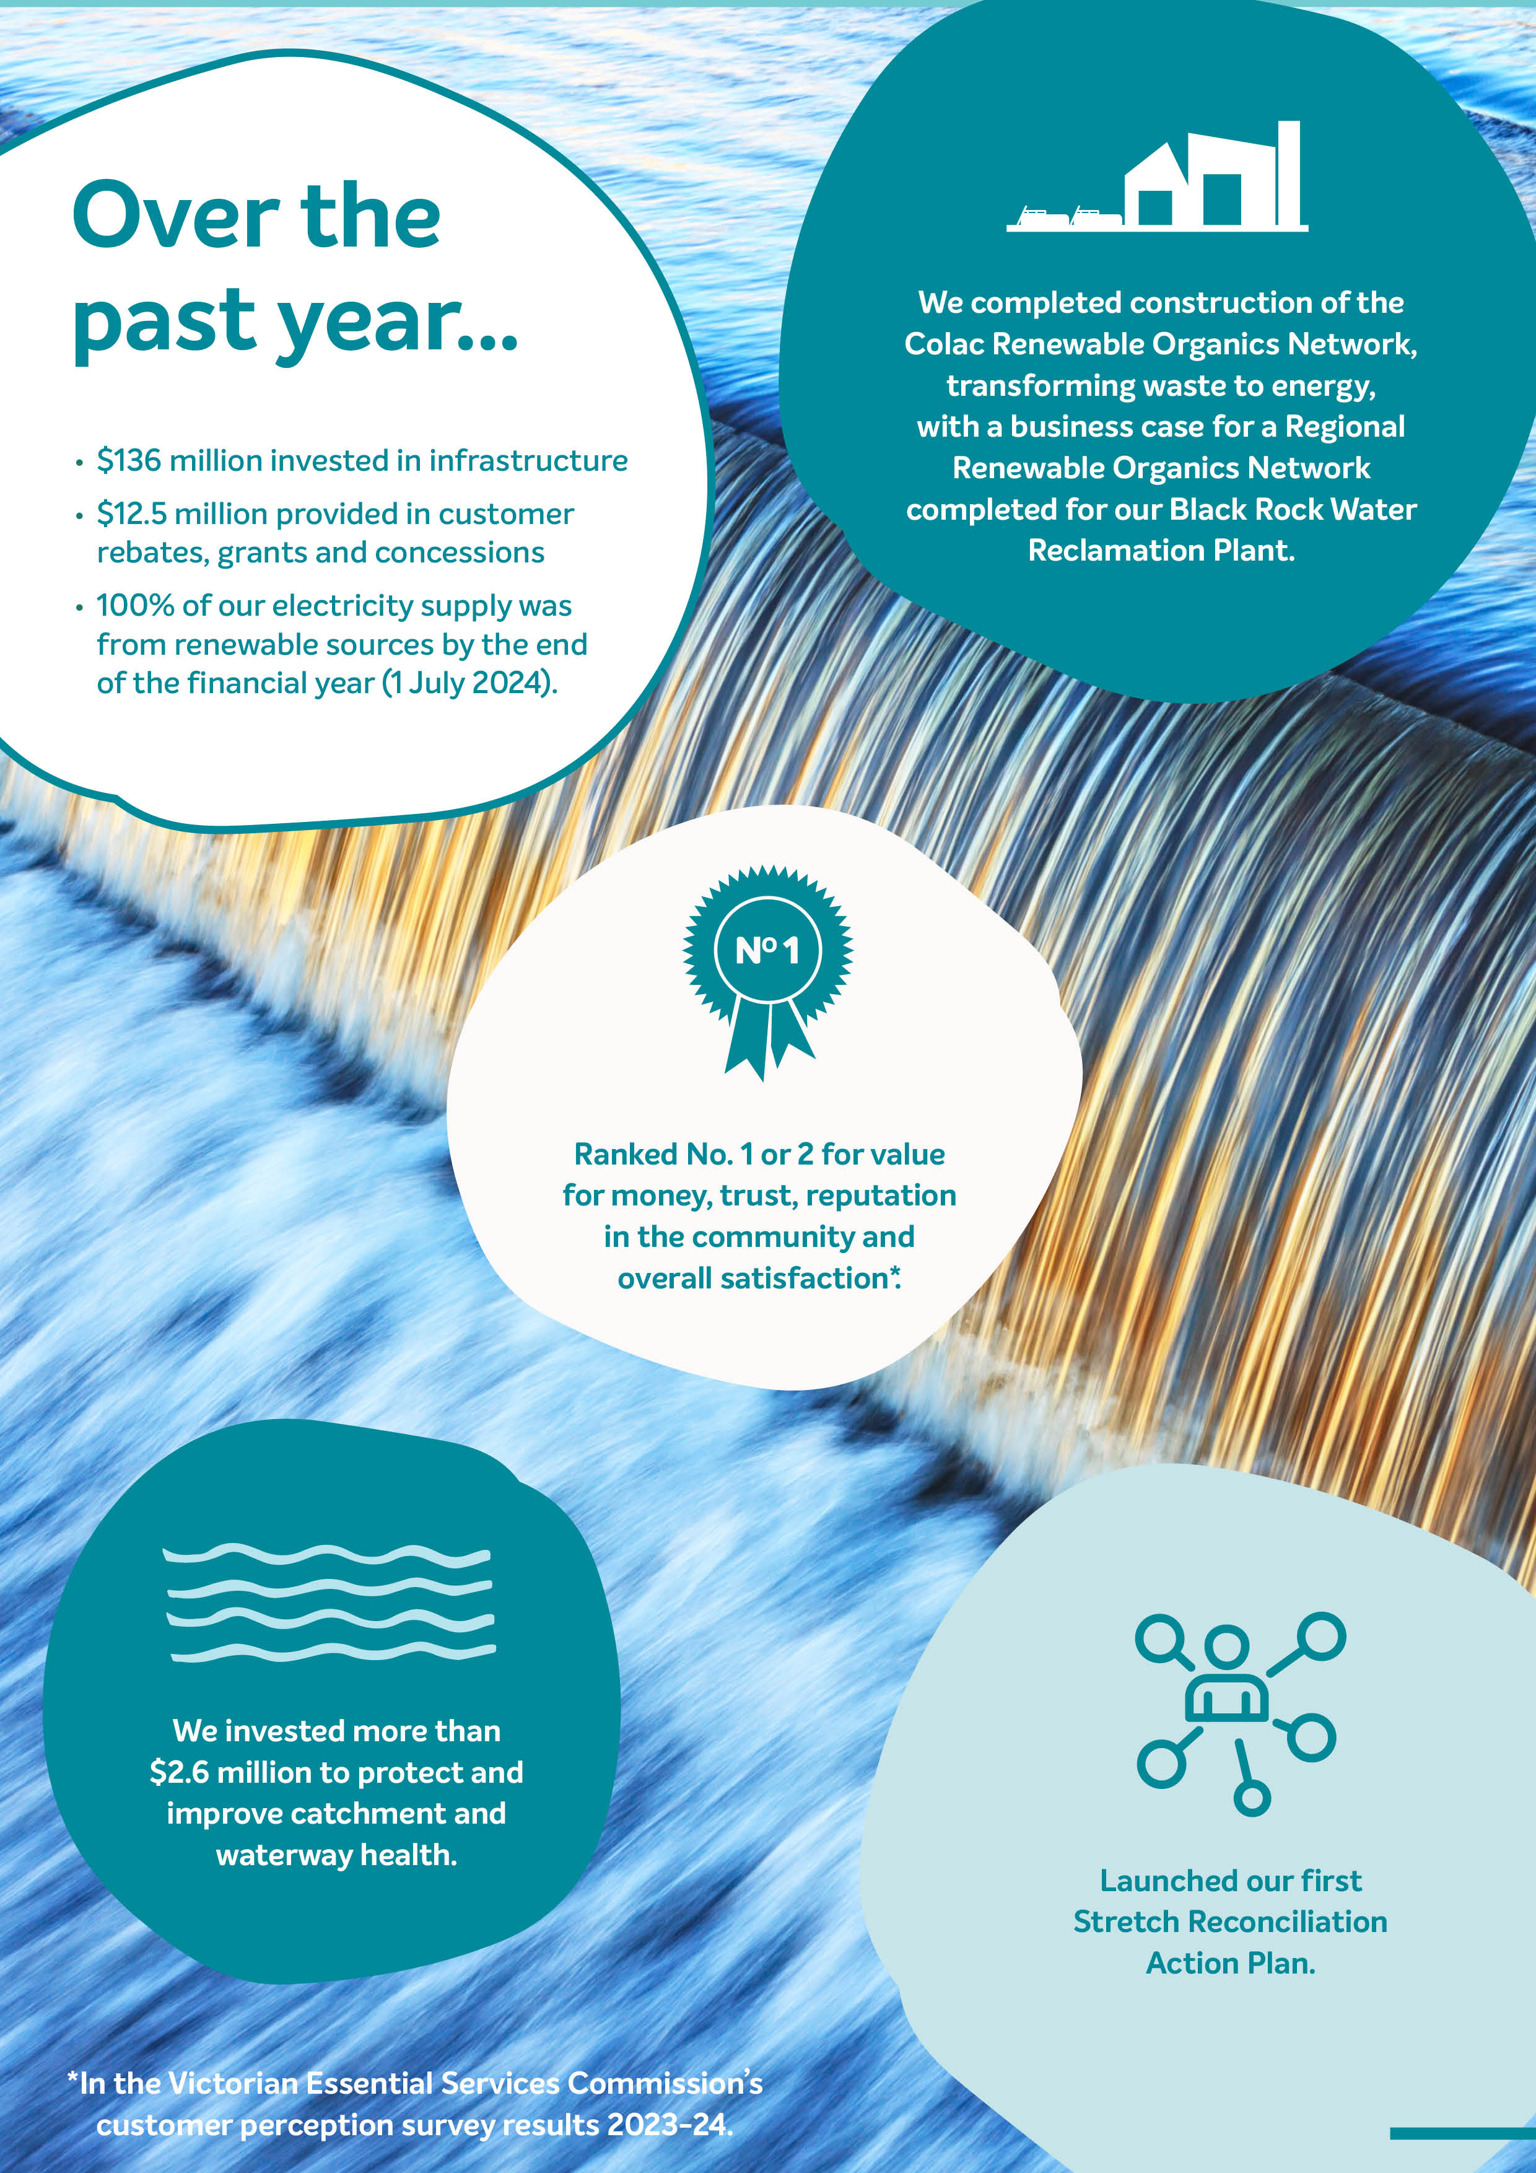

Title Page
Barwon Water
Annual report
(DRAFT)
2023 – 24

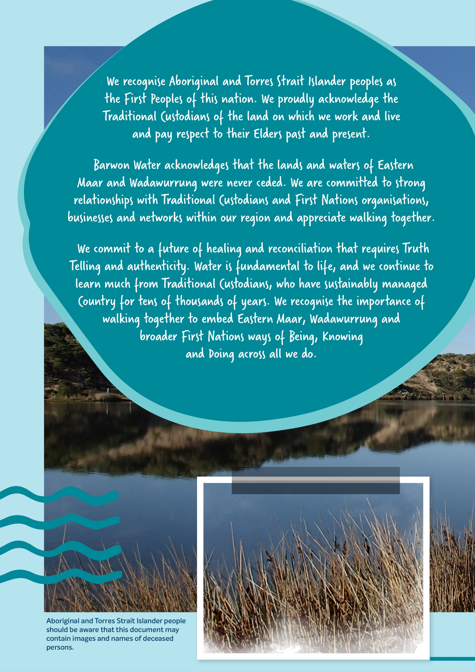

Acknowledgement

We recognise Aboriginal and Torres Strait Islander peoples as the First Peoples of this nation. We proudly acknowledge the Traditional Custodians of the land on which we work and live and pay respect to their Elders past and present.

Barwon Water acknowledges that the lands and waters of Eastern Maar and Wadawurrung were never ceded. We are committed to strong relationships with Traditional Custodians and First Nations’ organisations, businesses and networks within our region and appreciate walking together.

We commit to a future of healing and reconciliation that requires Truth Telling and authenticity. Water is fundamental to life, and we continue to learn much from Traditional Custodians, who have sustainably managed Country for tens of thousands of years. We recognise the importance of walking together to embed Eastern Maar, Wadawurrung and broader First Nations’ ways of Being, Knowing and Doing across all we do.

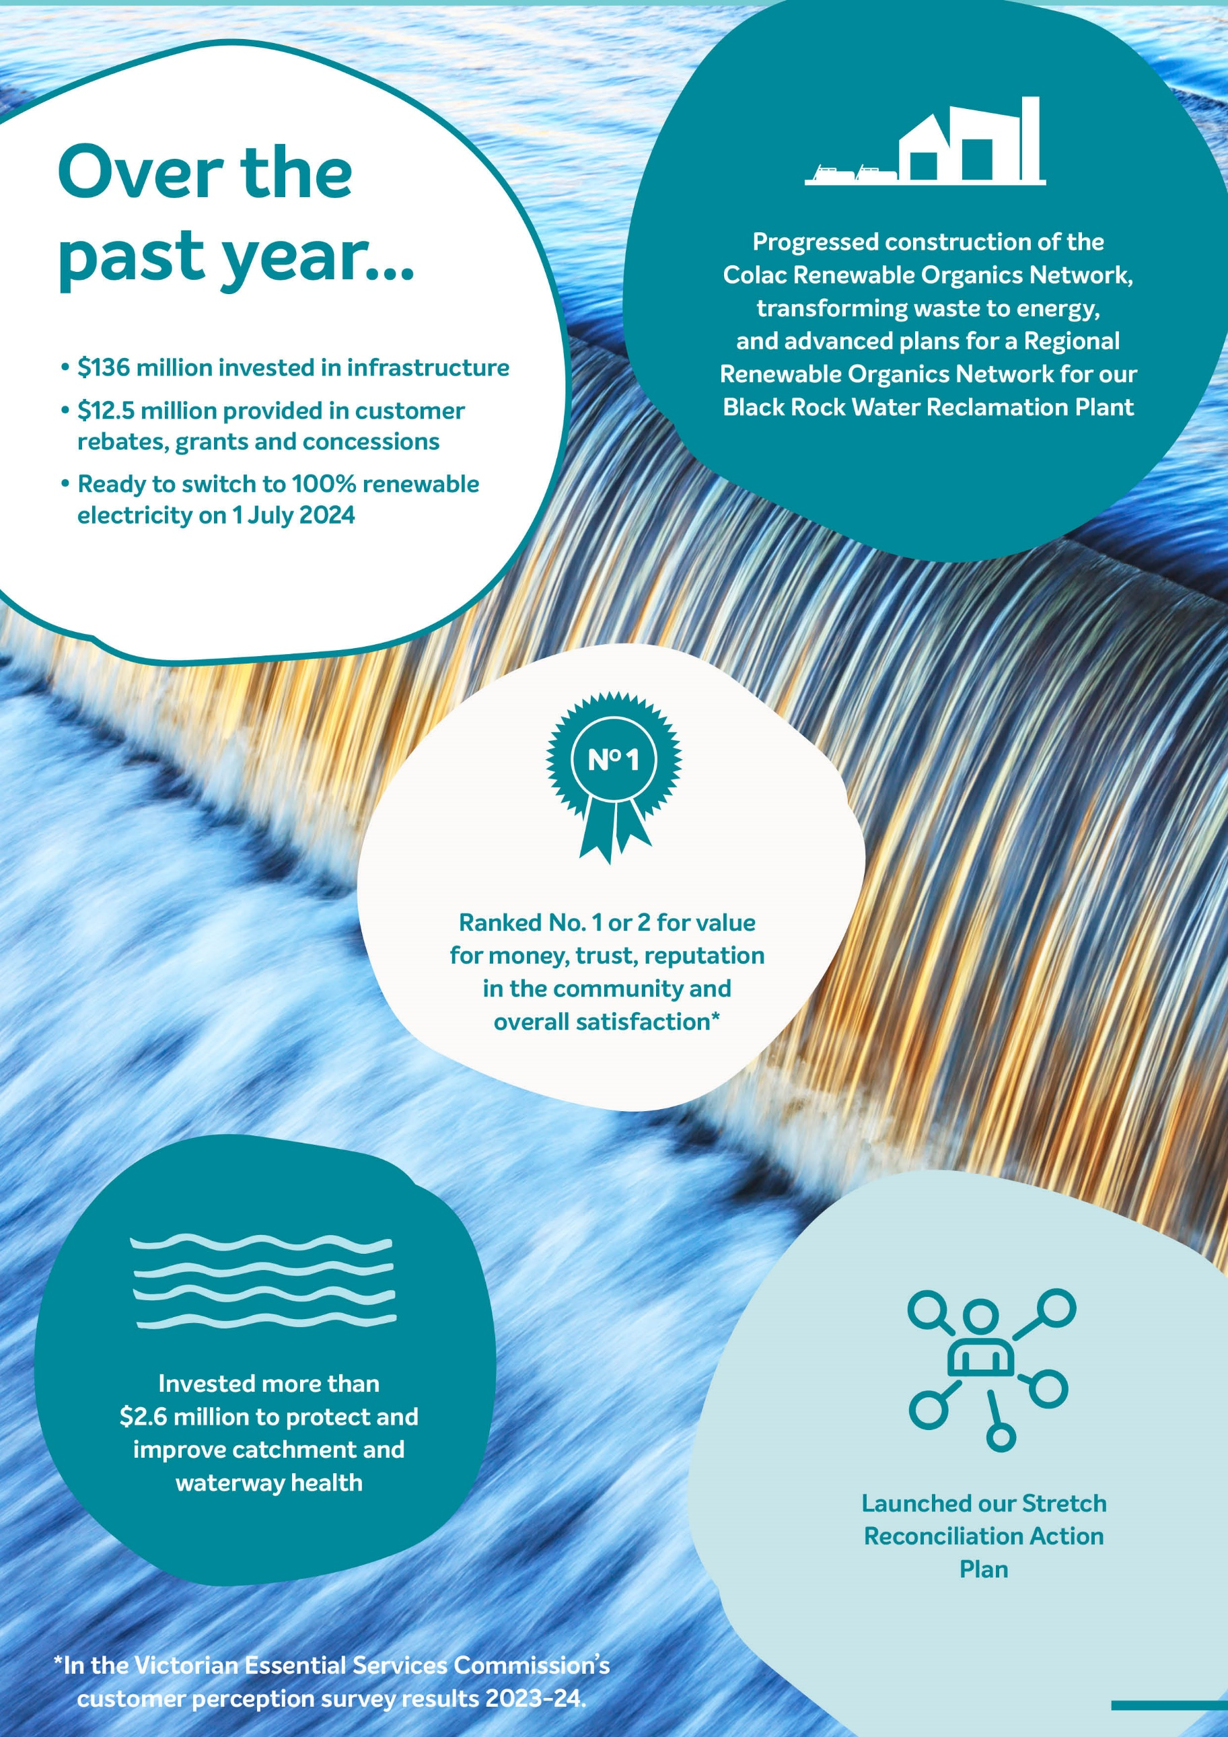
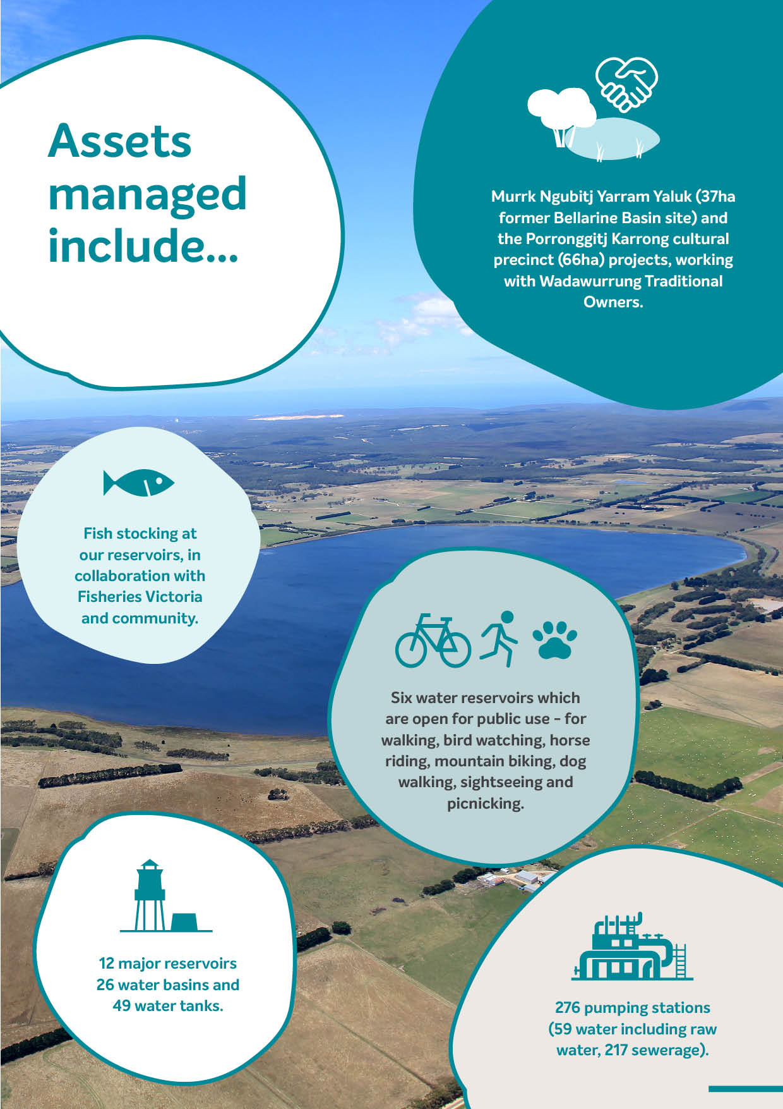
<#Will be made into a graphic>

Over the past year…
- $136 million invested in infrastructure
- $12.5 million provided in customer rebates, grants and concessions
- In 2023–24, we invested more than $2.6M to protect and improve catchment and waterway health.
- 100% of our electricity supply was from renewable sources by the end of the financial year (1 July 2024)
- Launched our first Stretch RAP
- Ranked No. 1 or 2 for value for money trust, reputation in the community and overall satisfaction*
- We completed construction of the Colac Renewable Organics Network, transforming waste to energy, with a business case for a Regional Renewable Organics Network completed for our Black Rock Water Reclamation Plant.

Our assets include…
- 12 major reservoirs, 26 water basins and 49 water tanks
- 11 water reclamation and 8 water treatment plants
- 7,597 kilometres of pipes
- 276 pumping stations (59 water including raw water, 217)
- Six water reservoirs which are open for public use - for walking, bird watching, horse riding, mountain biking, dog walking, sightseeing and picnicking.
- fish stocking at our reservoirs, in collaboration with Fisheries Victoria and community groups
- Murrk Ngubitj Yarram Yaluk (37ha former Bellarine Basin site) and the Porronggitj Karrong cultural precinct (66ha) projects, working with Wadawurrung Traditional Owners.

*In the Victorian Essential Services Commission’s customer perception survey results 2023-24.

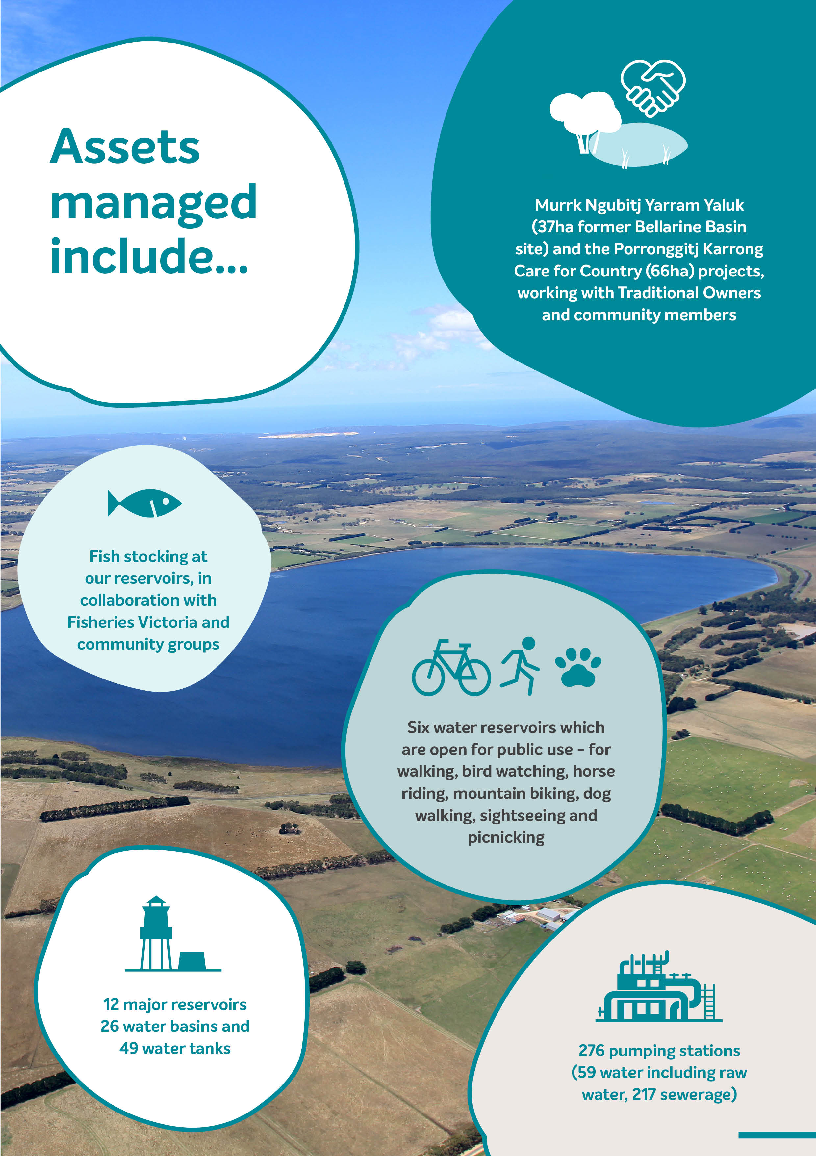
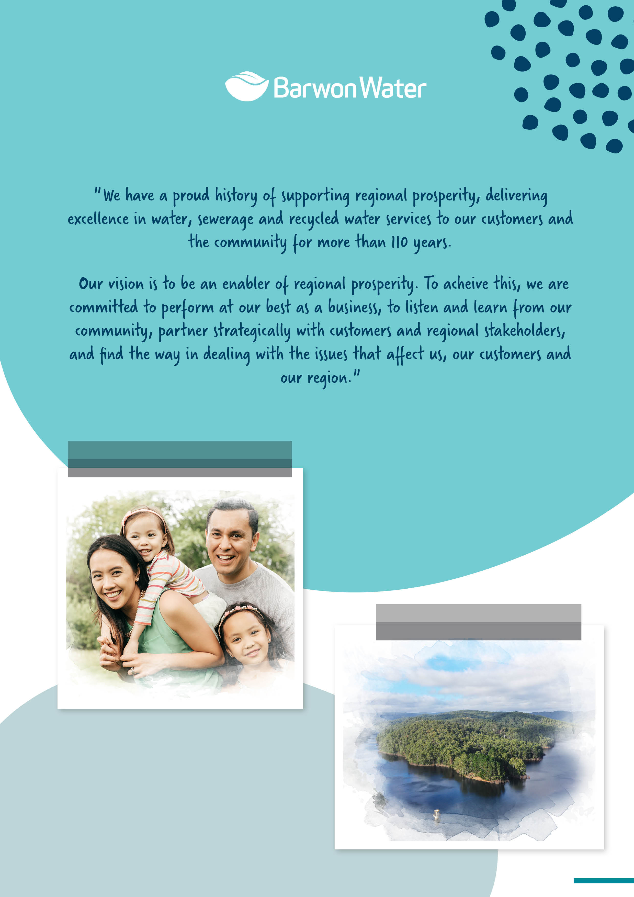

CONTENTS

Part 1: Year in review 4
- Responsible body declaration 5
- Chairs & MD Message 5
- Financial summary & tables 8
Part 2: About us 13
- Vision and values 13
- Strategy 15
- At a glance – graphs 19

Part 3: Water consumption 20
- Consumption tables 21
- Residential water efficiency 23
- Non-residential water efficiency 24
- Grants provided 26

Part 4: Reconciliation 27
- Reconciliation Action Plan 28
- Working with Traditional Owners 28
- Cultural Awareness Training 29
- NAIDOC & Reconciliation Week 30
- Traineeship program 30

Part 5: Caring for Customers 31
- Customer Advisory Committee 32
- Customer experience program 33
- Assisting customers experiencing 34
financial vulnerability
- Concessions 35
- Helping customers save water 35
- Community service obligations 35


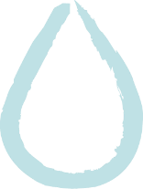

Part 6: Caring for Community 36
- Environmental Advisory Committee 37
- Community and stakeholder engagement 37
- Education 38
- Urban Water Strategy 39
- Integrated Water Management 39
- Recycled water 40
- Drought preparedness 40
- Drinking water quality 41

Part 7: Caring for Country 42
- Catchment and waterway management 43
- Environmental flows 43
- Protecting Victoria's environment 44
- Biodiversity 2037
- Environmental licence compliance 44
- Greenhouse gas emissions, electricity 45
consumption and generation
- Climate change resilience 50
- Environmental performance 52
- Bulk Entitlement reporting 53

Part 8: Governance & Corporate Information 59
- Organisational structure 60
- The Board 61
- Workforce data 65
- Health, safety & wellbeing 69
- Compliance with policies 73
- Social procurement 76
- Asset Management 77
- Reviews and studies 78
- Ministers Letter of Expectations 82
Part 9 Performance Report 93
Part 10 Financials 98
Appendices 160
- Disclosure index 161
- At a glance - table 163



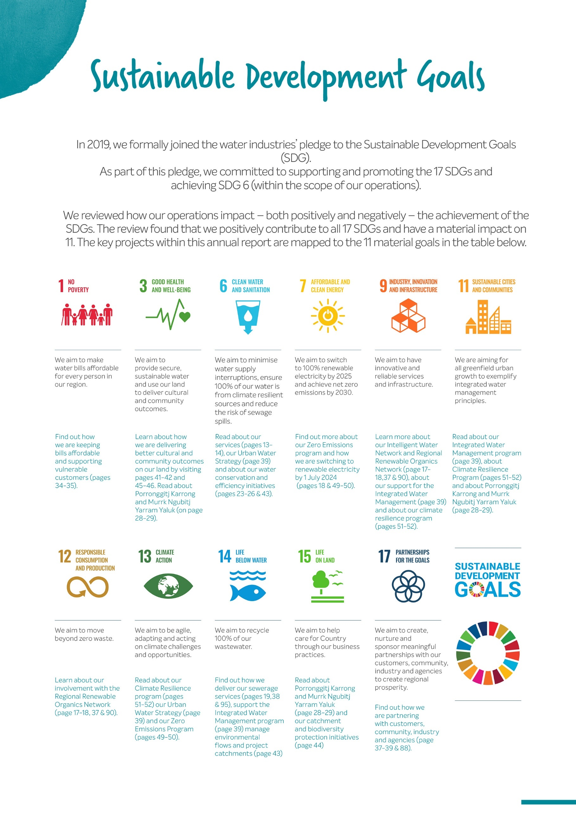

Sustainable Development Goals
In 2019, we formally joined the water industries’ pledge to the Sustainable Development Goals (SDG). As part of this pledge, we committed to supporting and promoting the 17 Sustainable Development Goals and achieving Sustainable Development Goal 6 (within the scope of our operations).
We reviewed how our operations impact – both positively and negatively – the achievement of the SDGs. The review found that we positively contribute to all 17 SDGs and have a material impact on 11. The key projects within this annual report are mapped to the 11 material goals in the table below.

 | 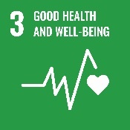 | 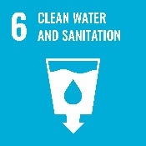 | 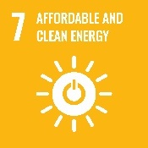 |  | 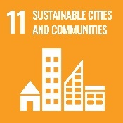
We aim to make water bills affordable for every person in our region. | We aim to provide secure, sustainable water and use our land to deliver cultural and community outcomes. | We aim to minimise water supply interruptions, ensure 100% of our water is from climate resilient sources and reduce the risk of sewage spills. | We aim to switch to 100% renewable electricity by 2025 and achieve zero net emissions by 2030. | We aim to have innovative and reliable services and infrastructure | We are aiming for all greenfield urban growth to exemplify integrated water management principles.
Find out how we are keeping bills affordable and supporting vulnerable customers  (pages 36-37). | Learn how we are delivering better cultural and community outcomes on our land.  by visiting pages 41-42 and 45-46. Read about Porronggitj Karrong and Murrk Ngubitj Yarram Yaluk on (page 31). | Read about our services (pages 13), our Urban Water Strategy (page 41) and about our water conservation and efficiency initiatives (pages 25-26 & 43). | Find out more about our Zero Emissions program and how we are switching to renewable electricity by 1 July 2024 (pages 47-52). | Learn more about our Intelligent Water Network and Regional Renewable Organics Network (page 19-20), about our support for Integrated Water Management (page 41) and about our climate resilience program (pages 51-52). | Read about our Integrated Water Management program (page 41), about Climate Resilience Program (pages 51-52) and about Porronggitj Karrong and Murrk Ngubitj Yarram Yaluk (page 31).
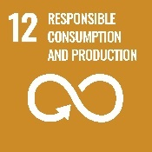 | 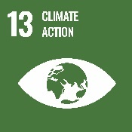 | 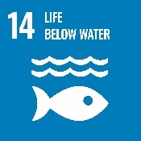 | 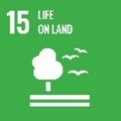 | 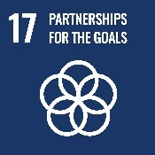 | 
We aim to move towards zero waste. | We aim to be agile, adapting and acting on climate challenges and opportunities. | We aim to recycle 100% of our wastewater. | We aim to help care for Country through our business practices. | We aim to create, nurture and sponsor meaningful partnerships with our customers, community, industry and agencies to create regional prosperity. | 
Learn about the Regional Renewable Organics Network (page 20, 39, 51, 92). | Read about our Climate Resilience program (pages 51-52) our Urban Water Strategy (page 41) and our Zero Emissions Program (pages 47-52). | Find out how we deliver our wastewater services (pages 12, 97), support the Integrated Water Management program (page 41) manage environmental flows and project catchments (page 45) | Read about Porronggitj Karrong and Murrk Ngubitj Yarram Yaluk (page 31) and our catchment and biodiversity protection initiatives (page 46) | Find out how we are partnering with customers, community, industry and agencies (page 30, 34, 39 & 41)

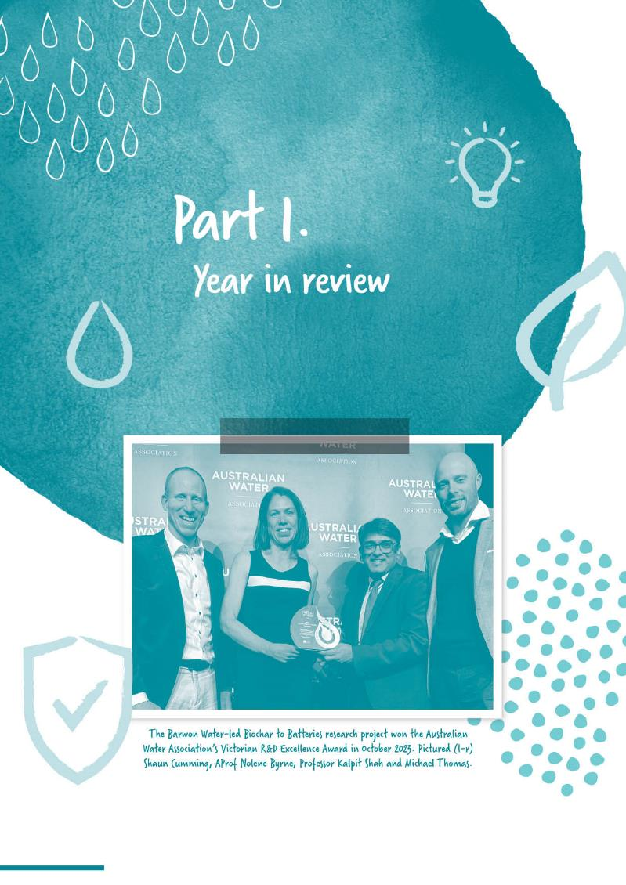

Section divider page
WITH IMAGE

Part 1.
Year in review


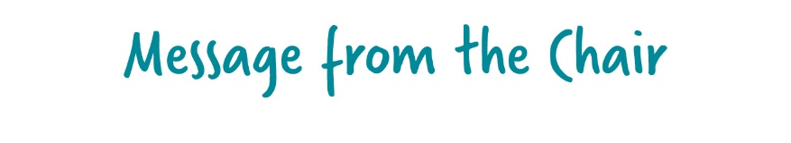
I'm delighted to share our progress and future priorities, detailed in our 2023-24 Annual Report. The report highlights our unwavering commitment to delivering our core services while ensuring a clear focus on innovation, sustainability and community engagement, to enable our Strategy 2030 and the Water for Victoria Plan.

I would like to acknowledge the Traditional Owners of the lands on which we live and work and acknowledge that they never ceded this land. I thank them for the care they have taken of the land, water and environment for tens of thousands of years and continue to this day.
I pay my respects to Elders past, present and future and to all Aboriginal and Torres Strait Islander people. It is a privilege to share in the knowledge and experiences from the oldest living culture in the world.
This annual report reflects a strong period of transition and growth for Barwon Water. This was the first year of our 2023-28 Price Submission, which sees us delivering on four key customer outcomes: safe, secure, sustainable water; innovative, reliable services; a healthier environment; and trust, affordability, and value.
We also moved into a new era as a Board, with the appointment of Managing Director Shaun Cumming, after a period of serving as Interim Managing Director, and three new Board Directors - Chris Chesterfield, Jason Kambovski and Jodie Leonard – in October 2023.
Thank you to outgoing directors Elaine Carbines (Deputy Chair), John Gavens and Bernard Walsh. Through their passion, commitment, and decision-making, they have all played critical roles in the organisation’s success.
An undoubted highlight of the year is the culmination of our transition to renewable energy. As of 1 July 2024, Barwon Water will be using 100 per cent renewable electricity to power its facilities. We are the first water corporation in the state to reach this milestone, and we have achieved it a full year ahead of the 2025 target for the sector, set by the Victorian Government.
Responsible Body Declaration
In accordance with the Financial Management Act 1994, I am pleased to present
Barwon Water’s Annual Report for the year ending 30 June 2024.
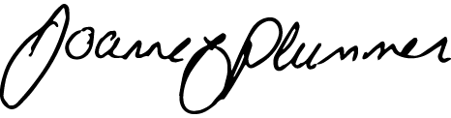
Jo Plummer
Chair, Barwon Water, 19 September 2024

Building on this – and our development of a circular economy - we also advanced plans for the Regional Renewable Organics Network (RON), which will repurpose the region’s organic waste, reduce emissions and provide renewable energy for our wastewater treatment plants.
In conjunction with tackling the impacts of climate change, responding to the challenge of a growing population remains a key priority.
We’re working with the City of Greater Geelong to facilitate the development of its Northern and Western Geelong Growth Areas, with plans for a large-scale alternative water grid, to maximise the use of stormwater and recycled water.
We’re also committed to supporting future growth areas, including those outlined via the Victorian Government’s Homes for Victorians strategy. We’ll work with the Government and other stakeholders to ensure our services keep pace with an accelerated supply of regional housing.
In further support, we’re partnering with GROW, gforce and Northern Futures on a program to create career pathways for priority jobseekers in the construction industry.
Alongside these initiatives, Barwon Water’s extensive capital works and strategic planning programs will facilitate regional growth by investing in the required infrastructure.
To help us meet other future demands, we’re continuing to invest in digital technology that helps us maintain our infrastructure and improves the experience of our customers.
In a highly challenging financial environment, we were proud to again achieve outstanding results in the Essential Services Commission’s customer surveys.
Our ongoing commitment to supporting customers experiencing financial hardship – and improvements to all levels of our Customer Experience transformation program – have assisted in this space.
The 2023-24 financial year has set a strong foundation for Barwon Water’s future. As we navigate the economic challenges ahead, we remain committed to financial sustainability and performance. Rigorous risk assessments and efficiency measures have been implemented to manage costs and ensure we continue delivering value to our customers.
I extend my gratitude to our team, customers and partners for their support and dedication.


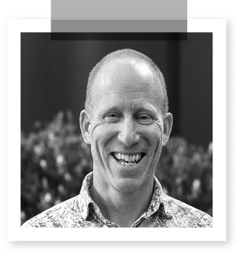

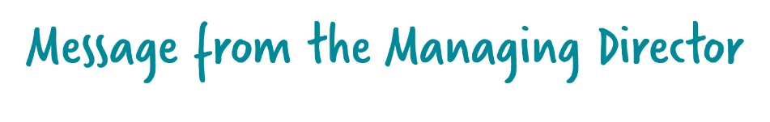
Building on the Message from our Chair, Jo Plummer, and on behalf of the team at
Barwon Water, we are proud to report on our performance over the
2023-24 financial year.
We have:
made significant progress across the four key service outcome areas that reflect our
customer’s values and expectations
continued to learn from Traditional Owners and how we support their Heathy Country Plans
invested in our future to meet the demand of a growing population and enable the region’s
economic, social, cultural and environmental prosperity.
The following is a snapshot of highlights, with a greater variety of achievements detailed in the full Annual Report.

Outcome 1: Safe, Secure, Sustainable Water
We are providing clean drinking water, compliant wastewater treatment, promoting recycled water use, and maintaining secure supplies.
In line with our Urban Water Strategy 2022: Water for our Future, we delivered or progressed initiatives in a variety of service areas in 2023-24, including investments in recycled water use on the Bellarine (Portarlington); upgrading water treatment plants (Forrest, Gellibrand); and providing safe and secure services via pipelines (Birregurra to Colac).
There was a strong focus on smart water efficiency initiatives and community education, to minimise water loss and help customers save more than 200 million litres of water, via our Sustainable Water Use Plan.
We fostered strategic partnerships with councils and government for Integrated Water Management solutions, and increased awareness about the need to safeguard our precious resources via a ‘Water Matters’ campaign.
Our community engagement was a key component of our planning for long-term water security in Lorne, with the Community Working Group meeting on several occasions over the financial year.
Outcome 2: Innovative, Reliable Services
We ensure our customer experience is second-to-none.
We achieved 100% compliance with Drinking Water and EPA licence standards.
Ensuring a superior customer experience remains paramount and we advanced our Customer Experience transformation program, driving a culture of care at all touchpoints and improving complaints management.
We doubled our Customer Advisory Committee's membership, ensuring we get a wider range of advice about customer priorities.
Communication processes were improved for planned and unplanned outages, while we provided customers with more options to contact us and increased the take-up of e-billing.
Drawing on clever data analytics, we optimised sewer maintenance and replacement programs, allowing us to extend the life of assets and minimise risk to services.
We also grew the business of Barwon Asset Solutions (BAS), the locally based maintenance services company that as a wholly owned subsidiary of Barwon Water, delivers profit so we can keep customer bills low.
Our customers have recognised this commitment, ranking us as the Victorian water industry leader in a number of community satisfaction metrics.
Outcome 3: Healthier Environment
We will complete our switch to 100% renewable electricity use on July 1, 2024, and aim to be net zero emissions in our operations by 2030. We are reducing resource consumption and waste production through improved efficiency and support waterway and catchment health.
Achieving our target of using 100 per cent renewable electricity to power our facilities was a major milestone.
The increased use of renewable electricity – driven by solar array initiatives, renewable power purchase agreements, and innovative projects like the Colac RON – helped reduce our carbon emissions by a further 19 per cent in 2023-24.
We closed in on completing Stage 2 of the Colac RON, with renewable electricity being generated and the hot water system to soon supply neighbouring businesses. We also progressed plans with businesses and councils to implement the Regional RON at Black Rock.

With an eye on our 2030 target of achieving net zero emissions in our operations, we initiated our first nature-based carbon sequestration program, at Dewing Creek. In addition to improving biodiversity and drinking water catchment health, this project will remove over 50,000 tonnes of carbon dioxide from the atmosphere over the next 25 years.
In other key partnerships, we worked with Wadawurrung Traditional Owners, to better understand how we can return water to rivers, in support of Traditional Owner cultural values.
In an exciting development, we are on track to return
3,700 million litres a year to the Moorabool River by the end of 2025.
We have also been continuing conversations with Eastern Maar to better understand how we can best work alongside them.

Outcome 4: Trust, Value, and Affordability
We will keep bills flat (at or below inflation) in the next five years and proactively seek opportunities for strengthening partnerships with key groups where we have clear mutual interests. We will build two-way community relationships and work collaboratively with our customers, stakeholders and industry.
Led by our Customer Support Strategy, we worked collaboratively with local agencies and councils and helped customers experiencing hardship.
We increased our funding to assist customers to manage their bills, and to improve their water efficiency. This allowed more customers to access grants, led by an increase in the Arrange & Save program.
We are determined to maintain one of the lowest bills in Victoria for a water company of our size during this pricing period. During 2023-24, we shielded our customers from the inflationary environment, by keeping our bills under the rate of CPI.
We increased our capital investment by 24 per cent on the previous year, to $136 million, helping to maintain and upgrade our assets and support regional growth. Pleasingly, we progressed 100 per cent of our capital works program, which has seen us deliver commitments we made to our customers.
Across all parts of our operations and service delivery, we’re committed to ensuring our actions align with our promise to our customers.
We look forward to continuing to deliver on our ambitious goals over 2024-25 and I thank our team, customers, community and partners for your support, inspiration and commitment.


I’m proud to present the Barwon Water Annual Report for 2023–24.

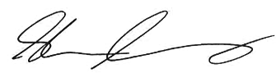

Shaun Cumming
Managing Director

Summary of financial results
Barwon Region Water Corporation Financial Management Compliance Attestation Statement
I, Joanne Plummer, on behalf of the Barwon Region Water Corporation, certify that the Barwon Region Water Corporation and its wholly owned subsidiary Barwon Asset Solutions has no Material Compliance Deficiency with respect to the applicable Standing Directions under the Financial Management Act 1994 and Instructions.
Jo Plummer
Chair, Barwon Region Water Corporation, 30 August 2024

Financial summary
The 2023–24 financial year was the first year of the 2023-2028 Price Submission period, which acknowledged, among other things, key capital initiatives to increase the resilience of regional infrastructure to deal with challenges including climate change and population growth, while also increasing direct financial support for customers experiencing vulnerability and those affected by family violence, while providing for falling (real) prices, indicating improved value for customers.

During the financial year, we received revenue of $292.8 million, contributing towards a $9.4 million net surplus. Further, we delivered our largest capital works program in twelve years of $136 million, as total assets reached $3.8 billion.
Challenges overcome
The economic environment continued to raise numerous challenges during 2023-24 as cost-of-living pressures continued for customers and businesses in the region. Although some downward movement in Inflation has occurred since the prior year, upward pressure on supplier prices continues. This continued financial pressure has required a diligent but caring approach to the recovery of aged debt, through the ongoing support of our customers. Following the success of our Customer Affordability Pipeline (CAP) in the

previous pricing period which delivered over $40 million of savings through
efficiencies, this continued to be our primary mechanism of finding efficiencies to support lower prices.
The ongoing commitment to the management of our debt portfolio and our disciplined approach to cash management, and the capital works portfolio, has minimised the impact of these financial pressures. Our strategic aspiration of being a financially sustainable business remains a key focus for the Board and management of Barwon Water.
Major changes or factors affecting performance
As stated, revenue for the year increased to $292.8 million from $258.4 million in the prior year. Drier climate conditions, especially in the second half of the financial year, lifted water usage volumes, and were accompanied by continued higher levels of the Consumer Price Index (CPI). Despite increased expenditure mainly due to economic conditions, the decision to increase staff FTE in the short term to help move us more rapidly towards our strategic goals, movement of digital costs from Capital to Operating expenditure impacting contractor and consultancy costs, and some one-off items related to the disposal of assets, the Group, through strong fiscal management, delivered a strong surplus of $9.5 million.
Depreciation, amortisation and impairment costs of $82.9 million were
higher than prior year by $4.8 million. 2023-24 saw the full year effect of the revaluation of water and sewer
infrastructure assets undertaken in 2022-23, along with the continued impact of accelerated depreciation due to the decommissioning of assets related to the Forrest, Gellibrand and Birregurra Water Treatment Plants which will continue into 2024–25.
Significant changes in financial position
Total assets have increased year on year by $83.7 million. Investment in infrastructure during the financial year was funded through $86 million in funds from operations with the balance funded through an increase in borrowings. Total debt increased by $50.0 million to $607.9 million, with cash and cash equivalents decreasing by $1.7 million to $12.6 million.
Barwon Water delivered a $136 million capital works program, building on the significant program from the prior year. $62 million was spent on renewing and replacing infrastructure across the network, while a further $42 million was spent on assets required to support the continuing growth in our region including $12 million for the upgrade of the Colac Reclamation Plant.
Events subsequent to balance date
No material events occurred after balance date.

Summary of financial results
 | 2023–24  ($’000) |  | 2022–23  ($’000) |  | 2021–22  ($’000) |  | 2020–21  ($’000) | 2019–20  ($’000)
 |  | 230,582 |  | 206,922 |  | 199,784 | 195,094 | 193,181
Capital revenue |  | 50,729 |  | 39,128 |  | 31,327 | 42,302 | 44,026
Government contributions |  | 1,622 |  | 1,433 |  | 4,404 | 660 | 389
Other revenue |  | 9,905 |  | 10,945 |  | 19,630 | 9,978 | 12,305
Total revenue |  | 292,838 |  | 258,428 |  | 255,145 | 248,034 | 249,901
Operating expenditure |  | 140,849 |  | 122,564 |  | 118,713 | 105,952 | 107,271
Depreciation expenditure |  | 82,887 |  | 78,128 |  | 72,720 | 73,839 | 70,816
Finance costs |  | 35,307 |  | 31,905 |  | 32,855 | 35,018 | 36,845
Other expenditure |  | 10,206 |  | 10,872 |  | 10,119 | 10,801 | 8,719
Total expenditure |  | 269,249 |  | 243,469 |  | 234,407 | 225,610 | 223,651
Net other economic flows |  | (10,027) |  | (6,394) |  | 4,371 | 5,042 | n/a
Net result before tax |  | 13,562 |  | 8,565 |  | 25,109 | 27,466 | 26,250
Current assets |  | 68,969 |  | 67,403 |  | 65,607 | 72,234 | 83,670
Non-current assets |  | 3,725,299 |  | 3,643,161 |  | 3,170,403 | 3,139,657 | 2,761,023
Total assets |  | 3,794,268 |  | 3,710,564 |  | 3,236,010 | 3,211,891 | 2,844,693
Current liabilities |  | 146,574 |  | 111,979 |  | 104,484 | 107,111 | 111,301
Non-current liabilities |  | 1,224,937 |  | 1,184,303 |  | 1,015,589 | 1,029,591 | 938,995
Total liabilities |  | 1,371,511 |  | 1,296,282 |  | 1,119,073 | 1,136,702 | 1,050,296
Net cash flows from operations |  | 86,383 |  | 74,193 |  | 49,970 | 83,722 | 77,699
Payments for infrastructure, property, plant and equipment |  | 138,750 |  | 118,159 |  | 63,393 | 76,845 | 79,299

Barwon Water’s financial performance to 30 June 2024
Financial result | 2023–24 | 2022–23 | 2021–22 | 2020–21 | 2019–20
Internal financing ratio | 64.4% | 62.6% | 108.07% | 162.55% | 103.90%
Gearing ratio | 17.1% | 16.15% | 17.24% | 17.88% | 21.70%
Interest cover (EBIT) | 1.39 times | 1.27 times | 1.77 times | 1.79 times | 1.71 times
Interest cover (Cash) | 3.48 times | 3.34 times | 2.53 times | 3.42 times | 3.10 times
Return on assets | 1.29% | 1.16% | 1.80% | 2.06% | 2.23%
Return on equity | 0.39% | 0.27% | 0.92% | 1.08% | 1.11%

The full financial report can be found on pages 99 to 159 and contains more discussion of the results shown in the tables above.

Capital investment
We delivered $136 million of capital and related infrastructure works during 2023-24 to continue and improve our $3.8 billion asset base on behalf of our customers and community.
Water supply
We invested $57.6 million in our water supply system. The largest of the water supply investments were Colac Birregurra Pipeline ($9.3 million), Water Reticulation Main Renewal ($6.4 million), Forrest Water Treatment Plant Upgrade ($4.7 million) and Colac Pipeline Upgrade ($4.3 million).
Category | $ million
Headworks | 8.4
Reticulation systems | 12.4
Transfer and major distribution systems | 28.4
Water treatment and quality improvements | 8.4
Total water supply | 57.6

Wastewater system
We invested $61.7 million in our wastewater system. The largest of the investments were Colac Water Reclamation Plant Upgrade ($11.9 million), Mains Rehabilitation and Replacement ($10.9 million), Main Sewer Lining ($6.6 million) and Austin Lara Sewer Pump Station ($3.7 million).
Category | $ million
Main sewers | 19.7
Reticulation and other works | 22.0
Water reclamation and disposal | 20.0
Total wastewater system | 61.7

Recycled water
We invested $5.7 million in our recycled water system. The largest of the recycled water investments were Winchelsea Water Reclamation Plant Recycled Water Infrastructure ($1.6 million) and Recycled Water on the Bellarine ($1.1 million).
Other works and services
We made $11.0 million capital works investment in other works and services. The largest was the Northern Water Reclamation Plant Minor Improvements and Renewal ($2.0 million), Regional Renewable Organics Network ($1.6 million) and Aqueduct works to undertake conservation propping and partial demolition of the heritage-listed Barwon River Aqueduct ($1.1 million).
Category | $ million
Building | 2.9
Corporate information systems | 2.4
Other corporate works | 5.7
Total other works and services | 11.0

Capital projects
During the year ending 30 June 2024, two capital projects that Barwon Water is responsible for with a Total Estimated Investment (TEI) of $10 million or greater, reached practical/financial completion. Details are set out in the table below.
For information on recent capital projects managed by Barwon Water and the broader Victorian public sector, please refer to the most recent Budget Paper No. 4 State Capital Program (BP4) available on the Department of Treasury and Finance’s website at this link: https://www.budget.vic.gov.au/budget-papers.

Project  Name | Original  completion  date | Latest  approved  completion  date | Practical  completion date | Reason for  variance in  completion  dates | Original approved TEI budget  ($ million) | Latest approved TEI budget  ($ million) | Actual  TEI  cost  ($million) | Variation between actual cost and latest budget | Reason for  variance
Colac Water Reclamation Plant upgrade | 30/12/23 | 30/12/24 | 30/12/24 | Overseas equipment procurement delays impacted initial program and more recent construction delays have caused some further impact to completion timelines. | 11.8 | 13 | 11.9 | 1.1 | Saving due to construction delays.
Water Mains rehabilitation and replacement panel | 30/06/28 | 30/06/28 | 30/06/28 | n/a | 10.9 | 7.9 | 10.9 | -3 | Project not yet completed and has movements between the years of the program.

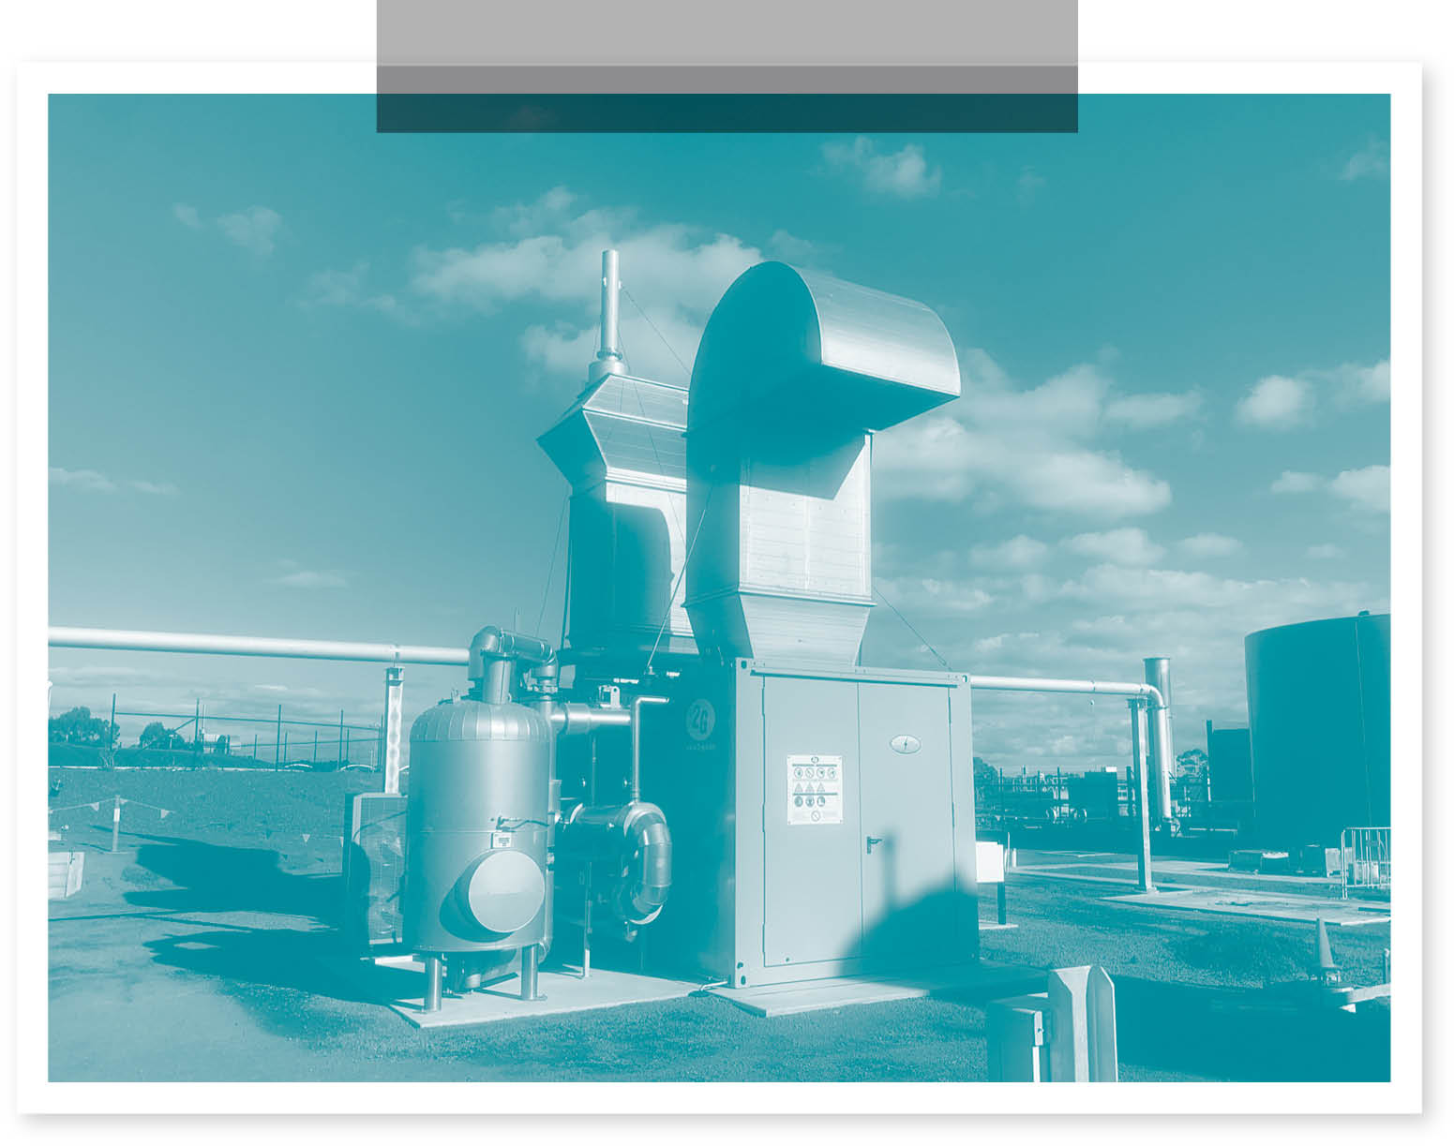



The new cogeneration unit powered by biogas at Colac Water Reclamation Plant.
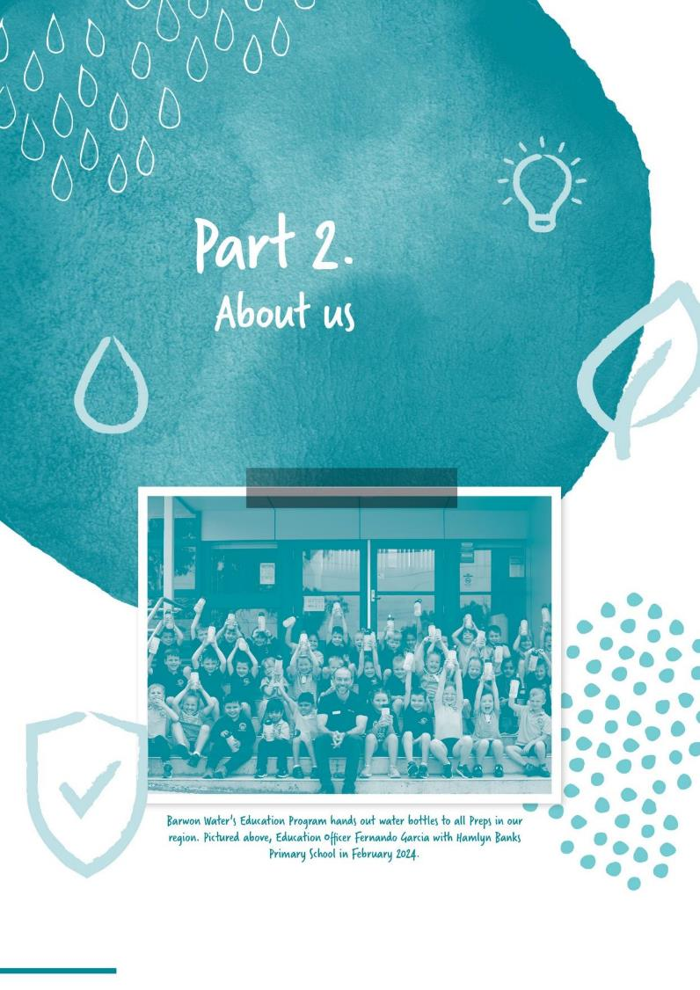
Section divider page
WITH IMAGE

Part 2.
About us

About us
Barwon Region Water Corporation (Barwon Water) is Victoria’s largest regional urban water corporation.
Commitment to service delivery has been our strength for more than 110 years
To help our region prosper, we perform at our best as a business, listen and learn from our community, partner strategically with customers and regional stakeholders, and find the way in dealing with the issues that affect us, our customers and our region.
Our mission is to strengthen the economic, social, cultural and environmental prosperity of our region through the delivery of sustainable, affordable, innovative and reliable water and wastewater services.
In 2023-24, we continued delivering on this commitment and have highlighted how in examples detailed throughout this report.
As a major employer in the region, the Barwon Water Group has more than 486 employees. The Group includes Barwon Water and Barwon Asset Solutions (BAS), our dedicated maintenance services company. BAS are 100 per cent owned by Barwon Water and provide operational and maintenance services to us and other external entities. They support our vision by bringing in external revenue, to help us keep customer bills low.
Barwon Water – 364.87 full-time- equivalent employees
Barwon Asset Solutions (BAS) – employs 121.9 full-time-equivalent employees
we also employ approximately 2,000 contractors.

Our employees are from a diverse range of disciplines, including operations, engineering, strategic planning, community engagement, customer, technology, finance and administration.
Two percent of our workforce identify as Aboriginal or Torres Strait Islanders.
We recruit and support people of all abilities. We recognise that people living with disability are widely represented in our community.
We are Work180 endorsed and proud to be named one of Australia's top 101 workplaces for women. We celebrate our diversity, show respect and appreciate the unique talents and perspectives that each of us brings to work each day.
The money we spend in the region also supports employment outside of our organisation. We estimate that our annual capital and operating expenditure sustains an additional 120 full-time-equivalent jobs.
Our vision
Our vision is to become an enabler of regional prosperity.
As the trusted water authority in our region, we understand our core business is delivering high-quality water and wastewater services, and customer and community value. Clean, high quality drinking water and a world-class wastewater treatment system has kept our region healthy and safe.
Despite this record of achievement and motivated by significant and rapid change in the world around us, we heard what our customers and community wanted from us in response to global challenges and developed Strategy 2030 to guide how we lean in and help address these challenges. We are working in partnership with our customers and community, leveraging the intrinsic value of our services to enhance the prosperity of our region.
Our values
The values of the Barwon Water Group are at the core of who we are and what we stand for as an organisation. They guide the actions we take, the decisions we make, and how we work together with each other and our community.
Our values are:
Caring – We care for our customers, community, region, the environment and each other
Safe – We look out for the health, safety and wellbeing of ourselves, each other, our contractors and our community
Inclusive – We celebrate diversity and the unique talents we each bring; we show respect and collaborate. We learn from and work with Traditional Owners
Accountable – We take ownership, are trustworthy and committed to delivering outstanding outcomes in each of our roles
Courageous – We speak up, lean in and challenge ourselves to grow.



Our commitment to customers
Through deep, genuine and ongoing engagement with our customers and community as part of our 2018 and 2023 Price Submissions, we heard what our customers and community wanted from us in response to global challenges and we refreshed our Strategy 2030 to guide how we lean in and help address these challenges in partnership with them.
The core of our promise to customers is reflected in four key outcomes which are:
Safe, secure, sustainable water – We will support our growing region to be prosperous and sustainable, by securing enough water and building the infrastructure to meet all our needs
Innovative, reliable services – By listening to our customers and community, and by being forward thinking and technologically advanced, we will continually improve, be inclusive, caring and easy to deal with
Healthier environment – We will apply a caring for country approach to our land and waterways in partnership with our Traditional Owners and other agencies. We will strive for zero emissions in our operations and generate useful products from our waste
Trust, value and affordability – We will respond to the diverse needs and values of our customers and aim to be a valued and trusted leader. We will actively support customers, keep bills affordable and resolve issues fairly.

Our 2023–28 Price Submission commenced on 1 July 2023. This is the first year in our five- year commitment to these updated customer outcomes.

Our customers
We provide services to a population of more than 370,000 permanent residents across an 8,100 square-kilometre region. In peak tourist periods, the population can reach up to 638,000 people.
We regard every individual we interact with as a customer and a member of our community, regardless of whether they receive a bill. The majority of our customer base, about 93%, is made up of residential customers who pay bills. The remaining 7% is contributed by the industrial and commercial sectors. Non-residential or business customers account for roughly 28% of the total metered water consumption.
We have researched the diversity and demographics of our community to ensure that we can meet their needs, in terms of financial, disability, language and cultural requirements. We also used this data to reflect the diversity of our region within our own workforce targets*. City of Greater Geelong 2021 census data shows that 13.4% of our region’s population use a language other than English at home, 6% have a disability and 1.3% are Aboriginal or Torres Strait Islanders. 32% of the population (age 15+) earns less than $500 per week and 4.7% are on Job Seeker or Youth Allowance.
Our own 2022 research identified several barriers for customers in accessing our services, which included communication challenges, low financial literacy and low awareness of support. These findings helped shape our Customer Experience (CX) Strategy, focusing on partnership with community agencies, increasing other language speakers, improved data analysis and more sophisticated engagement.
Our participation with the Geelong Settlement Committee will continue to improve our understanding of barriers faced by new/ emerging communities.

Additionally, we are focused on improving our capability to proactively identify and reach out to customers vulnerable to financial pressures, before it creates bill stress. This has strong support from our community, with 95% of our surveyed customers wanting us to care for those who need support.
We are one of eighteen organisations in Geelong that have pledged work together to use our collective influence in combatting financial disadvantage in our region. Through the creation of a refreshed Geelong Region Financial Inclusion Action Plan (FIAP), we are combining forces to enhance the financial inclusion, resilience, and wellbeing of our customers.

*Across our own workforce, 2% identify as Aboriginal or Torres Strait Islanders, 7% identify as having a disability and 13% have a cultural and linguistic diversity (language other than English or born overseas).

Our Strategy 2030
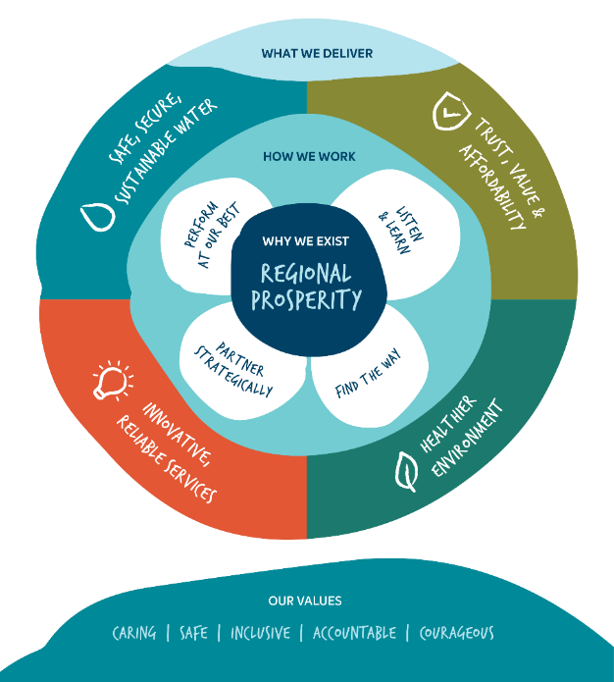

Delivering Strategy 2030

We recognise that we are in a time of significant and rapid change – from climate change to population growth, technological advancements to economic transitions – with our society growing increasingly intolerant of inequity and injustice in any form.
Through our ongoing engagement, we have heard what our customers and community want from us when it comes to facing significant global challenges; they want us to work in partnership with others, leveraging the intrinsic value of our services to enhance the region’s prosperity – economically, socially, culturally and environmentally.
Our Strategy 2030 reflects this change in approach and is aligned with our five-year pricing submission.
Strategy 2030 includes 14 aspirations across the four key customer outcomes (see Figure on the following page). These aspirations are deliberately ambitious, and we know they will stretch and challenge us. Yet we think they are achievable if we adopt the growth mindset we expect of ourselves and strive to do our best work.

Our Strategy 2030 Aspirations

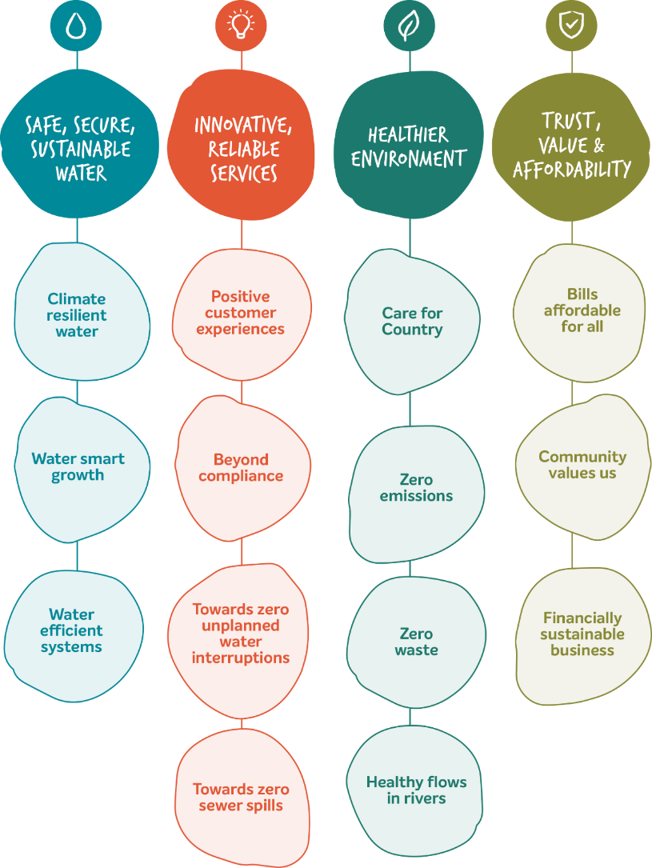

Our region
Barwon Water’s region of responsibility stretches from Little River and the Bellarine Peninsula in the east to Colac in the west, and from Meredith and Cressy in the north to Apollo Bay on Victoria’s south-west coast. This region incorporates the local government areas covered by the City of Greater Geelong, Borough of Queenscliffe, Surf Coast and Colac Otway shires and part of Golden Plains Shire. There are two Registered Aboriginal Parties in our region, Wadawarrung Traditional Owners Aboriginal Corporation and Eastern Marr Aboriginal Corporation.
Assets
We own and operate:
12 major reservoirs
8 water treatment plants
1 water pre-treatment plant
11 water reclamation plants, including Colac, where our Renewable Organics Network is converting waste into renewable electricity and renewable heat
2 Class A recycled water plants
1 groundwater field (Anglesea)
276 pumping stations (59 water – including raw water, 217 sewerage)
26 water basins
49 water tanks
7,597 kilometres of pipes.

Water sources
The Greater Geelong region’s water is supplied by three major surface water sources – the Barwon River and its tributaries, the Moorabool River and its tributaries, and water from the Greater Yarra Thomson system (accessed via the Melbourne to Geelong Pipeline).
The Otway Ranges feeds the Barwon system, which typically supplies the majority of the water needed for Geelong, the Bellarine Peninsula and the Surf Coast. The Moorabool system supplies water to towns north of the Geelong city centre.
The Melbourne to Geelong Pipeline can supply up to 16 billion litres of water per year, which is approximately 50 per cent of the Greater Geelong region’s annual water demand.
Another water source that can be accessed is the Anglesea Borefield which is used to help boost surface water supplies during dry conditions.
Colac and Otway regions water sources are primarily drawn from pristine catchments in the Otway Ranges. The Colac system provides water to urban and rural districts, extending as far north as Cressy. A pipeline connecting the Colac system to the Geelong system was completed in 2018 to provide additional water security.
Gellibrand, Apollo Bay, Skenes Creek and Lorne all have their own water supply systems.
Water reclamation plants
Barwon Water has 11 water reclamation plants which we operate in accordance with Environmental Protection Authority (EPA) requirements. Black Rock, Anglesea, Apollo Bay and Lorne plants supply recycled water for a variety of uses, with the balance released through ocean outfalls. The plants at Aireys Inlet, Bannockburn, Portarlington, Birregurra and Winchelsea are land- based systems also supplying recycled water for a variety of uses, including agriculture, horticulture and irrigating public open space.
Recycled water from the Colac facility is released into Lake Colac. The Northern Water Plant, which is an advanced recycled water facility, supplies Class A recycled water mainly for industrial use at the Viva refinery, and also irrigates public open space at Stead Park in Corio. Black Rock also has a Class A advanced treatment plant that supplies recycled water for residential use in the Armstrong Creek and Torquay North growth areas.

Circular Economy / Sustainable practices
Recycled water
To meet our Strategy 2030 aspiration of zero waste, we’re aiming to maximise the availability of recycled water for valuable uses, such as industry, agriculture, golf courses and public open space. This saves drinking water for the community, eases pressure on local drinking water supplies and helps us foster liveable communities with secure and sustainable water supplies.
Projects of note this year include continuing an investigation into a large-scale alternative water grid in our region, supported by funding from the State Government. We also continued an investigation into an alternative water scheme in the Surf Coast Hinterland, also supported by State Government funding, looking to use recycled water as well as urban stormwater that otherwise would adversely impact the health of the significant Karaaf coastal saltmarsh, for productive use.
The infrastructure required to supply recycled water to Barwon Park in Winchelsea has been constructed and we have also progressed the design of the recycled water plant for Deakin University’s Waurn Ponds campus.
We progressed the design and procurement phase for the Bellarine recycled water project, upgrading our plant so we can maximise the use of recycled water to support agricultural production and tourism in the area.
We have partnered with Viva Energy to turn recycled water into hydrogen at the New Energy Service Station being built in North Geelong adjacent to our Northern Water Plant (NWP). The circular process involves treating wastewater at the NWP, which is then used by Viva Energy to produce renewable hydrogen.
Pure oxygen that would ordinarily be released to the atmosphere as an inconsequential waste product is then captured and used by Barwon Water to enhance the treatment of wastewater, which ultimately ends up as recycled water.
We achieved 13.2 per cent water recycling in 2023–24. This figure was low due to the amount of rain, which minimised the amount of recycled water needed for irrigation purposes.
Biosolids
We continually explore innovative ways to efficiently treat and manage wastewater as our population grows.
During 2023–24, we continued to turn 100 per cent of our biosolids – a co-product of the wastewater treatment process – into a valuable nutrient-rich farm fertiliser at the thermal drying facility at Black Rock.
The drying process involves sterilising the biosolids with heat and turning them into pellets that are produced in accordance with the standards set by the EPA for use on farms. In 2023–24, we produced 54,543 tonnes of wet biosolid and turned it into 9,021 tonnes of dried biosolid product that was sold as a commercial fertiliser product. The proven benefits of the product created strong demand, and the supply chain was extended to farms across Victoria, New South Wales, South Australia and Tasmania.
We also signed a sales agreement with HDrive for a hydrogen-powered prime mover, which will be the first in Victoria. The truck will be used for the collection of organic waste for recycling at our water reclamation plants. The vehicle will be on road around mid-2025.

Emissions Reduction
As part of our Strategy 2030, we are switching to 100% renewable electricity from 1 July 2024 and aim to achieve zero net emissions by 2030.
Electricity use was previously our most significant emissions source and represented around 80 per cent of our underlying emissions. We’ve completed a diversified portfolio of renewable electricity projects, to supply 100% renewable, zero emissions electricity for our operations.
Our zero emissions program reduced emissions by at least 13,798 tonnes CO2-e in 2023-24 through a range of initiatives, including:
operating more than 4 megawatts of on-site renewable electricity generation assets, including a 3-megawatt solar farm at our Black Rock water reclamation plant and six solar arrays situated at our plants and depots
the innovative Colac biogas co-generation facility, recently expanded from 360-kilowatts capacity, with an additional 550 kilowatt unit commencing operation in early 2024-25
our Barwon Renewable Energy Partnership (BREP) Power Purchase Agreement with Mt Gellibrand Wind Farm and Zero Emissions Water Power Purchase Agreement with Kiamal Solar Farm continued to operate and generated more than 45 gigawatt-hours of renewable electricity that was fed into the grid

Looking further ahead to our target of zero net emissions (scope 1 and 2) by 2030, we are progressing scope 1 emissions reduction initiatives including:
commencing our first nature-based carbon sequestration initiative, the Dewing Creek catchment restoration project
Regional Renewable Organics Network (RRON) - Barwon Water and four local councils are joining forces to transform organic waste into biochar – a high value product for agriculture that also sequesters carbon dioxide - and at the same time generates digestate and renewable energy. In 2023-24 our next steps involved further design and community engagement in preparation for a planning permit application to the Department of Transport and Planning and a development license application to the Environmental Protection Agency
initiating an innovative trial to enhance wastewater treatment efficiency by using oxygen-enriched air, with the aim of enabling our plants to operate more efficiently, consume less energy, and have longer lifespans, ultimately leading to cost savings at every stage.


At a glance
Water: 2.40%
Sewer: 2.30%
from 2022-23
Water: 1.90%
Sewer: 2.00%
from 2022-23
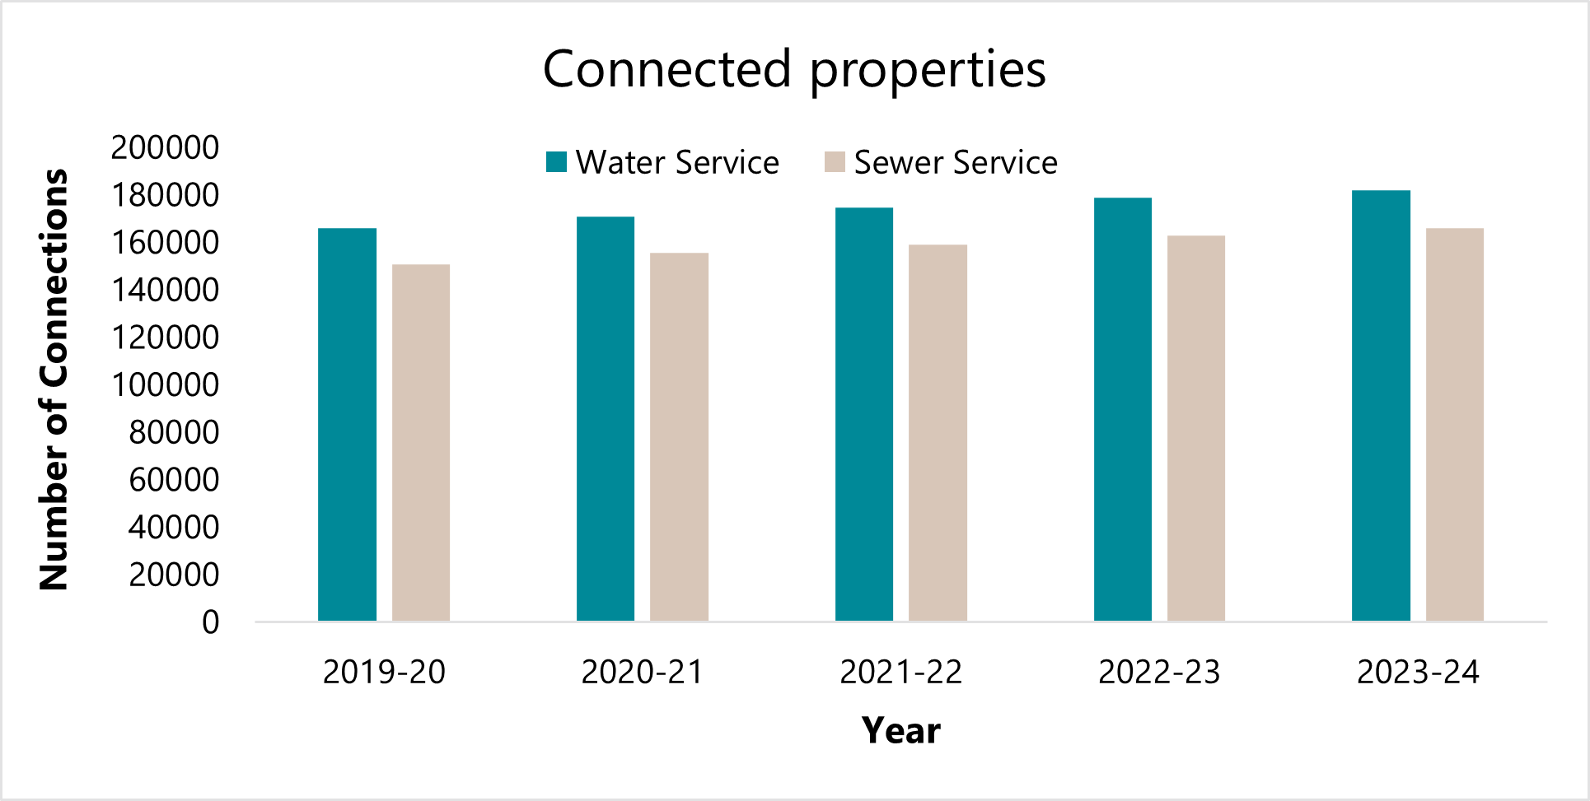
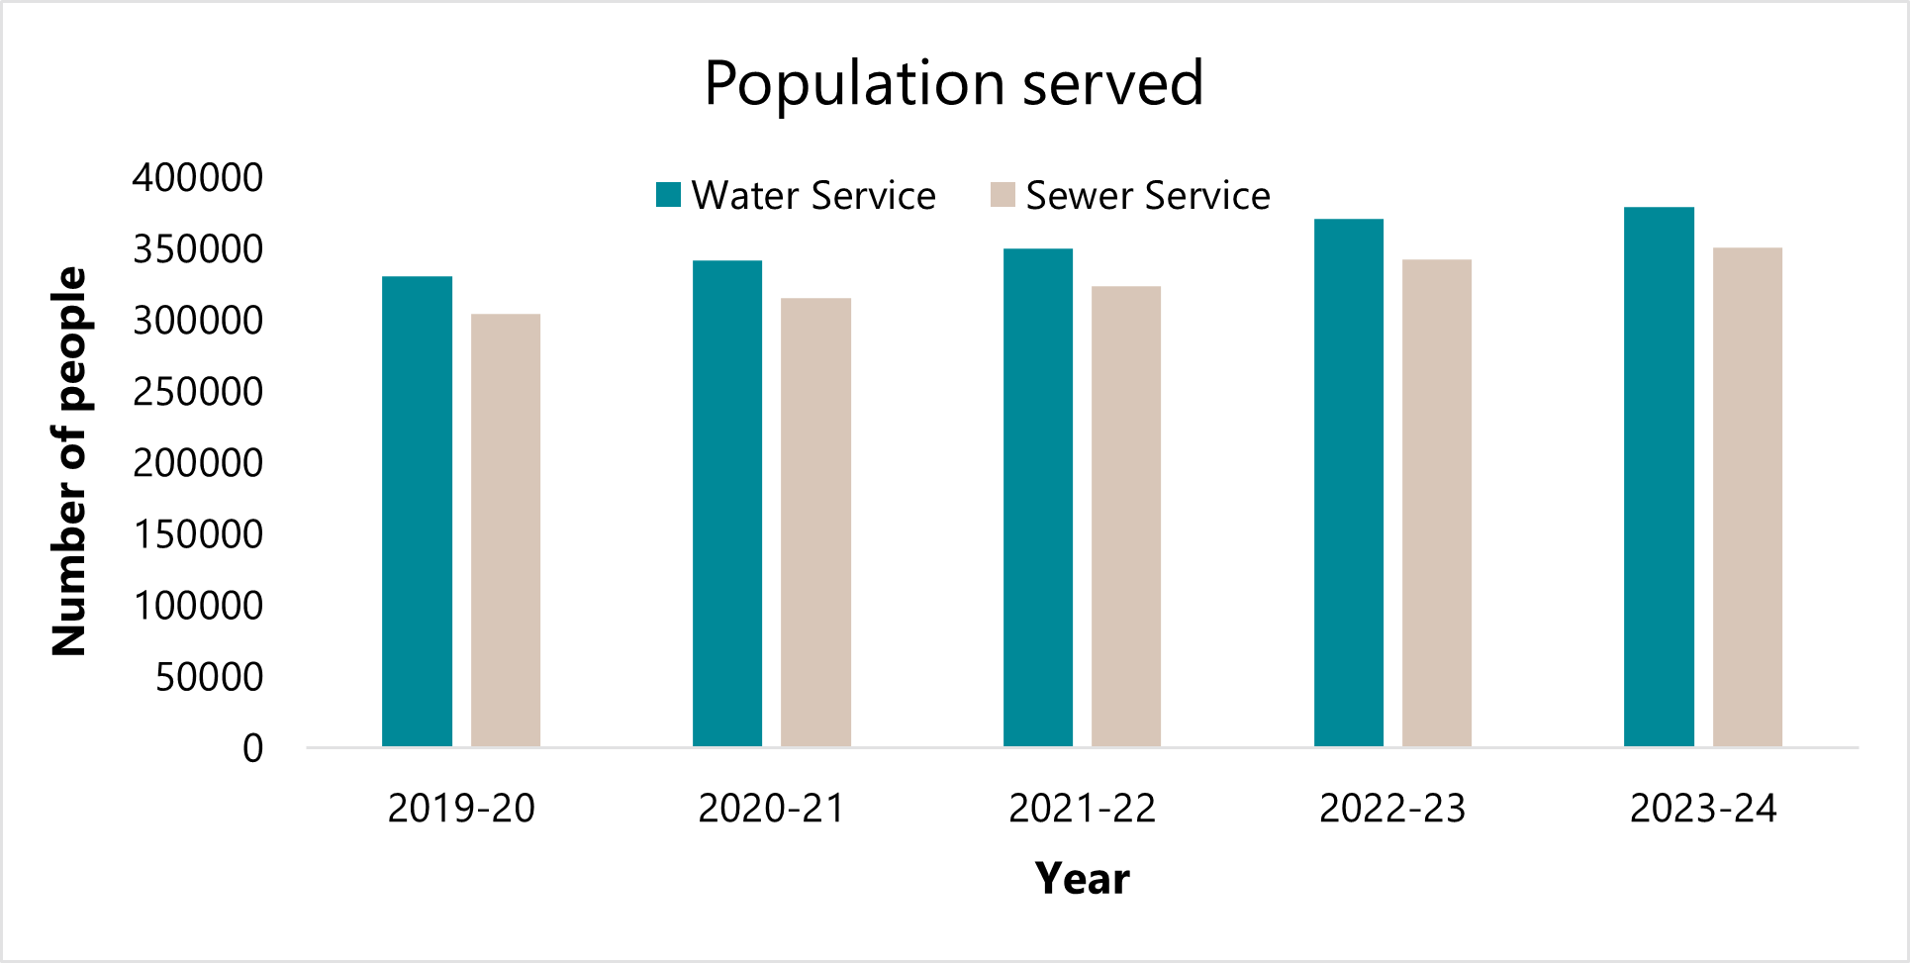

Treatment: 11.70%
Reclamation: -5.00%
from 2022-23
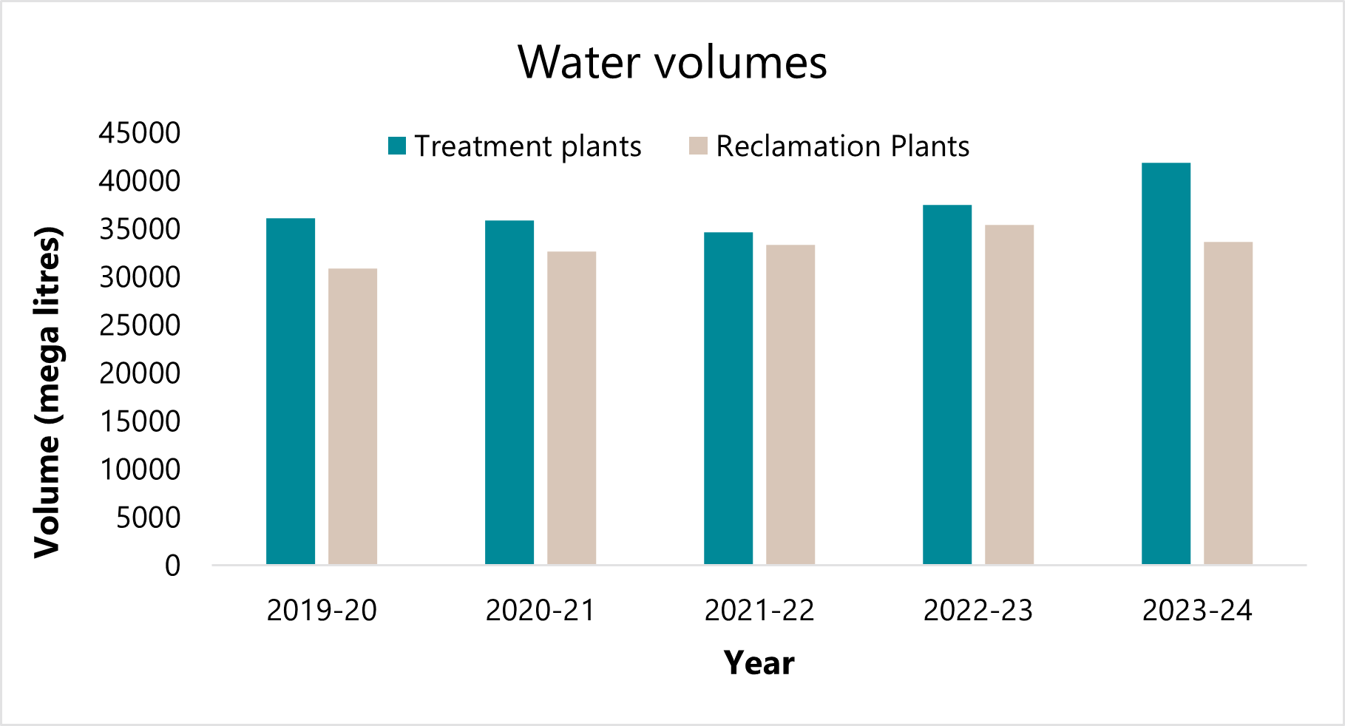

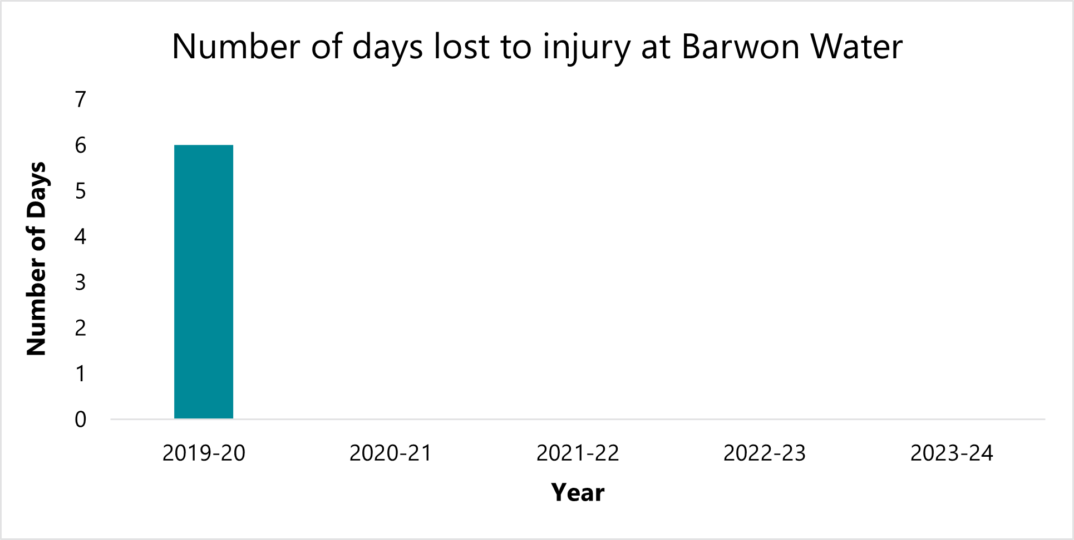
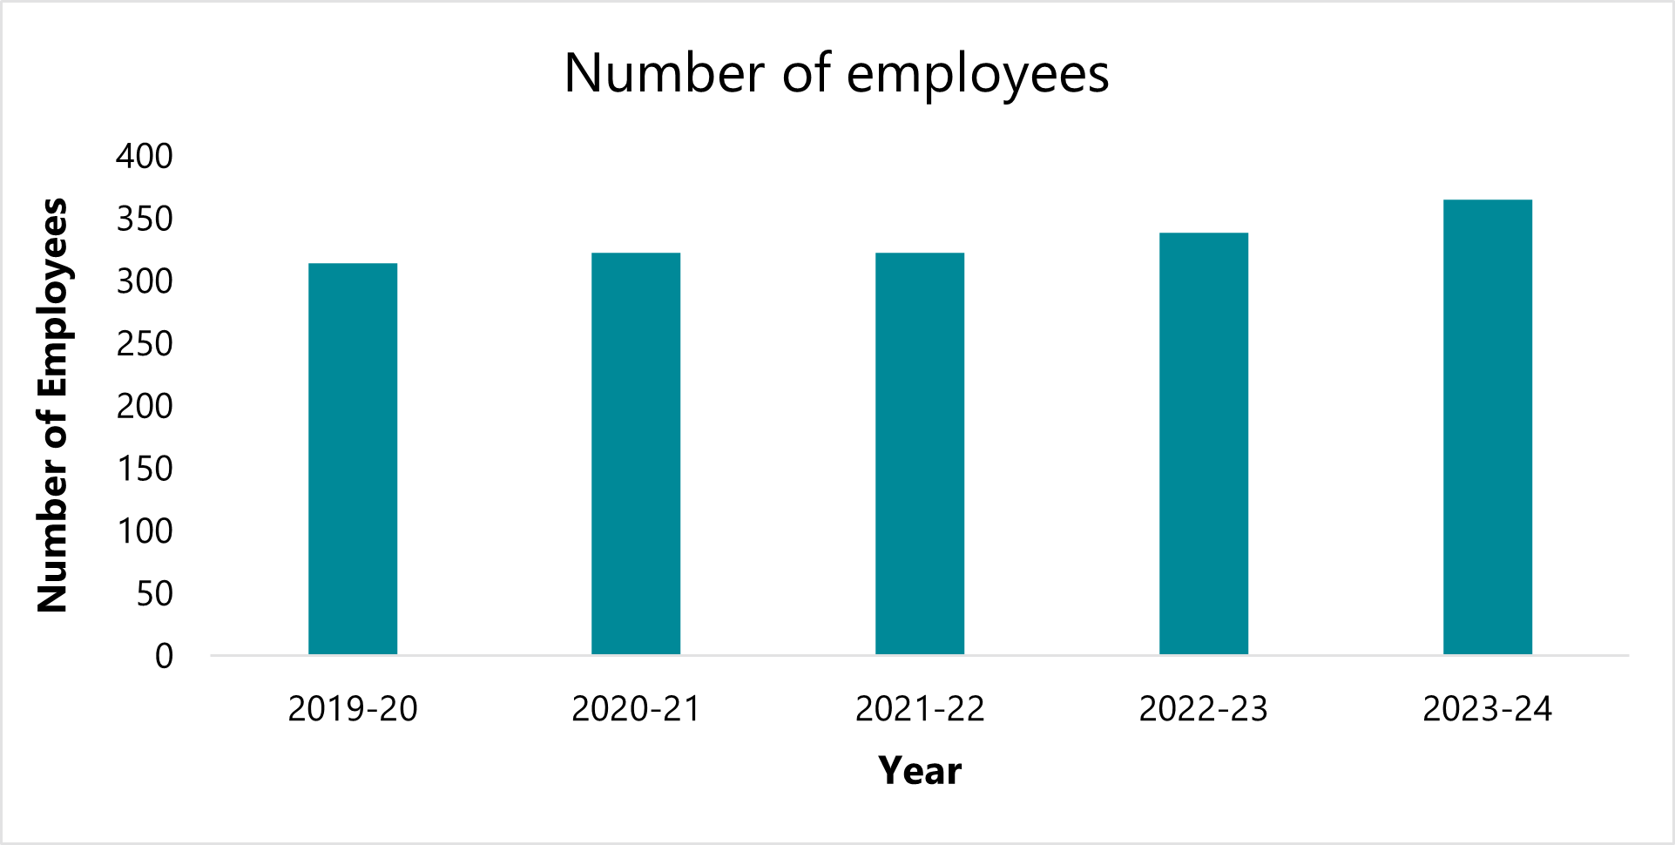
10%
increase from 2022-23
to 2023-24

No lost time injuries since 2019-20

Manner of establishment

Barwon Water was established under the Water Act 1989. The responsible Minister for the period from 1 July 2023 to 30 June 2024 was the Hon Harriet Shing MP, Minister for Water.
Since 28 July 2004, Barwon Water has operated under a Statement of Obligations issued by the Minister for Water under section 41 of the Water Industry Act 1994.

The statement imposes obligations on the organisation regarding the performance of functions and exercise of powers. We are required to monitor compliance with the obligations set out in the statement, report on non- compliance and take remedial action in relation to non-compliance.

On 1 January 2004, the Essential Services Commission became the economic regulator of the Victorian water sector. The commission’s role encompasses regulation of prices, service standards and market conduct.

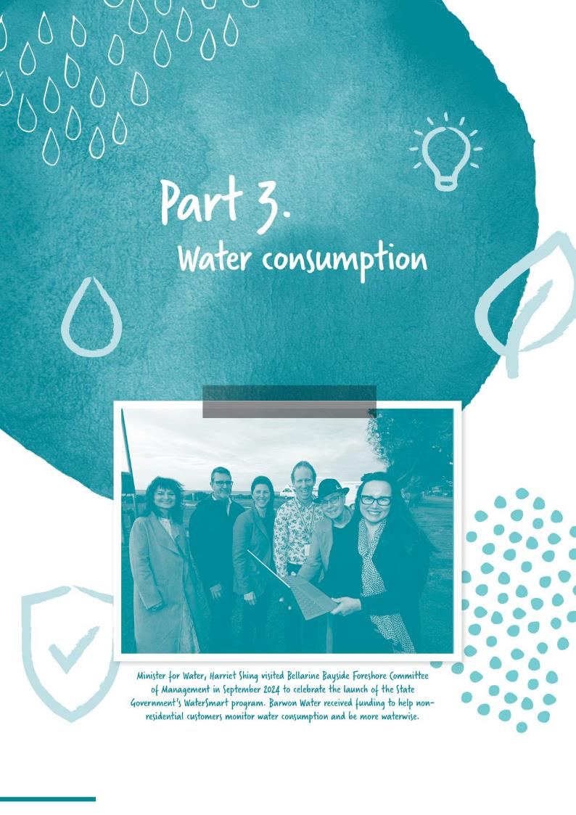
Part 3.
Water consumption

Barwon Water supplied 37,229 million litres of water in 2023-24, to meet customer demand for water. Despite the levels of rainfall, permanent water saving rules still apply across the whole state of Victoria, to ensure we all use water wisely.
We continued to deliver actions from our Sustainable Water Use Plan by delivering water literacy campaigns, supporting a range of water-saving programs, and promoting the Permanent Water Saving Rules across our region.
Weekly household water consumption (kilolitres)
Month | Week 1 | Week 2 | Week 3 | Week 4
January | 3.9 | 3.9 | 3.9 | 3.9
February | 3.9 | 3.9 | 3.9 | 3.9
March | 3.9 | 3.9 | 3.9 | 3.9
April | 3.5 | 3.5 | 3.5 | 3.5
May | 3.5 | 3.5 | 3.5 | 3.5
June | 3.5 | 3.5 | 3.5 | 3.5
July | 2.6 | 2.6 | 2.6 | 2.6
August | 2.6 | 2.6 | 2.6 | 2.6
September | 2.6 | 2.6 | 2.6 | 2.6
October | 3.3 | 3.3 | 3.3 | 3.3
November | 3.3 | 3.3 | 3.3 | 3.3
December | 3.3 | 3.3 | 3.3 | 3.3
Total | 39.9 | 39.9 | 39.9 | 39.9

Regional metered water consumption (megalitres)
Region | 2023–  24 | Change  (%) | 2022–  23 | Change  (%) | 2021–  22 | Change  (%) | 2020–  21 | Change  (%) | 2019–  20 | Change  (%)
Apollo Bay | 254 | 2.4 | 248 | 0.9 | 246 | 5.4 | 233 | -1.0 | 235 | -13.0
Aireys Inlet | 134 | 17.5 | 114 | -15.0 | 134 | 0 | 134 | 2.9 | 130 | -2.1
Anglesea | 411 | 28.4 | 320 | -21.5 | 408 | 5.5 | 387 | 1.7 | 380 | 2.3
Bellarine Peninsula | 5,574 | 12.2 | 4,968 | -5.2 | 5,242 | 3.3 | 5,073 | 4.0 | 4,879 | -8.2
Colac and district | 2,951 | 5.6 | 2,794 | -0.1 | 2,796 | 8.7 | 2,573 | -3.6 | 2,746 | -2.9
Geelong urban | 25,032 | 12.1 | 22,323 | -5.0 | 23,494 | 3.4 | 22,721 | -2.6 | 23,248 | -6.0
Lorne | 320 | 19.0 | 269 | -11.2 | 303 | -2.9 | 312 | 2.5 | 304 | -6.2
Skenes Creek | 28 | 7.7 | 26 | -8.8 | 29 | -10.7 | 32 | 11.1 | 29 | -13.6
Torquay | 2,525 | 15.1 | 2,192 | 1.3 | 2,165 | 4.7 | 2,067 | -1.6 | 2,100 | 3.1
Total | 37,229 | 12.0 | 33,254 | -4.5 | 34,817 | 3.8 | 33,533 | -1.5 | 34,051 | -5.6
Geelong urban includes:
Anakie, Armstrong Creek, Avalon, Balliang, Batesford, Bell Park, Bell Post Hill, Belmont, Breakwater, Ceres, Charlemont, Connewarre, Corio, Drumcondra, East Geelong, Fyansford, Geelong, Geelong West, Grovedale, Hamlyn Heights, Herne Hill, Highton, Lara, Leopold, Little River, Lovely Banks, Manifold Heights, Marshall, Moolap, Moorabool, Newcomb, Newtown, Norlane, North Geelong, North Shore, Rippleside, South Geelong, St Albans Park, Staughton Vale, Thomson, Wandana Heights, Waurn Ponds, Whittington.
Colac and district includes:
Colac, Colac West, Colac East, Gerangamete, Warncoort, Yeo, Yeodene, Alvie, Balintore, Bamganie, Barongarook, Beeac, Buckley, Coragulac, Cororooke, Corunnun, Elliminyt, Gellibrand, Gherang, Irrewarra, Irrewillipe East, Kawarren, Larpent, Maude, Nalangil, Ondit, Petticoat Creek, Pirron Yallock, Russells Bridge, Warncoort, Warrion, Whoorel, Yeo.
Bellarine Peninsula includes:
Barwon Heads, Bellarine, Breamlea, Clifton Springs, Curlewis, Drysdale, Indented Head, Mannerim, Marcus Hill, Ocean Grove, Point Lonsdale, Portarlington, Queenscliff, St Leonards, Swan Bay, Wallington.
Torquay includes: Torquay, Jan Juc, Mount Duneed.

Residential and non-residential metered potable water
 | Residential |  |  | Non-residential
Region | Number of  water customers¹ | Volume  consumed  (ML)² | Weekly  potable  consumption  (kL) | Number of  water customers¹ | Volume consumed  (ML)² | Total consumption  (ML) | Per capita consumption  (litres/  person/day) | Average  annual  consumption  (ML)⁴
Geelong and district | 154,994 | 24,921 | 479,245 | 11,852 | 8,536 | 33,457 | 191 | 31,270
Colac and district | 7,079 | 1,514 | 29,117 | 1,242 | 1,432 | 2,946 | 277 | 2,820
Apollo Bay/Skenes Creek | 2,341 | 204 | 3,931 | 172 | 114 | 318 | 221 | 3,008
Lorne | 2,299 | 229 | 4,400 | 159 | 91 | 320 | 313 | 2,958
Aireys Inlet/Fairhaven | 1,659 | 173 | 3,334 | 47 | 14 | 188 | 338 | 1,736
Total | 168,372 | 27,041 | 520,027 | 13,472 | 10,188 | 37,229 | 195 | 41,792
Notes:
1. Properties connected to Barwon Water’s water supply service.
2. Metered consumption excludes non-revenue water.
3. The per capita usage figure is based on the yearly residential consumption figure divided by permanent population, which is calculated using Australian Bureau of Statistics Census data for 'per cent of occupied dwellings' and 'average people per (occupied) dwelling'. The figure doesn't take into account the high summer tourism population of some towns.
4. Average calculated over three years.
Residential and non-residential metered recycled water consumption
Non-residential (Class C) | Non-residential (Class A) | Residential (Class A)
Region | Number of recycled  water customers | Volume consumed  (ML) | Number of recycled water customers | Volume consumed  (ML) | Number of recycled water customers | Volume consumed  (ML) | Total consumption  (ML) | Average  annual consumption
Geelong and district | 25 | 1,611 | 100 | 1,152 | 13,663 | 516 | 2,924 | 2,645
Colac and district | 4 | 15 | N/A | N/A | N/A | N/A | 15 | 11
Apollo Bay/Skenes Creek | 2 | 0 | N/A | N/A | N/A | N/A | 0 | 0
Lorne | N/A | N/A | N/A | N/A | N/A | N/A | N/A | N/A
Aireys Inlet/ Fairhaven | 3 | 49 | N/A | N/A | N/A | N/A | 49 | 36
Total | 34 | 1,675 | 100 | 1,152 | 13,763 | 516 | 2,989 | 2,692

Non-revenue water (ML) 2023–24
 | Leakage | Firefighting* | Other** | Total
Barwon Water service region | 4,369 | - | 223 | 4,592
Notes:
*Water used for firefighting purposes is not metered.
**Includes combined potable metered hydrant volumes and volumes used by Barwon Water for mains flushing, scouring and
other maintenance. The two cannot be separated and the mains flushing, scouring and other maintenance is marginal.

Corporate water consumption
2023–24
Location | Total full-time  equivalent  employees | Office  space  (m2) | Water  consumption  (kL) | kL/FTE | Water consumption  by office space  (l/m2)
55 – 67 Ryrie Street (Geelong) | 365 | 6,071 | 1146 | 3.14 | 188.77
Total |  | 6,071 | 1146 |  | 188.77

Major non-residential water users
Customer by volume range 2023-24
Volumetric range – ML per year | No. customers
Equal to or greater than 100 ML and less than 200 ML | 10
Equal to or greater than 200 ML and less than 300 ML | 2
Equal to or greater than 300 ML and less than 400 ML | 1
Equal to or greater than 400 ML and less than 500 ML | 2
Equal to or greater than 500 ML and less than 750 ML | 2
Equal to or greater than 750 ML and less than 1,000 ML | 0
Greater than 1,000 ML | 1
Total no. of customers | 18

Residential water efficiency
Water literacy campaigns
We educated and advised customers about sustainable water use, in line with the Victorian Government’s Sustainable Water Strategies (SWS). One way we did this was through ‘Summer Awareness’ and ‘Permanent Water Saving Rules’ campaigns, which were designed to remind customers and visitors about the ongoing need to be mindful of their water-use. The campaigns were promoted through local newspaper advertising, social media, media releases, and targeted radio and bus advertising throughout the region.
Over summer, we attended 33 events in 15 locations across region, with fun activations promoting Water Matters and
the importance of sustainable water use.

In November 2023 we launched "Water Matters", a new water literacy campaign to raise community awareness of the value of water, the challenges of climate variability and growth, and the solutions (savings, smarts and sources). We also continued the ‘Three Ps’ campaign on social media to remind everyone to keep our wastewater network free of materials that might cause blockages and overflows.
Birregurra Sustainable Communities – Water Program
Our partnership with the local community in Birregurra to implement the Birregurra School Water Efficiency Program (SWEP) and Sustainable Communities – Water Program continued to have success. We estimate the partnership has helped the local community save 48 million litres of water since it was introduced in December 2020, by supporting behaviour change programs coupled with leak detection and repairs.
A highlight of the partnership during the financial year was engaging with the younger generation through a school holiday event and education sessions at the local school, designed to help future customers to learn how they can make a difference to support a sustainable water future.
Support programs
In 2023–24, we continued to support residential customers through our plumbing support programs to improve the water efficiency of their homes by assisting customers to save water and reduce bills by providing a high-quality, affordable home water-use assessment and plumbing services to repair leaks and upgrade to more water efficient fixtures and fittings.
A total of 544 customers participated in a variety of programs including the Victorian Government Community Rebate and Community Housing Retrofit Programs, WaterAssist Home and a new WaterSmart Washing Machine Rebate Program. This new program supported customers to upgrade to a minimum 4.5-star WELS and 4-star energy rated front loading washing machine. Combined, these residential water efficiency programs saved approximately 30.15 million litres of water and $73,100 on customer water bills.

Schools Water Efficiency Program (SWEP)
We continued to support the Victorian Government’s Schools Water Efficiency Program (SWEP) in 2023–24, which enables schools to track their water usage using data logger technology.
By monitoring water usage, schools can detect and rectify leaks, saving water and money. The program also provides students with an opportunity to learn about water efficiency through program specific curriculum resources.
The program requires a three-year commitment from schools and the first year is subsidised by the Department of Energy, Environment and Climate Action (DEECA). To encourage schools to continue to participate in SWEP, we subsidise data hosting and ongoing access.
Ninety nine schools in our region participated in the program, with 16 of these schools also receiving a new Barwon Water school grant, which was intended to help them be more water efficient or implement a sustainability project within the school grounds. This school grant program will be offered again in 2024–25.
SWEP schools in the Barwon Water region have saved a total of 53.8 million litres of water and around $130,000 in water-related charges over the last financial year. Since the program started in 2012, they have collectively saved more than 1.13 billion litres of drinking water and $3.7 million in water-related charges.
99 schools in our region participated in the SWEP program in 2023-24.
Non-residential water efficiency
Non-residential water efficiency programs saved
104 million litres of
drinking water in 2023-24.
Our focus on water efficiency and supporting our non-residential customers through various programs continued in 2023–24, in line with our five-year Sustainable Water Use Plan.
We provide more than 25 business, agricultural and industrial customers with Class C recycled water. The water is not suitable for drinking or residential use, but is often used to irrigate golf courses, agriculture, sporting grounds, vineyards and flower farms. Golf courses at Anglesea, Barwon Heads, Portarlington, Bannockburn and Winchelsea are also connected to recycled water supplies, which allows the courses to be maintained at a reduced cost while operating more sustainably.
Business Water Grants and Rebates were open to non-residential customers in 2023–24. The water grants and rebates support business and agricultural customers to achieve permanent water savings by substituting drinking water with alternative sources, recycling wastewater or upgrading equipment to improve water efficiency.
We participated in the Victorian Government WaterSmart Business Program, targeting high water using organisations that provide important essential services to our community and in industries that have the potential to make significant water savings. The program involves the installation of digital technology to track and monitor consumption patterns and identify leaks in real-time as well as water efficiency audits to help identify further opportunities to save water.

Our WaterSmart Council and Coastal Partnership programs continued, where we are working closely with our catchment partners to promote sustainable water use to the broader community through education initiatives, water efficiency and sustainability projects. In 2023–24, projects included public amenity upgrades – providing water efficient fixtures and fittings across the Bellarine, educational signage encouraging users to save water and permanent hydration stations to improve access to drinking water in high traffic areas along the coast.
Overall, we supported more than 250 non-residential customers to detect and rectify leaks as part of the WaterSmart Business, Council and Coastal Programs. This effort, combined with our business rebates and dedicated Colac on-farm project, helped to save approximately 104 million litres of drinking water in
2023–24.

Major customer participation in water conservation programs
Name of customer | Information as to customers participation in water efficiency programs
Viva Energy Refining Pty Ltd | Water management and recycling program in use
City of Greater Geelong | Participates in Sustainable Water Use and WaterSmart data logger and WaterSmart Council programs
Malteurop Australia Pty Ltd | Participates in Sustainable Water Use and WaterSmart data logger program
Turi Foods Pty Ltd | Participates in Sustainable Water Use and WaterSmart data logger program
Australian Lamb (Colac) Pty Ltd | Participates in Sustainable Water Use and WaterSmart data logger program
J R & C A Santospirito | Participates in Sustainable Water Use and WaterSmart data logger program and is a recycled water user
MC Herd Pty Ltd | Participates in Sustainable Water Use and WaterSmart data logger program
Thirteenth Beach Golf Links Ltd | Participates in Sustainable Water Use and WaterSmart data logger program and is a recycled water user
Barwon Health - The Geelong Hospital | Participates in Sustainable Water Use and WaterSmart data logger program
Bulla Dairy Foods | Participates in Sustainable Water Use and WaterSmart data logger program
Bulla Cream Co Pty Ltd | Participates in Sustainable Water Use and WaterSmart data logger program
Bannockburn Golf Club Inc | Participates in Sustainable Water Use and WaterSmart data logger program
Barrett Burston Ltd | Participates in Sustainable Water Use and WaterSmart data logger program
AMC Cameron | Participates in Sustainable Water Use and WaterSmart data logger program and is a recycled water user
Deakin University | Participates in Sustainable Water Use and WaterSmart data logger program
Fremantle Harbour Properties Pty Ltd | Participates in Sustainable Water Use and WaterSmart data logger program
Pavilion Partners Pty Ltd | Participates in Sustainable Water Use and WaterSmart data logger program
Bellarine Property Nominees Pty Ltd | Participates in Sustainable Water Use and WaterSmart data logger program and is a recycled water user

Grants provided
We offer grants for community, business, and schools to help fund local projects that enhance the quality of life in our region.
In early 2024 we gave our community support program a makeover and refreshed our schools grant category, so that we could fund even more local projects. Below is the list of organisations supported during the financial year. More information is available on our dedicated grants webpage: yoursay.barwonwater.vic.gov.au/barwon-water-grants.
School grant recipients 2023-24:
Organisation | Description of project | Payment
Barwon Heads Primary School | Water efficient irrigation system | $2,500
Queenscliff Primary School | Nature play space | $2,500
St. Brendan's Primary School, Coragulac | Outdoor classroom and native habitat | $2,000
South Geelong Primary School | Sustainable upgrades for school vegetable garden | $850
Hamlyn Banks Primary School | Water efficient bubbler taps | $2,500
Torquay Coast Primary School | Enhance student knowledge of regenerative and sustainable farming | $2,180
Oberon High School | Establish a native bush tucker garden | $2,500
St. Anthony’s School Lara | Replanting project to replace lost trees and plants from a summer storm | $2,500
Lake Colac School | A water efficient watering system in the greenhouse | $2,500
St. Leonard’s Primary School | Water smart wicking beds | $2,500
Birregurra Primary School | A nature play space to support social inclusion | $2,500
Colac South West Primary School | A Garden Guru project | $2,200
Newcomb Secondary College | A water efficient Hydrotap in the wellbeing area | $2,500
Clairvaux Catholic School | Upgrade drinking fountains | $2,500
Newtown Primary School | Earth Crusaders incursion | $2,320
Kardinia International School | To convert no dig vegetable gardens into sustainable, water efficient wicking beds | $2,500

Community grant recipients 2023-24:
Organisation |  | Description of project | Payment
The Scout Association of Australia Victorian Branch (ABN 39 662 387 026) |  | Purchase of wheelie bins to collect containers for recycling as a fundraising activity for the 1st Barwon Heads Scout Group | $895
Armstrong Creek Boomerang Bags  (ABN 50 314 194 006) |  | Make reusable bags for the community to reduce single use waste and needed funding to have sewing machines serviced | $630
Barwon Heads Community Arts Garden Inc.  (ABN 46 897 689 417) |  | Foodcube wicking beds (water efficient) for a community garden | $1010
Beeac Golf Club Incorporated  (ABN 98 511 995 519) |  | 50% contribution for automated sprinklers for golf course in low socio-economic area | $3596
Bluebird Foundation Inc.  (ABN 44 206 851 526) |  | Addition of First Nations sculptures to a bush garden at Newcomb Primary School, accessible for the broader community | $5000
Colac Otway Residents Action Group Inc  (ABN 45 864 608 375) |  | Providing a lunch for primary school aged children across Colac that don’t have lunch | $2000
Leopold Lakers Basketball Club Inc.  (ABN 53 484 316 386) |  | Facilities and resources, such as suitable uniforms and changerooms, to cater for female players | $3850
North Shore Football and Netball Club Incorporated (ABN 41 978 855 245) |  | Uniforms for players of club in low socio-economic area who educates and encourages First Nations culture | $2520
Anglesea Aireys Inlet Society for the Preservation of Flora and Fauna (auspice organisation for Painkalac Valley Network)  (ABN 73 211 744 882) |  | A series of activities to deepen people’s engagement with local environment and encourage protection of the Painkalac Creek ecosystem | $4900
Bellarine Training and Community Hub (auspice organisation for Repair Café Bellarine)  (ABN 45 840 639 622) |  | Contribution to re-establish the café which offers a free service to the community to repair and extend the life of common household items | $3300
Winchelsea Community Playgroup  (ABN 13 094 186 877) |  | Improvement of the community playgroup which is accessible to the whole community through a multi-use space | $2500

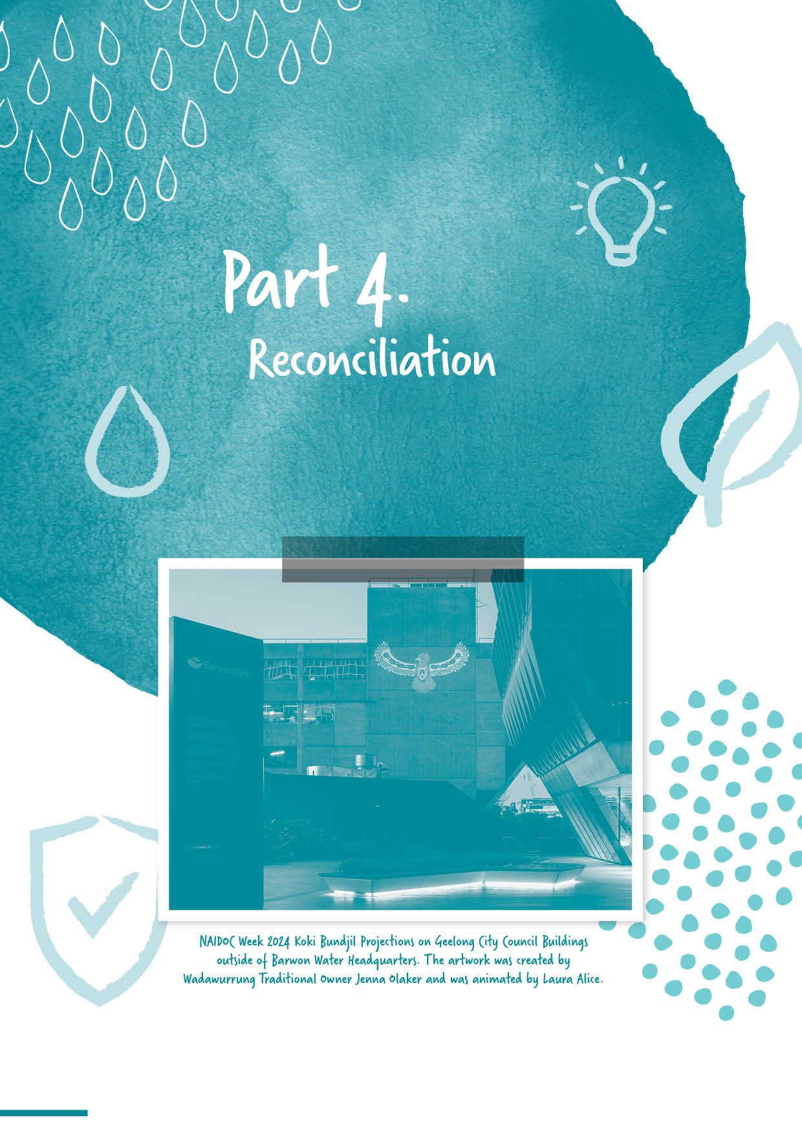
Section divider page
WITH IMAGE

Part 4.
Reconciliation

Reconciliation
We recognise Barwon Water’s Reconciliation Journey. Starting in 2016, we have moved from transactional relationships with Traditional Custodians to building genuine relationships with a focus on reciprocity. Our Innovate RAP ran from 2018 to 2020 and focused on building Cultural awareness and partnering in landscape regeneration to reflect Cultural values. We then worked on our Stretch RAP, which focuses on building First Nations values into our ways of working and was launched in 2023.
Key achievements in 2023–24 included:
establishing a standalone First Nation Values department, with all First Nations staff, within the Planning, Delivery and Environment group of Barwon Water
continued implementation of our partnership agreement with Wadawurrung Traditional Owners Aboriginal Corporation which ended June 2024
we have implemented an interim Partnership agreement with Wadawurrung that honours the previous partnership agreement while we build a new agreement, which will evolve our relationship to a new level, due for completion at the end of 2024
supporting cultural awareness training for all our staff, so everyone can understand the truth about colonial history, and work towards healing historical wounds.
visiting key sites with Traditional Owners in an effort to embed First Nations approaches to land, water and design into our business, so we can protect the natural assets on which we all depend
enhancing Aboriginal and Torres Strait Islander employment opportunities
engaging with Traditional Owners on strategic projects, such as Murrk Ngubitj Yarram Yaluk and Porronggitj Karrong
we undertook business cases to consider impacts and opportunities in relation to Traditional Owner values and broader threats and objectives as they apply to the land
supporting National Reconciliation Week and NAIDOC Week events.
In the second half of 2023, we launched our first Stretch RAP. It has been developed in consultation with key stakeholders, including Eastern Maar and Wadawurrung Traditional Owners within the Barwon Water region. Local First Nations consultancy Arranyinha played a pivotal role in developing the Stretch RAP.
The focus of our Stretch RAP will be further building on, and embedding, the strategies and positive changes that were developed during the implementation of our last RAP. We will also be working towards having a positive impact and creating change within our sphere of influence – notably in areas such as engagement and involvement with the Traditional Owner and First Nations communities.
Our Stretch RAP is formed around the pillars of relationships, respect, and opportunities, and will push us to constantly embed and expand on our commitments. The Stretch RAP outlines the steps we will take to ensure that reconciliation becomes part of everything we do at Barwon Water. It shows we will continue to invest in relationships with Traditional Owners and First Nations organisations, and advance reconciliation within our organisation and other spheres of influence in the region and the broader water industry.
Over the last financial year, we have continued building and maintaining our relationships with Wadawurrung Traditional Owners Aboriginal Corporation (Wadawurrung) and Eastern Maar Aboriginal Corporation (Eastern Maar), who are the Registered Aboriginal Parties.
We have a formal Partnership Agreement (2021–24) with Wadawurrung that helps guide us as we undertake projects together and helps Wadawurrung to estimate the resources required to do the work.
We have a Relationship Forming Agreement with Eastern Marr and look forward to continuing our developing relationship.
Another key achievement in this time period was the creation of a new role at Eastern Maar – Water Partnerships Officer – via a multi-party agreement between Eastern Maar and the three Water Corporations that operate within their country.
Working with Traditional Owners to Care for Country
Our focus on Caring for Country has continued through the delivery of our Stretch Reconciliation Action Plan commitments and the establishment of the First Nation Values department in 2023-24.
Our “Caring for and Connecting to Country” principals are guiding Barwon Water staff in meaningfully considering Cultural Values in all aspects of their work and positively impacting how we design, plan, deliver and maintain our key assets over the footprint of Barwon Waters operational area, respecting the Cultural landscapes and heritage of both Wadawurrung and Eastern Maar.
A tool is currently in development that will guide employees on how best to embed Cultural values at every stage of project delivery, from ideation to delivery and beyond.
Murrk Ngubitj Yarram Yaluk
We celebrated the one-year anniversary of the establishment of the volunteer Friends of Murrk Ngubitj Yarram Yaluk in June 2024. The community group has been undertaking practical activities such as weeding, planting and biodiversity monitoring. The ongoing restoration of this 37-hectare site (the former Bellarine Water Basin) recognises the important and unbroken connection
and stewardship of land and water on the Bellarine Peninsula by Wadawurrung Traditional Owners.
Working with Wadawurrung Traditional Owners and the Gobata Dja team, with Victorian Government funding, we have also been developing designs aligned with the site masterplan and been obtaining statutory approvals for a new carpark and walking tracks. These works are anticipated to be undertaken in 2024/25, enabling the wider community to freely access the site.
Ongoing development of the area will be guided by four objectives covering nature, culture, community and sustainability.
Porronggitj Karrong
Barwon Water and the Wadawurrung Traditional Owners Aboriginal Corporation are collaborating to transform the 66 hectares of land surrounding the Ovoid Sewer Aqueduct in Geelong into a new living Cultural landscape and community precinct. Named Porronggitj Karrong, this means ‘place of the brolga,’.
With the successful approval of the conservation exemption and planning scheme amendment, Wadawurrung have commenced work, maintaining and managing pathway access. They will soon begin implementing Wadawurrung land management practices, beginning the journey of bringing the Country back into Cultural and ecological balance.
Guided by the Gobata Dja team, Porronggitj Karrong will facilitate teachings about songlines, interwoven between past, present, and future. It is envisioned as a place to learn about sustainable ecologies and Wadawurrung land management practices. The site will be established as a Cultural and community precinct, supporting Wadawurrung living Culture and benefiting the wider region.
The Regional Development Victoria project phase has successfully concluded.
Throughout this next stage, the project community reference group will remain actively engaged. Together, we aim to realise our shared vision: “A balanced ecological system incorporating Wadawurrung Values for the whole community to connect, listen, and learn from Country.”
We were successful in receiving funding under the first round of the Green Links grant program, enabling Wadawurrungs Gobata Dja team to begin the “reimagining the landscape” journey. The program is focused on invasive weed and Native biomass management along the riparian areas of the Barwon River at Porronggitj Karrong. This will enable revegetation to be undertaken, restoring the Cultural and ecological balance of that section of the landscape.
As we move into the 2024-25 financial year, we will continue our collaboration with our principal contractor, structural engineers, and heritage advisers to plan the aqueduct works. Given the unique and complex nature of the aqueduct conservation and river opening, involving many stakeholders and an intermittently inundated floodplain, careful planning is essential.
Cultural Awareness Training
Cultural Awareness training throughout 2023-2024 was essential in promoting understanding, respect, and collaboration with First Nations communities. Covering a variety of topics, including Truth Telling, First Nations history, contemporary life, Cultural Heritage, and on Country engagement with Traditional Custodians.
Truth Telling:
delivering guided conversations based on the lived experiences of a First Nations person
focusing on historical and contemporary truths, offering a deep dive into the impacts of colonisation and the resilience of First Nations communities

providing an immersive introduction to First Nations perspectives, cultural practices, and knowledge systems
encouraging staff to appreciate and respect diverse ways of living and understanding the world of First Nations people
Children's Ground delivered the Executive Leadership Team (ELT) and Senior Leadership Team (SLT) truth-telling workshops, which received excellent feedback
on Country tours with Wadawurrung and Eastern Maar communities, engaging different departments in hands-on learning experiences.
Education on the 2023 Referendum:
delivering an apolitical approach to educating staff on both the Yes and No campaigns of the 2023 Referendum
ensuring staff received balanced information to foster informed discussions and creating respectful dialogue.
Outcomes:
training enabled employees to view the world through the eyes of a First Nations person, fostering empathy and understanding
improved employee knowledge on how best to support and work collaboratively with Traditional Owners
enhanced awareness of the history and values of the region’s Traditional Owners
contributed to the creation of a more Culturally safe workplace for First Nations employees
improved ability of staff to apply “Caring for Country” approach to work.
Barwon Water remains committed to continuing this important work throughout 2024-2025, ensuring ongoing education for truth-telling, and promoting a Culturally inclusive and respectful workplace.

Aboriginal and Torres Strait Islander Employee Network
In 2023-24, our employee-led Aboriginal and Torres Strait Islander Network hosted three quarterly, one-hour events at Barwon Water regional facilities. These events provided a Culturally safe and respectful space for First Nations Employees to connect. Moving forward, we will continue to hold these inclusive and accessible networking events quarterly across our regional facilities.
NAIDOC Week
The 2023 NAIDOC week theme was ‘For Our Elders’. One of the key messages from the 2023 theme recognises that across every generation, Elders have played, and continue to play, an important role and hold a prominent place in First Nations communities and families. They are Cultural Knowledge holders, trailblazers, nurturers, advocates, teachers, survivors, leaders, hard workers and loved ones. To celebrate this Barwon Water hosted special pop-up cinema for a screening of a documentary series, “The First Inventors” at the Ryrie HQ hub and the Colac depot. Team members also attended the flag raising ceremony at the Wathaurong Aboriginal Co-operative.
Reconciliation Week
Barwon Water proudly participated in National Reconciliation Week 2024, themed "Now More Than Ever."
This significant event, held from 27 May to 3 June 2023, provided an opportunity to reflect on shared histories, cultures, and the collective journey toward reconciliation. It was a celebration and acknowledgement of our progress since the inception of our first Reconciliation Action Plan. The strengthened relationships with Traditional Custodians and the invaluable knowledge shared about Country and Water were instrumental in this learning journey.

The series of events, including a precinct walk, a film screening of "Babakiueria," Ryrie Street projections, and Yarning Circle discussions, provided opportunities for reflection on the journey and reaffirmed the ongoing commitment to reconciliation. Together, the focus remains on redressing past injustices and building a reconciled future.
Since 2017 we have had
23 trainees (including 3 currently on the program)
with 5 former trainees currently working at
Barwon Water.
Employment – Traineeship program
Our Aboriginal Employment and Retention Strategy was developed as part of our Innovate RAP, and is structured around five key areas: Recruitment, Induction, Inclusive Workplace Practices, Retention and Development.
The core principles guiding our strategy are understanding and embedding First Nations cultural values and supporting the holistic wellbeing of First Nations peoples. These principles are the foundation for creating and delivering culturally appropriate, respectful and meaningful outcomes for First Nations employees.
To embolden this strategy, we have been participating in the Geelong Aboriginal Employment Taskforce (GAET). The taskforce brings together local First Nation community representatives, employers and businesses to create pathways for employment and drive better outcomes for First Nation’s communities. Barwon Water was invited to present at the GAET summit in January 2023, where we shared our progress and what we are doing to delivery our strategy.

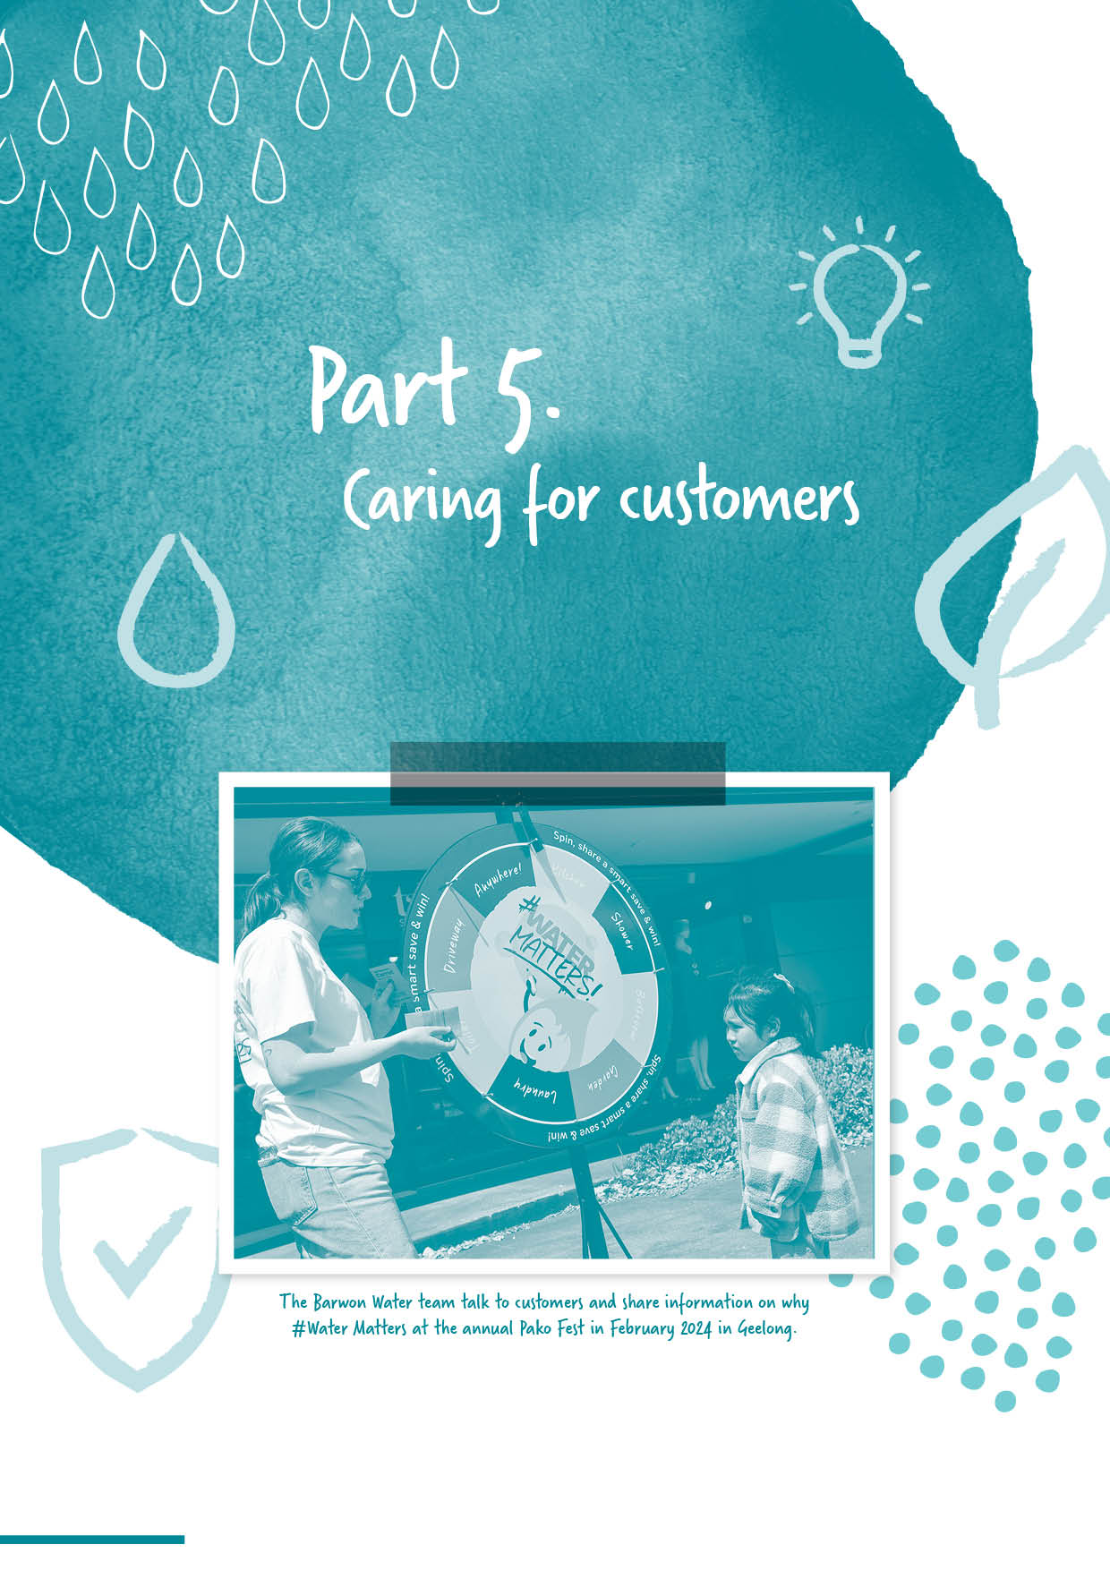

Section divider page
WITH IMAGE

Part 5.
Caring for Customers

Customer Advisory Committee
Since it was first convened in 1996, our Customer Advisory Committee has been helping us respond to customer needs, involve our community in project planning, understand issues raised by interest groups and access valuable community knowledge.
Following a great response to an invitation for expressions of interest, we doubled the membership of our Customer Advisory Committee (CAC) in 2023-24. Twelve new members were welcomed to the group in November 2023, representing a cross section of age, geographic locations, gender and cultural diversity. They bring a broad range of experience and perspectives, with a mix of interests and skills, including customer service, tourism, agribusiness, renewable energy, health, arts and culture, education and youth work.
The committee met five times in 2023–24 to share insights and help put customers and community at the heart of strategies, services, programs and projects.
Key areas of focus for the committee during this time were prices and performance, water security, community education, Reconciliation and cultural awareness training.
In addition, we shared updates on key projects and programs, including:
Lorne: Water, Your Say program
Regional Renewable Organic Network
Porronggitj Karrong and Aqueduct
Murrk Ngubitj Yarram Yaluk (formerly Bellarine Basin)
Anglesea borefield
Boundary Creek and Big Swamp remediation
Birregurra water supply upgrade
2018-23 Price Submission performance review
capital works program performance
Barwon Heads sewer upgrade
Colac water pipeline upgrade
Sustainable Water Use Plan
bushfire resilience
digital metering trial for the Customer Advisory Committee.

Customer service
We performed well this year in the Victorian Essential Services Commission’s customer perception surveys for the water sector.
In the most recent results (September 2023 to May 2024), Barwon Water was rated first for value for money, second for level of trust, second for reputation in the community and first for overall satisfaction.
This year Barwon Water ranked either first or second amongst all Victorian water businesses for each survey metric, performance we have maintained since August 2022. Although we consider the ranking results encouraging, we remain focused on the movement of the underlying survey scores. Our Voice of Customer program also continues to provide vital positive and constructive feedback, which drives improvement at an operational level.
In June 2024, Customer Service Benchmarking Australia ranked us second in the Victorian water sector for call quality for the preceding 12 months. We ranked second nationally for the water sector and eighth out of 244 organisations from all Australian sectors. We were also proud to have one Contact Centre agent, Kate Carr, awarded the CSBA Quarterly Agent Award in March 2024.

Essential Services Commission – Customer Perception Survey results
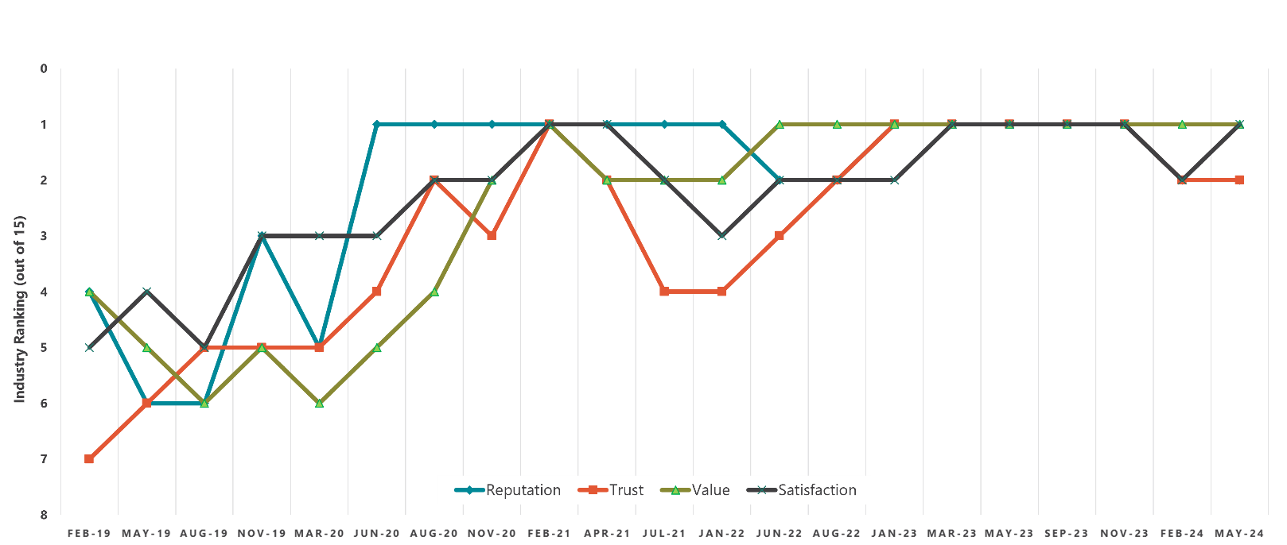

Customer experience program
This year we commenced delivery of our refreshed Customer Experience (CX) Strategy. This strategy will position the organisation well to achieve Strategy 2030 customer outcomes. The core intent of the new strategy is to scale our CX capability organisation-wide, to ensure a consistent, high quality customer experience is delivered at all Barwon Water customer touchpoints.
Key actions implemented in 2023–24 included:
continued implementation of our Voice of Customer survey program. This included measurement of our new Strategy 2030 post-interaction ‘customer satisfaction’ (CSAT) key performance indicator. At year end, we finished six points above target on this metric, which reflected positive customer sentiment
to build organisation-wide CX awareness and skills, we delivered CX Week. This event is designed to engage the business in Strategy 2030 customer outcomes and reinforce the importance of individual contributions to delivering a great customer experience
launch of a new CX Champions network. This network is designed to promote the sharing of CX knowledge and skills through dedicated training and information to team members across the entire Barwon Water Group
drawing on external expertise, we reviewed of our implementation of our Customer Family Violence Policy. While overall we complied with the policy, the review identified several tactical actions, which we progressed through a safety-by-design approach in the Customer Centre. The review also identified the need for a whole of organisation effort to identify privacy and data security vulnerabilities across our business. This includes processes, activities and systems that could pose a risk of harm to customers – especially those experiencing domestic or family violence. This program of work is currently in the planning phase for implementation next year
shaping up the customer experience stream of the Buniya Program (digital transformation). We identified the customer experience related opportunities and requirements for integration into our business case. This stream of work will deliver digital capability including a new Customer Relationship Management system, customer portal and contact centre platform. This portfolio of services will significantly improve the ease, efficiency and accessibility of customer interactions with Barwon Water
introducing a human centred design approach to several key projects this year including the Land Development and Connections project. We reviewed the channels strategy for the Land Development team to improve the customer experience and commenced a cross-department project to better support customers experiencing a sewer spill
progressing development of a CX service blueprint to guide the future implementation of smart (digital) meters in our region, later in this price period
reviewing our website’s functionality and accessibility. This review identified many opportunities for improvement and led to several enhancements. These included additional functionality such as online forms and online self-service for statements of transactions.

Assisting customers experiencing vulnerability
We understand that at times, our customers may experience circumstances that cause vulnerability. The extent and duration of these circumstances can vary significantly. Our Customer Support Program is designed to treat all customers with dignity and respect. We are building the capability of our staff, by expanding our data analytics and providing training on available support (financial, accessibility, digital literacy) as well as on specific new policies, such as customers experiencing family violence.
For our new pricing period of 2023-28, we have pledged $4.8 million to actively assist customers in managing their bills and enhancing their water efficiency. This represents an increase from the $3.1 million spent in our previous five-year pricing period, with $737,000 spent in 2023-24.
This year we delivered several initiatives to better support customers experiencing vulnerability, including:
continuing our participation in the Geelong Region Financial Inclusion Action Plan (FIAP) and implementing our public commitments to drive financial wellbeing in our region
specific training for Customer Centre teams to better identify and support customers experiencing vulnerability
participation in the Geelong Settlement Committee – chaired by Cultura - with the aim of improving the outreach of our customer support programs to multicultural communities and new arrivals to the region
working with Thriving Communities Australia to develop a vision and roadmap to provide strategic direction for how Barwon Water supports customers experiencing vulnerability
translation of key documents into multiple languages and Easy English
building a foundation of data analytics to guide our customer support engagement and interventions.
We maintained our support for customers experiencing financial hardship. Some of the key actions we undertook include:
calls to almost 35,000 customers via our dedicated outbound calling program
continuing our proactive ‘We’re here to help you with your water bill’ customer support campaign, which was promoted via email newsletters, our website, bills and via traditional and social media advertising
we significantly increased the number of customers who received grants through our support program and boosted the number of customers we helped to access Utility Relief Grants
actively promoting our WaterAssist Home Program to help homeowners with high-water use to reduce water use and save on their water bills, by providing a free plumbing assessment and plumbing works up to the value of $300.

Aged debtor management
A proactive program to manage our profile of aged debtors continued throughout the year. Despite our efforts, the value of outstanding tariff debt older than 60 days rose from $7.4 million to $8.6 million. This increase is not unexpected as a significant number of our customers continue to face financial hardship, and more are taking advantage of our assistance offers due to the pressure of living costs.
Our debt recovery program is underpinned by our ‘I Care, We Care’ values. This means a supportive approach is at the forefront of every customer interaction.
In accordance with our Customer Support Strategy, we continued to offer a variety of support options to customers needing assistance. In addition to a range of flexible payment terms, we aided 3,845 customers (a 19% increase from 2022-23), with grants totalling $464,311. This support was delivered through services like Arrange & Save, plumbing assistance, and support for high-leak bills. (Refer to the ‘Flexible payment plan’ section for more analysis).
Additional debt collection measures implemented this year include a new dedicated resource focused on intensive case management of high-value aged debtors, an internal credit review committee, and several pilots aimed at testing the effectiveness of different ways of engaging with customers regarding overdue debts.

Flexible payment plan – Arrange & Save
The Arrange & Save program helps customers experiencing financial hardship by offering them a payment plan that gives a ‘credit’ of one instalment if they can meet their instalment arrangements for five agreed periods. During 2023-24, we provided customer credits totalling $399,596 as part of this program and assisted 3,660 customers, which represents a 22 per cent increase compared to the previous year. This increase is a result of improvements in staff capability and refinements in our use of data to identify and reach out to vulnerable customers.
Across the year 34,996 call were made to attempt proactive contact with customers. This was a drop from 2022-23, when 37,486 calls were made. Whilst the call volume dropped by seven per cent, Arrange & Save conversion increased, signalling improved efficiency and capability within our Customer Care (outbound contact) team.

Government Utility Relief Grant Scheme
A total of 1,570 Victorian Government Utility Relief Grants were offered to eligible Barwon Water customers this financial year. This was a 67% increase on the 938 provided during 2022–23. This significant increase reflects enhanced data management, capability, and efficiency of our Customer Care team.
Concession cards
During 2023-24, we facilitated government concessions for 38,667 customer accounts, which represented approximately 23% of our residential customer base. These concessions were provided to individuals with Centrelink pension and health care cards, along with the holders of the Department of Veterans’ Affairs Gold Card.

Medical concessions
In 2023-24, we maintained our commitment to assist customers with unique medical requirements, by offering a supplementary concession to the dialysis concessions provided by the Victorian Government. Furthermore, we sustained our practice of granting concessions to customers whose medical conditions necessitate an above-average water usage. The Victorian Government’s dialysis rebates amounted to $2,159 in the 2023-24 year, and we further supplemented this with a direct contribution of $6,312.
Tenant rebate adjustment
In 2023-24, the $43 per annum rebate supported over 35,500 tenants and totalled just under $1.36 million. In line with the plan outlined in our pricing submission, we are progressively removing the tenant rebates in order to increase the financial assistance available to all customers who need it, including renters, through our customer support programs.

Helping customers save water
We received Victorian Government funding to continue the Community Housing Retrofit Program, designed to support not-for-profit and community housing organisations. Throughout the financial year, we worked closely with several organisations – including Aboriginal Housing Australia, Common Equity Housing, Unison Community Housing Ltd – to support 129 customers with plumbing audits and retrofits. Combined, these efforts saved over 12.6 million litres of water per annum.

Community service obligation
The following table highlights the concessions and financial rebates provided to Barwon Water customers over the past twelve months, comparative to the previous financial year.
$ per year | 2023–24 | 2022–23
Pension and health concessions | $10,878,819 | $10,845,684
Utility relief grants | $465,872 | $252,890
Dialysis rebates (State Government) | $2,159 | $2,746
Barwon Water medical rebates | $6,312 | $5,908
Barwon Water Customer Support (Hardship) program rebates | $464,311 | $367,193
Water and sewer rebates | $565,675 | $568,173
Community rebate/Government water bill rebates | $126,890 | $65,000
Hardship relief grant scheme (sewerage connection scheme) | $0 | $0
Total | $12,510,038 | $12,107,594

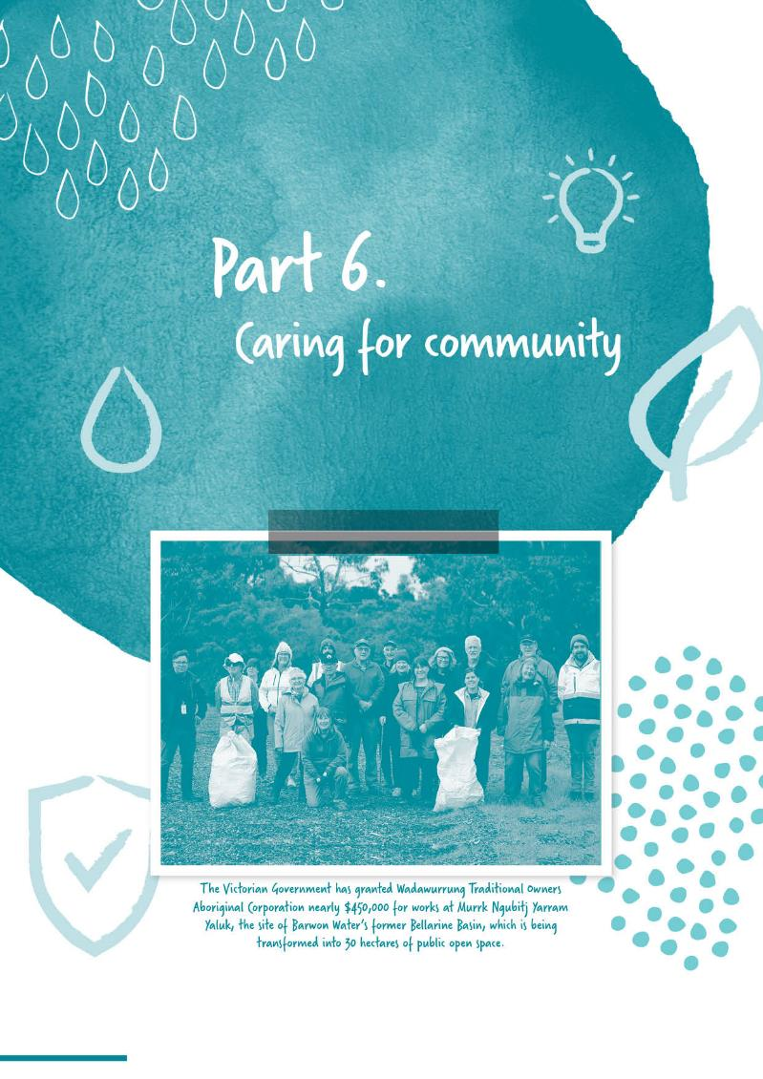

Section divider page
WITH IMAGE

Part 6.
Caring for Community

Environmental Advisory Committee
In 2023–24, our community-based Environmental Advisory Committee (EAC) continued to provide critical environmental and sustainability advice to our Board and management. The EAC consists of representatives from seven regional environmental groups, nine community representatives and an independent chairperson.
Over 2023–24, the EAC met four times to consider and advise on key issues including:
Traditional Owner led Porronggitj Karrong and Murrk Ngubitj Yarram Yalluk projects
the Regional Renewable Organics Network
the development of our Emerging Contaminants Strategy
the Remediation of Boundary Creek
our climate resilience and carbon emissions reduction programs
Barwon Water’s Reconciliation journey.

The EAC together with the Customer Advisory Committee, participated in a Cultural Awareness Training in May 2024, which included exploring the notions of cultural water and self-determination.
Community and stakeholder engagement
We have dedicated community and stakeholder engagement strategies for planned major projects, which outline various processes and methods of engagement with customers, stakeholders and the community. The strategies reference the IAP2 public participation spectrum and community engagement model.
Some of the key projects we supported with engagement strategies in 2023–24 are:
2023–28 Price Submission
We commenced delivering the 2023-28 Price Submission including engaging with customers on the key projects we are delivering over the coming five-years including our Forrest wastewater project, major sewer pipeline upgrades and next phase of our Bellarine Recycled Water project. Community engagement activities included letters, pop-ups, information sessions and key stakeholder briefings.
‘Lorne: Water, Your Say’
We launched a program to engage the Lorne community about how to secure a sustainable and resilient water future for Lorne. Key activities included community pop- ups, information sessions and an online survey to capture values and priorities of local residents, businesses and visitors. We also established a Community Working Group to provide input and feedback to shape a sustainable and resilient water future for Lorne. We are committed to ongoing community conversations and expect this community engagement to continue over coming years.
Murrk Ngubitj Yarram Yaluk
We continued our engagement with Wadawurrung Traditional Owners Aboriginal Corporation, Bellarine Catchment Network and the Friends of Murrk Ngubitj Yarram Yaluk. The ‘Friends of’ group – which celebrated its first birthday in June 2024 – this includes local community members who meet on the first Wednesday of each month to assist with bush regeneration activities.
Forrest wastewater investigations
We held listening posts in Forrest to provide an update on the Forrest wastewater investigations and an opportunity for community to learn more about the project and ask questions.
Regional Renewable Organics Network
Our Regional Renewable Organics Network engagement continued with targeted stakeholders, meetings with Black Rock landowners, community and environmental group briefings, events (including five in-person community information sessions in Geelong, Barwon Heads, Bannockburn, Torquay and Queenscliff, online webinar and industry events with Sustainability Victoria) and ongoing updates via social media and our website.
Boundary Creek, Big Swamp and Surrounding Environment Remediation and Environmental Protection Plan
We engaged with relevant stakeholders about this plan in 2023–24, meeting with the community and stakeholder reference group three times to maintain community oversight of implementation and harness community knowledge. We also continued to engage with the broader community via three community information sessions In Colac, Winchelsea and Kawarren and held a community electrofishing demonstration event in collaboration with the Arthur Rylan Institute (ARI) and the Corangamite Catchment Management Authority (CCMA). We also continued sharing project updates via a dedicated project webpage and with local media outlets and community newsletters.
Anglesea borefield
We continued to share information about the borefield’s environmental monitoring and assessment plan and bulk entitlement review process. Key to this process was the Anglesea River Advisory Group, which has continued to provide community oversight of the process. We also continued to engage with other local interest groups and the broader community via targeted briefings, community information sessions and attendance at the ANGAIR Wildflower Show.
Porronggitj Karrong and Barwon River Ovoid Sewer Aqueduct
The community reference group for the project met twice during 2023–24 to discuss the progress of the Porronggitj Karrong cultural and community precinct, and planning for the safety works on the Ovoid Sewer Aqueduct.

Class A recycled water for new communities
Our ongoing community education and awareness campaign continued about Class A recycled water for Armstrong Creek, Torquay North and Charlemont customers. Our campaign consisted of targeted engagement with users, school resources, videos and animations, and translated resources, all designed to explain the benefits and approved uses of Class A recycled water.

Infrastructure projects
We also continued community engagement planning and delivery for key infrastructure projects in 2023–24, including major regional sewerage system upgrades, Barwon Heads sewer upgrade, Colac Water Reclamation Plant upgrade, Birregurra water supply upgrade, and the Forrest and Gellibrand Water Treatment Plant upgrades.

Education program participation
Education activities | 2023-24 | 2022-23
Students and community members reached | 7,278 | 7,539
Tours conducted | 83 | 92
In-class sessions conducted | 87 | 62
Community presentations | 14 | N/A

Education
During 2023-24 our education program reached a total of 7,278 students and community members.

Barwon Water’s education program is centred around increasing community water literacy, while fostering a positive connection to water. We do this primarily through a dedicated kindergarten and early learning program, interactive school sessions, guided tours of reservoirs and treatment plants, and community group presentations.

Delivered free of charge by our dedicated Education Advisers, the program offers resources and information supporting the following key messages:
water as a natural resource
the health benefits of drinking water
the need for the efficient and sustainable use of water
our organisation’s role in the supply of water and wastewater services
recycled water reuse
what not to flush
the impacts of climate change on local water supply
our organisation’s transition to net zero emissions.

During 2023-24 we held 87 in-class sessions, 83 guided tours and 14 presentations. In addition, 53
kindergartens and early learning centres participated in our Water Hero program, highlighting the importance of water to our youngest community members.

Highlights of our education program also included:
tours and talks in partnership with Cultura, to help our region’s newest residents to understand their water supply and supports available to them
addition of a new tour option, to the historic Upper Stony Creek reservoir number one
a public panel discussion on water security challenges with Geelong Library & Heritage Centre
supply of around 2,200 native grasses and shrubs to 13 local schools undertaking tree planting and revegetation activities, through our partnership with genU Community Nursery.

Urban Water Strategy 2022: Water for our Future
The Urban Water Strategy 2022: Water for our Future was approved by the Victorian Minister for Water in September 2022.
With its 50-year outlook, five-year detailed plan, and annual review cycle, our Urban Water Strategy will help us prepare and respond flexibly and adaptively to ongoing challenges, such as climate change and a growing population. By adopting a long-term outlook for each of our region’s water systems, it will help us secure high-quality, affordable water for all our service areas and deliver an average of 1,000 million extra litres of water every year for the next 50 years.
This in turn will help us meet the needs of our cities, towns, businesses, industry and agriculture, while improving the health of our rivers – the Barwon and the Moorabool – protecting valuable ecosystems and helping Traditional Owners maintain connection to Country, as well as the significant cultural value of these places.
The strategy was co-designed with Traditional Owners, customers, community and stakeholders, and reflects their ideas and values. For more information about Water for our Future, visit barwonwater.vic.gov.au/ water-and-waste/water-for-our-future.
Sustainable water strategies
The Central and Gippsland Region Sustainable Water Strategy was released in 2022. Since its release, we have continued working closely with the Victorian Government to progress all relevant policy directions and actions.

Integrated Water Management
We continued to chair and provide executive support to the inter-agency Barwon Integrated Water Management (IWM) Forum over the last financial year. Made up of regional leaders, including Traditional Owners, five local councils, government agencies and Deakin University, the forum works collaboratively to identify and oversee the delivery of initiatives that will improve the integration of water management in urban and rural landscape.
Over 2023–24, the forum continued to facilitate delivery of 22 prioritised IWM opportunities, including capital and strategic projects identified in the 2022 Strategic Directions Statement from 2022. The prioritised opportunities range from regionally significant projects, such as urban stream restoration projects and large-scale alternative water capital projects. Of the 22 priority projects, 17 projects are in progress, two have been scoped and three are dependent on other processes before being scoped.
Over the last year the forum decided to add three new initiatives to the list of IWM opportunities it oversees, being the Porronggitj Karrong project, the Messmate Rd Torquay IWM Plan, and an investigation into short-term stormwater harvesting interventions in the growth areas of north and west Geelong.

Key IWM initiatives overseen by the forum in 2023–24 included:
ongoing progress, partnering with the City of Greater Geelong to implement agreed IWM actions into the Precinct Structure Plans within the growth areas of north and west Geelong
working in partnership with the Surf Coast Shire to address the impact of excessive volumes of stormwater entering the Karaaf wetlands ecosystem by developing a concept design and business case to treat and use the stormwater (and recycled water) for productive uses
progressing the development of a conceptual design and business case for a large-scale, staged alternative water grid, which will distribute recycled water and stormwater for throughout the region for beneficial uses
designing a sustainable and fit-for-purpose solution to the treatment of wastewater in the township of Forrest to replace existing septic systems
leading and contributing to specific regional and local IWM planning processes and capital works including:
- the finalisation and launch of the Kitjarra-dja-bul Bullarto Langi-ut Master Plan
- Avalon Corridor IWM Plan
- Bannockburn IWM Plan
- delivery of recycled water from the Apollo Bay Water Reclamation Plant to the Apollo Bay Golf Course.

Recycled Water
In 2023-24, we continued to invest in dual pipe water infrastructure to increase supply of Class A recycled water to residents at Armstrong Creek and Torquay North. We also continued a major feasibility study investigating the development of an alternative water grid in the Geelong region to link recycled and stormwater sources to locations of highest potential for productive use. We continued an investigation into an alternative water scheme in the Surf Coast Hinterland, looking to use recycled water as well as urban stormwater that otherwise would adversely impact the health of the significant Karaaf coastal saltmarsh, for productive use. Both investigations have been supported by funding from the State Government.
We supplied Class A recycled water from the Northern Water Plant to Viva Energy’s Geelong refinery, minimising the use of drinking water in refinery operations. All our water reclamation plants produce Class C recycled water, and we continued supplying this water for a range of non-residential uses in the last financial year including golf course maintenance, horticulture, agriculture and viticulture.
In 2023-24, we progressed recycled water projects on the Bellarine, and at Birregurra, Winchelsea, North Geelong, Waurn Ponds and Apollo Bay.
We also continued to deliver the Recycled Water on the Bellarine project. With previously allocated federal funding of $5.5 million, plus a further $1.972 million received from the Victorian Government in this financial year, we expect the project will produce 450 million litres per year of low-salinity, high-quality recycled water to support agriculture and horticulture, significantly reducing use of potable water.

Boundary Creek, Big Swamp and Surrounding Environment Remediation and Environmental Protection Plan (REPP)
In June 2017 we acknowledged that our historic management of periodic
groundwater pumping activities between 1983 and 2016 at the Barwon Downs Borefield had led to a reduction in groundwater contribution from the Lower Tertiary Aquifer into Boundary Creek (a tributary of the Barwon River).
Since then, we have been on a long-term journey to help remediate impacted areas and facilitate natural recovery processes, as guided by the Boundary Creek, Big Swamp and Surrounding Environment Remediation and Environmental Protection Plan (REPP).
Key highlights from 2023-24 include:
preparing a decommissioning plan to guide the works required to decommission the Barwon Downs Borefield extraction bores as promised in our 2023–28 Price Submission, obtained the licences required to facilitate these works, and appointed a suitably qualified driller to conduct these works
we submitted the revised REPP, surrounding environment investigation report and the proposed design of the mobile downstream treatment contingency measure to Southern Rural Water for their review, consideration and acceptance c
completing the first of two annual fish surveys in the Upper Barwon Region, including holding a community electrofishing demonstration event in collaboration with the CCMA
commencing work on climate resilience modelling to help understand what flow in the waterways impacted by our groundwater pumping from the Barwon Downs Borefield may look like in the future.

The outcomes of the REPP to date include:
the long-term recovery and re-pressurisation of the Lower Tertiary Aquifer system
recovery and maintenance of soil moisture within Big Swamp’s upper aquifer system, and subsequent decrease in the severity of wet-dry cycling processes and the potential for acid flush and/or acid related fish kill events in the Barwon River
improvements in the water quality and condition of the lower reaches of Boundary Creek and Big Swamp (noting that these have and will continue to be impacted by climate and other catchment-scale stressors due to the presence of the naturally occurring acid sulfate soils).

Further information regarding the Boundary Creek, Big Swamp and Surrounding Environment REPP, the outcomes of technical work, and quarterly and annual reports can be found on our dedicated webpage: yoursay.barwonwater.vic.gov.au/boundary-creek.
Drought Preparedness Plan
We have integrated our Drought Preparedness Plan into the Urban Water Strategy 2022: Water for our Future to better respond in the event of supply shortages. We use the Drought Preparedness Plan as a management tool to ensure security of water supply for customers during drought and when storages run low.

Drought Response Report
Climate conditions included below average for rainfall 2023–24. Below average catchment inflows resulted in declining water storage levels in the Geelong and Colac systems, while storage levels in the Lorne and Apollo Bay systems remain healthy. The Melbourne to Geelong Pipeline will continue to operate at minimum rates and as a base source over the summer period and may be brought on at higher flow rates in 2024–25 should storage levels continue to decline.
No water restrictions were applied during 2023–24, although permanent water saving rules remained in place.
Water saving and restrictions
In 2023–24, we continued to manage water supplies in a sustainable way using the following mechanisms:
Permanent water saving rules
The permanent water saving rules are a set of simple, common-sense rules to reduce demand and make sure we all use water wisely. Permanent water saving rules are always in place and are uniform across Victoria. The rules apply to drinking water only; they do not apply to greywater, tank water (rainwater), bore water or recycled water.
The rules are as follows:
hand water gardens and lawns with a hose fitted with a trigger nozzle can be used at any time, on any day
sprinklers and watering systems can be used after 6 pm or before 10 am
fountains and water features must recirculate water
cleaning of hard surfaces with water is restricted – use a broom instead.
For more information visit barwonwater.vic.gov.au.

Restriction rule curves
The restriction rule curves are developed for each water supply system. They guide the introduction of water restriction stages depending on the time of year and the volume of water in storages. They are also used in conjunction with weather forecasts to guide decisions on lifting restrictions.
Water restrictions by law
The water restrictions by-law is a statewide set of rules that establish the allowable uses for water throughout the various stages of restrictions. These rules provide us with the power to ensure water use is controlled during drought.
The four stages of water restrictions focus on outdoor water use and restrict activities such as garden watering, filling of pools and spas, and car washing. During the 2023-24 reporting year, no water restrictions were introduced.
Communications strategy
Our communications strategy aims to educate the community about the value of water and increase understanding of where our water comes from. It also aims to increase knowledge about using water sustainably to help customers preserve water resources and save money on bills.
To raise awareness of the status of water supplies and encourage water conservation, we regularly communicated with the community through a variety of targeted channels including print and digital advertising, social media, messaging on our bills, proactive media stories and monthly customer e-newsletters. We also shared our rationale for planning for a secure water future via communications and briefings with our larger customers and stakeholder groups, ranging from local councils to sporting clubs and our advisory committees.

Drinking water quality
In accordance with the Safe Drinking Water Act 2003, Barwon Water has a water quality risk management plan in place to ensure the provision of safe drinking water. We also maintain a HACCP-certified drinking water quality management system, which covers the entire water supply system from the catchment to the point of supply at the meter.
In September 2023, we successfully passed our HACCP Surveillance Audit. This showed that we have a mature water quality risk management plan, and customers can be confident that we continually identify, assess and manage drinking water risks.
Throughout 2023–24, we delivered drinking water to each water sampling locality in accordance with the required standards of the Safe Drinking Water Regulations 2015.
The number of water quality complaints received in 2023–24 was 1.47 per 1,000 properties. There was an increase in water quality complaints compared to the number received in 2022–23 (1.17 complaints per 1,000 properties).
Operational changes to balance water resources due to raw water challenges created by a blue green algae bloom at the Wurdee Boluc reservoir resulted in customers experiencing taste profile changes. Customers were kept informed via a proactive communication campaign.

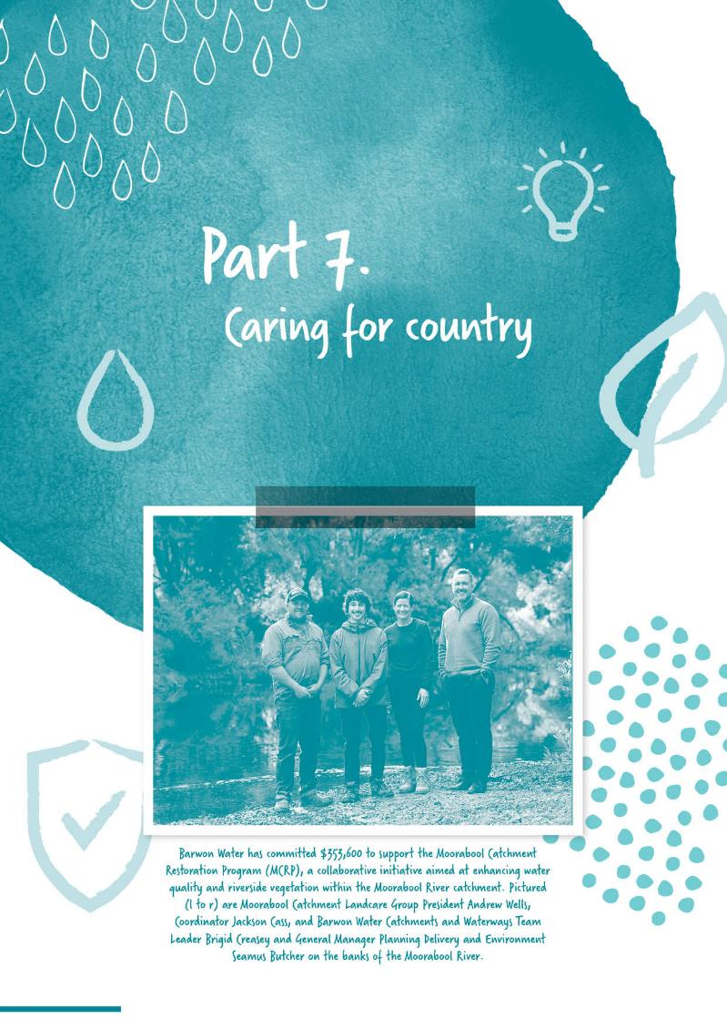
Section divider page
WITH IMAGE

Part 7.
Caring for Country

Catchment and waterway management
We harvest water from declared drinking water supply catchments on the Barham, Barwon, Gellibrand, Moorabool, and St George rivers and their tributaries. While these are largely contained within publicly managed national parks and reserves, significant areas of private land are also present within some catchments.
We have a keen interest in ensuring the protection and rehabilitation of land and waterways within these catchments, in accordance with the priorities established in the Corangamite Regional Catchment Strategy, the Corangamite Waterway Strategy and the Victorian Waterway Management Strategy.
In 2023–24, we invested more than $2.6 million to protect and improve catchment and waterway health. This included continuation of our ongoing partnership with the Corangamite CMA through our River Health Agreement and the Living Moorabool and Upper Barwon Flagship Projects. We also continued our long-standing partnerships with the Moorabool Catchment Landcare Group, Southern Otway Landcare Network and Upper Barwon Landcare Network to support a coordinated approach to delivery of on-ground protection and improvement works within drinking water supply catchments. to protect and improve catchment and waterway health. This included continuation of our ongoing partnership with the Corangamite CMA through our River Health Agreement and the Living Moorabool and Upper Barwon Flagship Projects. We also continued our long-standing partnerships with the Moorabool Catchment Landcare Group, Southern Otway Landcare Network and Upper Barwon Landcare Network to support a coordinated approach to delivery of on-ground protection and improvement works within drinking water supply catchments.
As part of this investment, we also completed on-ground works for Stage Two of a $4.3 million project to remove willows, stabilise the stream banks and revegetate streamside buffers for a 4 km reach of the East Barwon River. This is a significant project and is critical for improving flows in the river and reducing water logging of adjacent land. Stock exclusion fencing and revegetation will also improve and protect water quality.
In collaboration with the Corangamite CMA and Landcare, we continued ongoing maintenance of large river restoration projects on Dewing Creek, a tributary of the Barwon River, and the East Moorabool River at Bolwarra Weir. These projects included willow removal, fencing for stock exclusion and revegetation to improve water quality.
We have also been working with our stakeholder partners to return an additional 3.7 million litres/year to the Moorabool River by 2025 as promised in the Central and Gippsland Sustainable Water Strategy (2022).

In collaboration with Conservation Ecology Centre and Parks Victoria we monitored and supported the management of feral pig and deer populations at a number of locations within our drinking water supply catchments.
In 2023–24, we also continued our support for the ongoing operation of the Corangamite Citizen Science program. This program supports community groups to conduct water-quality testing at monitoring sites and delivers education programs for students in the Corangamite region, with staff also promoting river health and catchment issues through presentations and attendance at public events. The program also includes water-quality testing at Waterwatch sites selected and monitored by Wadawurrung Traditional Owners Aboriginal Corporation, with the results published in a water quality report produced in partnership with Wadawurrung Traditional Owners.
Environmental flows
In addition to ongoing delivery of passing flows from our storages, we continued to work with the Corangamite Catchment Management Authority (CMA) and the Victorian Environmental Water Holder to deliver environmental flows under the Upper Barwon and Moorabool River Environmental Entitlements in accordance with seasonal watering plans developed by the Corangamite CMA, to provide critical flow components required to maintain river health.
From September 2023 to June 2024, we supported the Corangamite CMA and Central Highlands Water to deliver environmental flows to the Moorabool River System, through coordination of water supply releases side-by-side with environmental flows. This increased the flow rate and helped the environmental releases to reach further into the lower reaches of the Moorabool River.
Although there is no formal environmental entitlement in place, we have continued to work with the Corangamite CMA to deliver environmental flows to Painkalac Creek from Painkalac Reservoir after the reservoir was taken offline for water supply purposes (the townships of Aireys Inlet and Fairhaven are now connected to the Geelong water supply system).

Protecting Victoria’s environment – Biodiversity 2037
As an organisation that is responsible for significant areas of land and major infrastructure, as well as a service provider for the region, we understand that managing our impact on native biodiversity is an important aspect of our work.
As such, we have continued to implement policies, procedures and programs to protect, enhance and restore biodiversity, consistent with the vision and goals of Victoria’s biodiversity strategy: Protecting Victoria’s Environment – Biodiversity 2037. We actively managed biodiversity assets at a wide range of sites, including active infrastructure sites and surrounding undeveloped land.
We developed and implemented procedures, training and advice to support environmental planning and management of capital works projects. At the same time, we kept up to date with new and amended legislation to ensure that our planning and management efforts continue to comply with requirements.
Throughout 2023–24, we developed and launched a new General Environmental Duty – Change Management and Awareness Program. The program focusses on understanding the risks our activities pose to the environment and aims to reduce the risk as much as reasonably practicable through a continuous improvement model.
By utilising our relationship with the Geelong Community Nursery, we have undertaken revegetation projects focused on catchment and biodiversity restoration, with an emphasis on historical vegetation types and increasingly through the lens of
Traditional Owners with a Caring for Country perspective. In this, we have continued building collaborative relationships with Traditional Owners

and sought advice and help in implementing environmental restoration and management programs.
We have also undertaken site rehabilitation and revegetation where capital works have happened and adopted an approach that re-planting native vegetation from an area in a more natural way is a better way of revegetating areas outside of urban settings when compared to formal landscaping.
An increasing focus of our work has been on sites around redundant assets, or adjacent to active assets, to increase their biodiversity values and ecological functioning. We’re also increasingly looking to manage these sites as environmental assets for the wider community to enjoy. This approach to landscaping has been applied around existing and new infrastructure, using locally indigenous species, to provide screening, aesthetic or ecological values, and in keeping with the vegetation that would have naturally occurred at that location.
Barwon Water has been working with the community and community groups on a number of projects, including the rehabilitation of the former Bellarine Basin site to deliver the Murrrk Ngubitj Yarram Yaluk community place in co-operation with Wadawurrung Traditional Owners and the Bellarine Landcare Network.
The Environment Team has also been supporting the First Nations Values team, who are working with Wadawurrung’s Gobata Dja to deliver positive environmental outcomes at Porronggitj Karrong as this location develops into a nationally significant cultural and community precinct.

Other statutory obligations
Managing and protecting water supply catchments is an essential first step in providing high-quality, safe drinking water for our customers and the community in accordance with our obligations under the Safe Drinking Water Act 2003 and the Australian Drinking Water Guidelines.
We understand we are just one of the many beneficiaries of healthy catchments and waterways. Catchments and waterways are a shared community asset, supporting a range of social, cultural, environmental, and economic values across the community and natural environment. It is for this reason that catchments and waterways are best managed through both individual and collaborative efforts to protect and improve these values.
Environmental licence compliance
Barwon Water has continued to update our environmental management and compliance systems in response to changes in the Environment Protection Act (EP Act) and subordinate regulations, reference standards and guidelines. This has included update and implementation of new Health and Environmental Management Plans (HEMPs), Recycled Water Quality Management Plans (RWQMPs) for our recycled water reuse schemes and the preparation of Risk Management and Monitoring Programs (RMMPs) for our water reclamation plant operating licence sites.
Throughout 2023-24 we have applied for and received either renewed or new EPA permits for recycled water supply and use schemes across our network of Water Reclamation Plants (WRPs), in accordance with the new EP Act.

Barwon Water hold the following active EPA permissions for our WRP operation and recycled water reuse schemes:
Permission category | Permission type | Qty | Sites/ detail
Operating Licence | A03 – Sewage Treatment | 10 | Black Rock WRP, Anglesea WRP, Aireys Inlet WRP, Lorne WRP, Apollo Bay WRP, Colac WRP, Birregurra WRP, Bannockburn WRP, Winchelsea WRP, Portarlington WRP
 | A06 + A01 (disposal to land and reportable priority waste management) | 1 | Western Treatment Plant (backup biosolids storage)
Permit | A14 – Wastewater supply or use | 11 | Northern Water Plant (Class A and CIP reuse, Black Rock WRP (Class C), Black Rock WRP (Class A), Portarlington WRP (Class C), Anglesea WRP (Class B), Lorne WRP (Class B), Apollo Bay (Class B), Bannockburn WRP (Class C), Winchelsea WRP (Class C), Colac WRP (Class C)
 | A15 – Biosolids supply or use | 2 | Colac WRP and Black Rock WRP (deemed permissions – no longer used)
 | A16 – Supply or use of reportable priority waste | 1 | Bannockburn Irrigation Farm (Reuse of T3 Biosolids)
During the reporting period we have achieved compliance against all 120 operating licence conditions and all 219 permit conditions.
Greenhouse gas emissions, electricity consumption and generation

As a major greenhouse gas emitter in our region, we are committed to being a leader in reducing emissions. Electricity use is our most significant emissions source and previously represented around 80 per cent of our underlying emissions.
To mitigate greenhouse impacts, we will complete our switch to 100 per cent renewable electricity use on 1 July 2024 and continue to pursue zero net emissions (scope 1 and 2) by 2030. To achieve these targets, we have been implementing a comprehensive program of timely and cost-effective measures. Our greenhouse gas emissions include carbon dioxide, methane and nitrous oxide.
These are reported in equivalent tonnes of carbon dioxide – tCO2-e.
We report direct emissions (scope 1) and indirect emissions from grid supplied electricity (scope 2), calculated in accordance with the National Greenhouse and Energy Reporting (Measurement) Determination 2008 and the Statement of Obligations (Emissions Reduction). Projected emissions were developed in 2017 as part of our emissions reduction pledge. Scope 3 emissions are not included in any results presented in this section.
Our calculated scope 1 and 2 emissions total for 2023-24 was our lowest on record at 19,083 tCO2-e.
This was 22 per cent less than our projected emissions of 24,560 tCO2-e and represents a 19 per cent reduction on last year’s result. Our renewable electricity initiatives supplied 57 per cent of our electricity needs for the year, reducing our scope 2 emissions by a total of 13,798 tCO2-e.
Emissions associated with wastewater collection, treatment and recycling, which make up the largest portion of our greenhouse emissions and energy use, were down 20 per cent on last year. Emissions associated with water treatment and supply were also down –17 per cent less than 2022-23. In both cases, this was largely due to the increased use of renewable electricity.

Total greenhouse gas emissions
 | Scope 1 and 2 Emissions (tCO2-e)
Greenhouse gas emissions (tonnes CO2-e) | 2022-23 Total | 2023-24  Scope 1 | 2023-24  Scope 2 | 2023-24  Total | Variance from last year
Water treatment and supply | 2,872 | 183 | 2,192 | 2,374 | -17%
Sewage collection, treatment and recycling | 19,129 | 7,324 | 7,950 | 15,274 | -20%
Transport | 1,036 | 995 | 0 | 995 | -4%
Other | 500 | 173 | 267 | 439 | -12%
Total emissions (tCO₂-e) | 23,538 | 8,674 | 10,409 | 19,083 | -19%
Carbon offsets (self-generated) retired | 0 | 0 | - | 0 | -
Net emissions (tCO₂-e) | 23,538 | 8,674 | 10,409 | 19,083 | -19%
Notes: calculation of wastewater process emissions for Colac WRP was partially impacted by a data anomaly. As a result, substitute data was used in-part, to enable a more accurate calculation of the 2023-24 emissions.

Progress towards 1 July 2024 greenhouse gas emissions target (net scope 1 and 2 emissions)

Total electricity consumption
MWh*
Activity | 2022–23 | 2023–24
Water treatment and supply | 5,294 | 5,889
Sewage collection, treatment and recycling | 24,434 | 23,963
Other | 699 | 789
Total electricity consumption | 30,426 | 30,641
Notes: * MWh = megawatt-hours

Renewable electricity consumption
 | MWh
Source | 2022–23 | 2023–24 | 2023–24  Percentage  of total use | Variance  from  last year
Renewable electricity use: from Commonwealth Government’s LRET
Grid sourced: Mandatory Large Scale Renewable Energy Target | 4,923 | 4,859 | 16% | -1%
Renewable electricity use: self-sourced activities
Biogas | 991 | 1,360 | 4% | 37%
Hydroelectric | 118 | 138 | 0% | 17%
Solar | 9,503 | 11,422 | 37% | 20%
Wind | 2,471 | 4,546 | 15% | 84%
Other | - | - | - | -
Total self-sourced renewable | 13,083 | 17,466 | 57% | 33%
Total renewable | 18,005 | 22,325 | 73% | 23%

Total electricity consumption segmented by source
Electricity source |  | MWh
 | 2022–23 | 2023-24
Purchased directly through an electricity retailer | 26,254 | 25,958
Not directly purchased but sourced from outside the organisation | - | -
Corporation led/self-sourced activities and initiatives | 4,173 | 4,682
Total electricity consumption | 30,426 | 30,641

On-site renewable electricity generation and capacity
On-site renewable electricity source | On-site generation capacity (MW) |  |  | 2023-24 on-site renewable electricity generated (MWh)
 |  |  | Consumed on-site |  | Exported | Other purposes | Total by source
Biogas |  | 0.36 | 1,191 |  | 168 | - | 1,360
Hydroelectric |  | 0.13 | 0 |  | 138 | - | 138
Solar |  | 4.02 | 3,491 |  | 1,660 | - | 5,151
Wind |  | - | - |  | - | - | -
Other renewable |  | - | - |  | - | - | -
TOTAL renewable |  | 4.51 | 4,682 |  | 1,966 | 0 | 6,648

On-site non-renewable electricity generation and capacity (large-scale facilities)
Non-renewable electricity sources | On-site generation capacity (MW) | 2023-24 on-site electricity generated (MWh)
 |  | Consumed  on-site | Exported | Other  purposes | Total by  source
TOTAL non-renewable | - | - | - | - | 0

Energy storage system capacity
Energy storage system | Power capacity (MW) | Storage capacity (MWh)
Wurdee Boluc WTP battery | 0.18 | 0.2

Voluntary retirement of Renewable Energy Certificates (RECs)
REC retirement method | RECs retired for 2023–24  (1 REC = 1 MWh renewable electricity)
Voluntarily retired by Barwon Water | 12,585
GreenPower | -
Certified carbon neutral electricity purchased | -
Voluntarily retired on Barwon Water’s behalf | -
Total RECs retired to reduce scope 2 emissions | 12,585

Breakdown of emissions by type of greenhouse gas
Greenhouse gas emissions (tonnes CO2-e) | Scope 1 Emissions by greenhouse gas (tCO2-e)
 | Carbon dioxide  (CO2) | Methane  (CH4) | Nitrous oxide  (N2O) | Other
Water treatment and supply | 182 | 0 | 1 | 0
Sewage collection, treatment and recycling | 26 | 3,104 | 4,194 | 0
Transport | 987 | 0 | 7 | 0
Other | 172 | 0 | 0 | 0
TOTAL | 1,368 | 3,105 | 4,202 | 0
Notes: tCO2-e represents the greenhouse gas emission in carbon dioxide equivalence, by applying the relevant Global Warming Potential (GWP). The GWP for one tonne of each gas is: CO2 = 1, CH4 = 28 and N2O = 265 (National Greenhouse and Energy Reporting Regulations 2008).
Stationary fuel use and emissions
Fuel type | Total stationary fuel use (buildings and machinery)
 |  | Energy (GJ) | Emissions (tCO2-e)
Fossil gas | 1,845 |  | 95
Biogas | 13,475 |  | 87
Diesel | 3,749 |  | 263
LPG | 0 |  | 0
Petrol | 301 |  | 20
Other | 0 |  | 0
TOTAL | 19,371 |  | 465

Transport fuel use and emissions
Transport energy use (gigajoules)
Used in | Diesel | Petrol | LPG | Electricity
Passenger vehicles | 506 | 307 | 0 | -
Goods vehicles | 12,814 | 15 | 572 | -
Total energy used | 13,320 | 322 | 572 | -
Greenhouse gas emission (tCO2-e) | 938 | 22 | 35 | -
Notes: Excludes electricity used in charging electric vehicles charged at Barwon Water sites (included in total electricity consumption results).

Transport vehicle fleet
Category | Vehicle fuel/engine type |  |  |  |  |  | Total number
 | Diesel | Petrol | LPG | Petrol-hybrid | Diesel-hybrid | Battery EV
Passenger vehicles | 13 | 6 | - | 7 | - | 2 | 28
Goods vehicles | 150 | - | 11 | - | 11 | - | 172
Total number | 163 | 6 | 11 | 7 | 11 | 2 | 200

Total energy use
Total energy use (GJ) | Renewable |  | Non-renewable |  | Total
From fuels |  | 13,475 |  | 20,110 |  | 33,585
From electricity |  | 62,878 |  | 47,429 |  | 110,306
TOTAL energy used |  | 76,353 |  | 67,538 |  | 143,891
Notes: Renewable electricity result excludes mandatory LRET component of grid electricity. Renewable electricity use includes consumption of electricity generated from renewable biogas, and the biogas used to generate that electricity is counted in renewable fuel use.
Energy use intensity
Service | Total energy  use (GJ) | Total units production/  service | Energy  intensity | Units | Descriptor
Water treatment and supply | 23,773 | 41,821 | 0.57 | GJ/ML | Gigajoules per megalitre of water produced at water treatment plants
Sewage collection, treatment and recycling | 100,119 | 649,645 | 0.15 | GJ/EP | Gigajoules per normalised unit of sewage treatment plant loading (COD + nitrogen)

Emissions reduction and renewable energy initiatives
We will complete our switch to 100 per cent renewable electricity on 1 July 2024. As mentioned above and reflected in the Statement of Obligations (Emissions Reduction), our target is to achieve zero net emissions in our operations (i.e. scope 1 and 2) by 2030.
To achieve this target, our approach will follow this emissions reduction hierarchy:
avoiding energy use and emissions through smart design of new and renewed assets
minimising energy and emissions through efficiency and optimisation
substituting emissions-intensive energy with zero-emission renewable sources
sequester carbon from the atmosphere
offsetting residual emissions through additional reductions elsewhere.
Our emissions reduction and renewable energy programs reduced emissions by at least 13,798 tonnes CO2-e in 2023-24 through a range of initiatives.

We operated more than 4 megawatts of on-site renewable electricity generation assets, including:
3-megawatt Black Rock solar farm
360-kilowatt Colac biogas co-generation facility (with an additional 550 kilowatts commencing operation in early 2024-25)
330-kilowatt Northern Water Reclamation Plant solar array
300-kilowatt Wurdee Boluc solar array and 200 kilowatt-hour battery
240-kilowatt Torquay solar array
80-kilowatt rooftop solar array at our Kadak Place maintenance depot
30-kilowatt rooftop solar array at our Anglesea Water Reclamation Plant
30-kilowatt rooftop solar array at our Apollo Bay Water Reclamation Plant.
Our Barwon Renewable Energy Partnership (BREP) Power Purchase Agreement with Mt Gellibrand Wind Farm and Zero Emissions Water Power Purchase Agreement with Kiamal Solar Farm continued to operate and generated more than 45 gigawatt-hours of renewable electricity that was fed into the grid.

We continued driving 11 hybrid trucks and two battery-electric passenger vehicles in our fleet, and recently adding seven petrol-hybrid passenger vehicles.
Looking further ahead to our target of net zero emissions by 2030, we are continuing to develop a comprehensive carbon sequestration and offsets program to mitigate our residual scope 1 emissions.
We have commenced our first nature-based carbon sequestration initiative, the Dewing Creek catchment restoration project, which secured a $643,000 grant from Victoria’s Bushbank program, and we continue to investigate further opportunities at both a local level, and in collaboration with the broader Victorian water industry. The development of the Regional Renewable Organics Network continues to progress and is expected to sequester significant volumes of carbon through biochar production, while reducing emissions by diverting organic wastes away from landfill and through renewable energy generation.

We have also continued engaging in scientific research, development and collaboration in pursuit of improved understanding and reduction of wastewater fugitive emissions.
This work requires us to be actively involved in water industry networks and programs, as well as maintain direct partnerships with the research sector.
We actively collaborate with the water industry via the Intelligent Water Networks’ programs, Institute of Water Administration Energy and Greenhouse Special Interest Group and the Water Services Association of Australia Climate Change, Energy and Environment Network.
Climate change resilience
In addition to reducing our emissions, we are deeply committed to managing climate change risks and building our resilience to climate change.
Our vision is to be agile in adapting and acting on climate challenges and opportunities so our region can continue to prosper and thrive.

In addition to reducing our emissions, we are deeply committed to managing climate change risks and building our resilience to climate change.
Climate risk governance and management
Climate change risks are governed by our enterprise risk management framework, which identifies our most important business risks. The dedicated Climate Change Key Business Risk (KBR) identifies our 2030 and 2070 risk rating, plus our target risk rating, key controls and treatments. The KBR is underpinned by our organisational wide climate change risk assessment.
The risk assessment aligns with the Water Services Association of Australia Climate Change Adaptation Guidelines and covers both physical and transition risks. The risk assessment also directly informs our Climate Resilience Plan, particularly the actions.

The KBR and progress towards achieving our target risk rating was reviewed by the Risk Management Committee in 2023–24, which also received an update on the Climate Resilience Plan. As part of this annual update, we measured both the implementation progress of Climate Resilience Plan actions and collected data across a range of Key Performance Indicators that help us measure our progress towards achieving the overall.
In addition to the annual update, the Risk Management Committee also reviewed the updated climate change transition risk register.

Climate planning and response
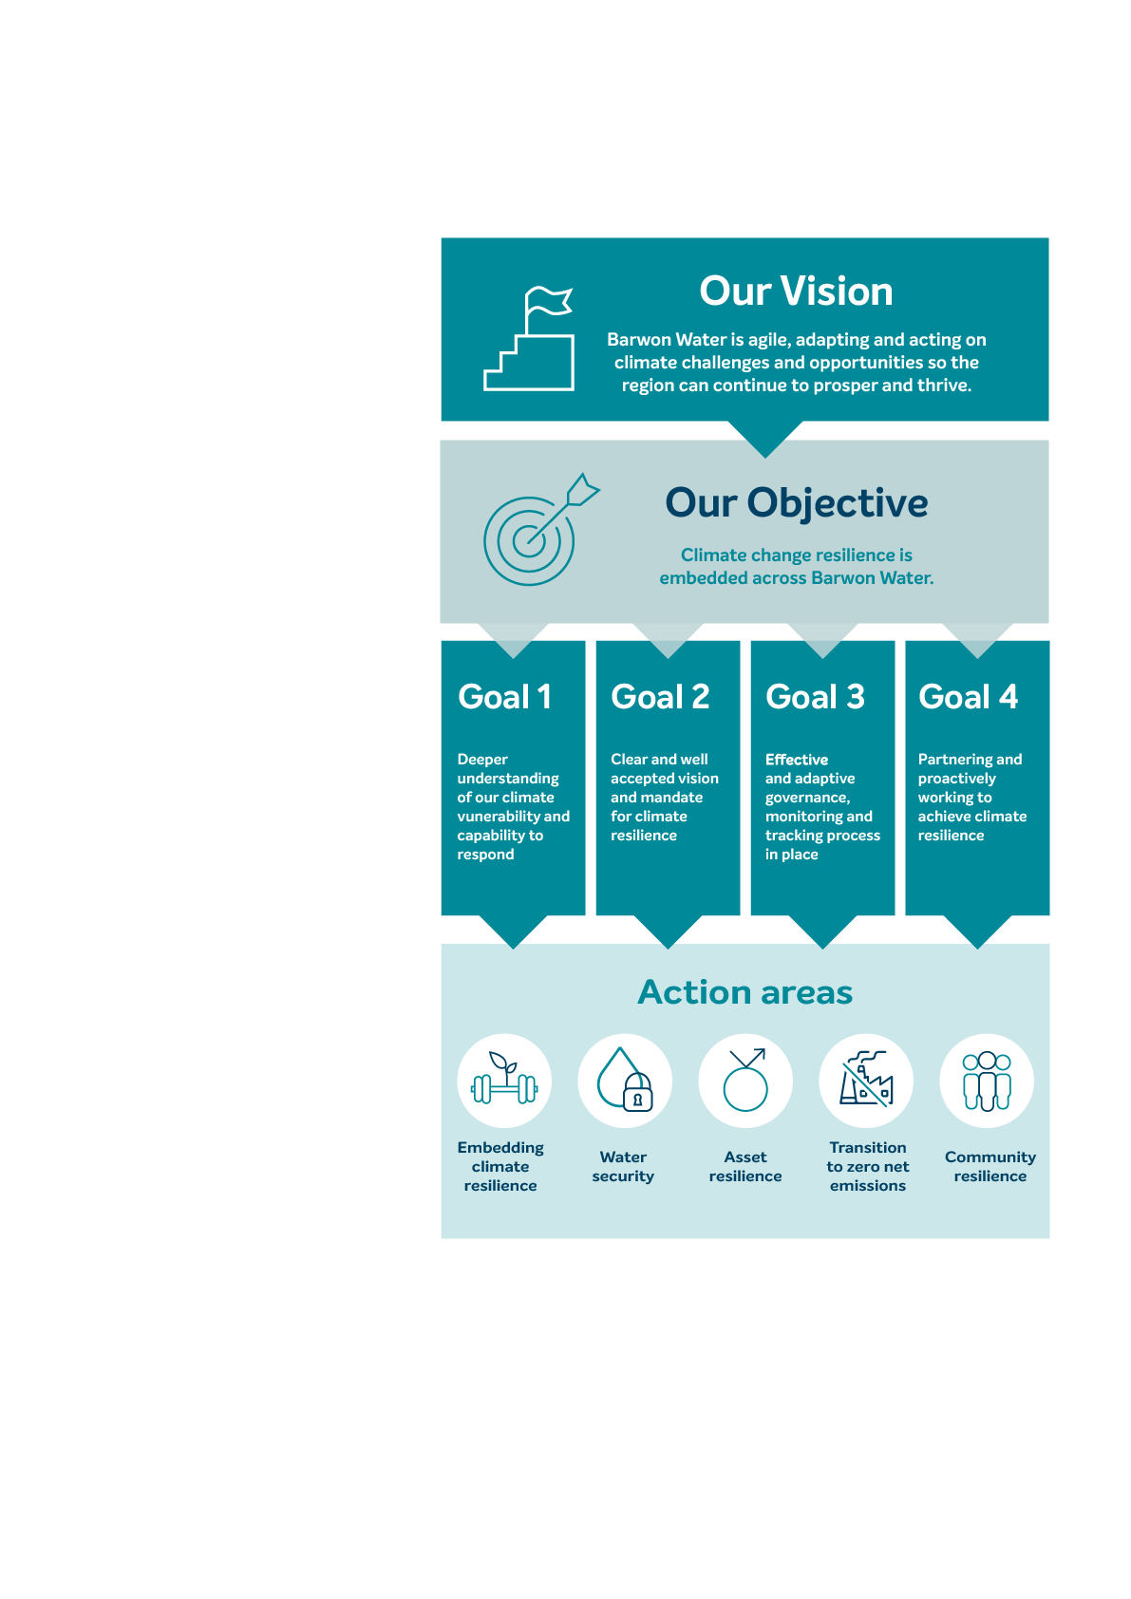
Delivering our Climate Resilience Plan is one of the major controls identified in the Climate Change Key Business Risk (KBR) and we are currently three quarters of the way through implementing the plan. Released in 2021, the Climate Resilience Plan provides a cohesive vision and plan for building our resilience to climate change.
The diagram on this page articulates our approach to climate resilience, including the five categories of actions – embedding climate resilience, water security, asset resilience, transition to zero net emissions and community resilience.
Our focus in 2023–24 was on treating the critical and high-rated risks, while also embedding climate resilience thinking within our processes. Actions carried out during this time include:
completing a pilot spatial climate change asset impact assessment – informed by the Guidelines for Adaptive Management of Wastewater Systems Under Climate Change in Victoria – to better understand the vulnerability of our assets to climate change
using the learnings from the pilot impact assessment we developed a roadmap of activities to build asset resilience to climate change
implementing our Urban Water Strategy 2022: Water for our Future
adding climate change risk considerations into our business case template, to ensure climate risks are considered at the asset planning stage
completing a detailed review of our organisational climate change transition risks
continuing to track implementation of the Climate Resilience Plan and monitoring progress towards achieving our outcomes.

Climate Resilience Plan goals and action areas

Environmental performance

Our Environmental Management System continued to be certified under ISO 14001:20015.
Key activities we carried out in 2023–24 include:
protecting, managing and monitoring environmental and cultural heritage values during capital project works and at our operational sites
continuing rolling out industrial waste reduction and management improvement activities
implementing an industrial waste collection and reporting tool to track the industrial waste we produce as part of our capital, operational and maintenance works. This will help inform efforts to reduce industrial waste sent to landfill
developing and launching a General Environmental Duty (GED) Change and Awareness Program across the business
set up an Internal Environmental Management Committee that reports Key Performance Indicators and other relevant topics and performance to the Executive Leadership Team on a bi-monthly basis
obtaining EPA permissions for Barwon Water and Barwon Asset Solutions regulated activities under the Environmental Protection Act 2017
obtaining planning, environmental and cultural heritage approvals for our capital works program
obtaining planning, environmental and cultural heritage approvals for our operational and Barwon Asset Solutions works programs
updating our internal environmental management tools.
In the next financial year, we will continue implementing our GED Change Program and other key risk treatments.

Bulk entitlement reporting

A bulk entitlement is a legal right to water granted by the Minister for Water under the Water Act 1989. Bulk entitlements are commonly held by water corporations in Victoria. The key objectives of these entitlements are to:
provide authorities with a clearly defined property right to water
provide authorities with flexibility to manage within their entitlements
provide a basis for sharing limited water resources, protecting the entitlements of other users and protecting in-stream values
facilitate water trading between user groups to ensure appropriate
redistribution over time of finite water resources
allow specific entitlements for environmental purposes.
Barwon Water operates under 11 surface water bulk entitlements, which cover the Barwon, Moorabool, Gellibrand, St Georges, Painkalac and Barham River systems, as well as the Greater Yarra System–Thomson River Pool.

2023–24 Overall surface water bulk entitlement performance
We achieved an overall compliance rate of 100 per cent in 2023–24 for the numerous daily extraction limits across our surface water bulk entitlements.
We also achieved 100 per cent compliance with passing flow requirements in 2023-24.
Each bulk entitlement requires annual reporting of water taken and any non-compliance with the provisions contained within the bulk entitlement. This information is provided in the following tables.

Bulk Entitlement (Aireys Inlet) Conversion Order 1997
14.1 (d) | Painkalac Reservoir Level at 30/6/24 |  | 28.08 mAHD
 |  | Painkalac Reservoir Storage Volume at 30/6/24 | 303 ML (57%)
14.1 (e) | Volume taken 2023–24 |  | 0 ML
14.1 (f) | Approval, amendment and implementation of programs and proposals under clauses 11, 12 and 13.  Clause 11 – Making Allowances  Clause 12 – Environmental Obligations  Clause 13 – Metering Program |  | Not applicable  Ongoing management in accordance with Barwon Water’s Environment Strategy and Environmental Obligations Program.  Ongoing implementation of Bulk Entitlement Metering Program as approved by DEECA in 2016.
14.1 (g to j) | Transfers, amendments or new entitlements under this order. |  | Nil
14.1 (k) | Any failure by Barwon Water to comply with any provision of this bulk entitlement. |  | No
14.1 (l) | Any existing or anticipated difficulties experienced by Barwon Water in complying with this bulk entitlement and any remedial action taken or proposed by the Barwon Water. |  | No

Bulk Entitlement (Apollo Bay) Order 2010
10.1 (c) | Approval, amendment and implementation of programs and proposals under clauses 8 and 9.
Clause 8 – Environmental Obligations |  | Ongoing management in accordance with Barwon Water’s  Environment Strategy and Environmental Obligations Program.
Clause 9 – Metering Program |  | Ongoing implementation of Bulk Entitlement Metering Program as approved by DEECA in 2016.
10.1 (d) | Volume diverted 2023–24 (West Barham diversion). | 0 ML
Volume pumped 2023–24 (Barham River). |  | 476 ML
10.1 (e to h) | Transfers, amendments or new entitlements under this order. | Nil
10.1 (i) | Any failure by Barwon Water to comply with any provision of this bulk entitlement. | No
10.1 (j) | Any existing or anticipated difficulties experienced by Barwon Water in complying with this bulk entitlement and any remedial action taken or proposed by Barwon Water. | No

Bulk Entitlement (Colac) Amendment Order 2003
12.1 (c) | Storage Volumes at 30/6/24
Olangolah Reservoir Level |  | 343.65 mAHD
Olangolah Reservoir Volume |  | 83 ML (64%)
West Gellibrand Reservoir Level |  | 336.16 mAHD
West Gellibrand Reservoir Volume. |  | 640 ML (10034%)
12.1 (d) | Volume taken 2023–24 | 3,941 ML
12.1 (e) | Approval, amendment and implementation of programs and proposals under clauses 9, 10 and 11.
Clause 9 – Making Allowances |  | Not applicable.
Clause 10 – Environmental Obligations |  | Ongoing management in accordance with Barwon Water’s Environment Strategy and Environmental Obligations Program.
Clause 11 – Metering Program |  | Ongoing implementation of Bulk Entitlement Metering Program as approved by DEECA in 2016.
12.1 (f to i) | Transfers, amendments or new entitlements under this order. | Nil
12.1 (j) | Any failure by Barwon Water to comply with any provision of this bulk entitlement. | No
12.1 (k) | Any existing or anticipated difficulties experienced by Barwon Water in complying with this bulk entitlement and any remedial action taken or proposed by Barwon Water. | No

Bulk Entitlement (Gellibrand) Conversion Order 1997
11.1 (b) | Volume taken 2023–24 | 17.6 ML
11.1 (c) | Approval, amendment and implementation of programs and proposals under clauses 8, 9 and 10.
Clause 8 – Making Allowances |  | Not applicable.
Clause 9 – Environmental Obligations |  | Ongoing management in accordance with Barwon Water’s Environment Strategy and Environmental Obligations Program.
Clause 10 – Metering Program |  | Ongoing implementation of Bulk Entitlement Metering Program as approved by DEECA in 2016.
11.1 (d to g) | Transfers, amendments or new entitlements under this order. | Nil
11.1 (h) | Any failure by Barwon Water to comply with any provision of this bulk entitlement. | No
11.1 (i) | Any existing or anticipated difficulties experienced by Barwon Water in complying with this bulk entitlement and any remedial action taken or proposed by Barwon Water. | No

Bulk Entitlement (Lorne) Conversion Order 1997
14.1 (d) | Allen Reservoir storage level at 30/6/24. | 120.3 mAHD
Allen Reservoir storage volume at 30/6/24. |  | 215 ML (100%)
14.1 (e) | Volume taken from the weir and storage 2023–24 (Note: the weir has been decommissioned) | 384 ML
14.1 (f) | Approval, amendment and implementation of programs and proposals under clauses 11, 12 and 13.
Clause 11 – Making Allowances |  | Not applicable.
Clause 12 – Environmental Obligations |  | Ongoing management in accordance with Barwon Water’s  Environment Strategy and Environmental Obligations Program.
Clause 13 – Metering Program |  | Ongoing implementation of Bulk Entitlement Metering Program as approved by DEECA in 2016.
14.1 (g to j) | Transfers, amendments or new entitlements under this order. | Nil
14.1 (k) | Any failure by Barwon Water to comply with any provision of this bulk entitlement. | No
14.1 (l) | Any difficulties experienced or anticipated by Barwon Water in complying with this bulk entitlement and any remedial action  taken or proposed by Barwon Water. | No

Bulk Entitlement (Meredith) Conversion Order 1995
11.1 (d) | Approval, amendment and implementation of programs and proposals under clauses 9 and 10.
Clause 9 – Environmental Obligations |  | Ongoing management in accordance with Barwon Water’s  Environment Strategy and Environmental Obligations Program.
Clause 10 – Metering Program |  | Ongoing implementation of Bulk Entitlement Metering Program as approved by DEECA in 2016.
11.1 (e) | Volume taken 2023–24 | 0 ML
11.1 (f to i) | Transfers, amendments or new entitlements under this order. | Nil
11.1 (j) | Any failure by Barwon Water to comply with any provision of this bulk entitlement. | No
11.1 (k) | Any existing or anticipated difficulties experienced by Barwon Water in complying with this bulk entitlement and any remedial action taken or proposed by Barwon Water. | No

Bulk Entitlement (She Oaks) Conversion Order 1995
13.1 (d) | Weir Pool Level at 30/6/24 | 0.26 m
Weir Pool Storage Volume at 30/6/24. |  | 19 ML (100%)
13.1 (e) | Volume taken under this entitlement 2023–24 (River Flow). | 0 ML
13.1 (f) | Volume taken under this entitlement over the past 3 years (2019-20 to 2023–24 ). | 0 ML
13.1 (g) | Approval, amendment and implementation of programs and proposals under clauses 11 and 12.
Clause 11 – Environmental Obligations |  | Ongoing management in accordance with Barwon Water’s  Environment Strategy and Environmental Obligations Program.
Clause 12 – Metering Program |  | Ongoing implementation of Bulk Entitlement Metering Program as approved by DEECA in 2016.
13.1 (h-k) | Transfers, amendments or new entitlements under this order. | Nil
13.1 (l) | Any failure by Barwon Water to comply with any provision of this bulk entitlement. | No
13.1 (m) | Any existing or anticipated difficulties experienced by Barwon Water in complying with this bulk entitlement and any remedial action taken or proposed by Barwon Water. | No

Bulk Entitlement (Lal Lal - Barwon) Conversion Order 1995 / Amendment Order 2010
19.1 (f) | Amount of water in Barwon Water’s share of reservoir capacity at 30/6/24. | 12,503 ML (100%)
19.1 (g) | Annual flow into Barwon Water’s share of reservoir capacity at 30/6/24. | -4,289 ML
19.1 (h) | Annual volume released to West Moorabool River from specified point A (Releases to Barwon Water). | 3,890 ML
19.1 (i) | Volume taken under this entitlement from specified point B (She Oaks Diversion Weir). | 2,289 ML
19.1 (k) | Volume taken from a location downstream of specified point A, other than specified point B. | Nil
19.1 (l) | Annual losses debited to Barwon Water’s share of reservoir capacity. | 1,042ML
19.1 (m) | Annual losses from releases between specified points A and B. | 1,617 ML
19.1 (n) | The implementation of programs approved under sub-clauses 16.2, 17.2, and 18.2.
Clause 16.2 – Environmental Obligations |  | Ongoing management in accordance with Barwon Water’s Environment Strategy and Environmental Obligations Program.
Clause 17.2 – Joint Metering Program |  | Ongoing implementation of Bulk Entitlement Metering Program as approved by the DELWP in 2016.
Clause 18.2 – Authority’s Metering Program |  | Ongoing implementation of Bulk Entitlement Metering Program as approved by the DELWP in 2016.
19.1 (o) | Any temporary or permanent transfer of all or part of this entitlement. | In February 2024, Barwon Water (BW) completed a temporary trade of 100ML of water allocation to Central Highlands Water (CHW) Corporation, in line with section 46 of the Water Act 1989. This trade was in support of a cultural flow trial release for Wadawurrung Traditional Owners Aboriginal Corporation to the West Moorabool River (100ML BW, 100ML CHW). This trade received approval from the Department of Energy, Environment and Climate Action on the 29th of December 2023.
19.1 (p) | Any bulk entitlement or licence in respect of the waterway temporarily or permanently transferred to Barwon Water with respect to the reservoir. | Nil
19.1 (q) | Any amendment to this Bulk Entitlement. | Nil
19.1 (r) | Any new bulk entitlement granted to Barwon Water with respect to its entitlement to a share of reservoir capacity. | Nil
19.1 (s) | Any failure by Barwon Water to comply with any provision of this bulk entitlement. | Nil
19.1 (t) | Any existing or anticipated difficulties experienced by Barwon Water in complying with this bulk entitlement and any remedial action taken or proposed by Barwon Water. | Nil

Bulk Entitlement (Upper Barwon System) Conversion Order 2002 / Amendment Order 2018
15.1 (d) | Storage Volumes at 30/6/24.
West Barwon Reservoir (Barwon Water Share). |  | 7,227 ML (37%)
West Barwon Reservoir (Total). |  | 8,544 ML (40%)
Wurdee Boluc Reservoir. |  | 20,785 ML (55%)
Barwon System Total. |  | 29,329 ML (49%)
15.1 (e) | Volume taken under this entitlement 2023–24 | 24,007 ML
15.1 (f) | Approval, amendment and implementation of programs and proposals under clauses 13.3 and 14.3.
Clause 13.3 – Environmental Obligations |  | Ongoing management in accordance with Barwon Water’s  Environment Strategy and Environmental Obligations Program.
Clause 14.3 – Metering Program |  | Ongoing implementation of Bulk Entitlement Metering Program as approved by DEECA in 2016.
15.1 (g-j) | Transfers, amendments or new entitlements under this order. | Nil
15.1 (k) | Any failure by Barwon Water to comply with any provision of this bulk entitlement. | No
15.1 (l) | Any existing or anticipated difficulties experienced by Barwon Water in complying with this bulk entitlement and any remedial action taken or proposed by Barwon Water. | No

Bulk Entitlement (Upper East Moorabool System) Conversion Order 1995 / Amendment Order 2004
14.1 (d) | Storage volume at 30/6/24.
Korweinguboora Reservoir |  | 302 ML (13%)
Bolwarra Weir |  | 113 ML (100%)
Bostock Reservoir |  | 6,017 ML (82%)
Upper Stony Creek Reservoirs |  | 6,717 ML (70%)
Lower Stony Creek Reservoir |  | 0 ML (0%)
14.1 (e) | Volume taken under this entitlement 2023–24 | 3,831 ML
14.1 (f) | Approval, amendment and implementation of programs and proposals under clauses 12.2 and 13.3
Clause 12.2 – Environmental Obligations |  | Ongoing management in accordance with Barwon Water’s Environment Strategy and Environmental Obligations Program.
Clause 13.3 – Metering Program |  | Ongoing implementation of Bulk Entitlement Metering Program as approved by DEECA in 2016.
14.1 (g-j) | Transfers, amendments or new entitlements under this order. | Nil
14.1 (k) | Any failure by Barwon Water to comply with any provision of this bulk entitlement. | No
14.1 (l) | Any existing or anticipated difficulties experienced by Barwon Water in complying with this bulk entitlement and any remedial action taken or proposed by Barwon Water. | No

Bulk Entitlement (Greater Yarra System – Thomson River Pool – Barwon Water) Order 2014
16.1 (a) | The annual amount of water taken under this bulk entitlement (MW billable) in 2023-24 | 2490 ML
16.1 (b) | The water allocation made available under this bulk entitlement and volume of carryover. | 11,666.3 ML  57,613.6 ML
16.1 (c) | Compliance with the entitlement share. | Yes
16.1 (d) | Any temporary assignment or permanent transfer of all or part of this bulk entitlement. | Nil
16.1 (e) | The approval, amendment and implementation of the metering program approved under clause 13. | Ongoing implementation of Bulk Entitlement Metering Program as approved by the DELWP in 2016.
16.1 (f) | Any amendment to this bulk entitlement. | On 21 September 2023, the Minister for Water made an amendment to Barwon Water’s Greater Yarra System – Thomson River Pool bulk entitlement, to update references to reflect the transfer of part of Yarra Valley Water’s Greater Yarra System – Thomson River Pool bulk entitlement to Gippsland Water.
16.1 (g) | Any new bulk entitlement of water granted to the Authority. | Nil
16.1 (h) | Any failure by the Authority to comply with any provision of this bulk entitlement and any remedial action taken or proposed. | No
16.1 (i) | Any difficulties experienced or anticipated by Barwon Water in complying with this bulk entitlement and any remedial action taken or proposed. | No

Groundwater bulk entitlements
The Bulk Entitlement (Anglesea Groundwater) Order 2009 authorises Barwon Water to take up to 35,000 ML of groundwater from the Lower Eastern View Formation in the Jan Juc Groundwater Management Area in any five-year period.
Bulk Entitlement (Anglesea Groundwater) Order 2009 / Amendment Order 2014
16.1 (a) | Annual amount taken (Volume) in 2023–24 | 0 ML
16.1 (b) | Any Amendment to this Order. | Nil
16.1 (c) | Any failure by Barwon Water to comply with any provision of this bulk entitlement. | Nil
Notes:
1. Information supplied refers to volume in megalitres unless stated otherwise.
2. References (e.g. 14.1 (d)) relate to clause numbers in each Bulk Entitlement Order.
3. Telemetry data has been used to evaluate compliance with passing flows and diversions (final quality checked data
collected under the Regional Water Monitoring Partnership is yet to be supplied for the full financial year).

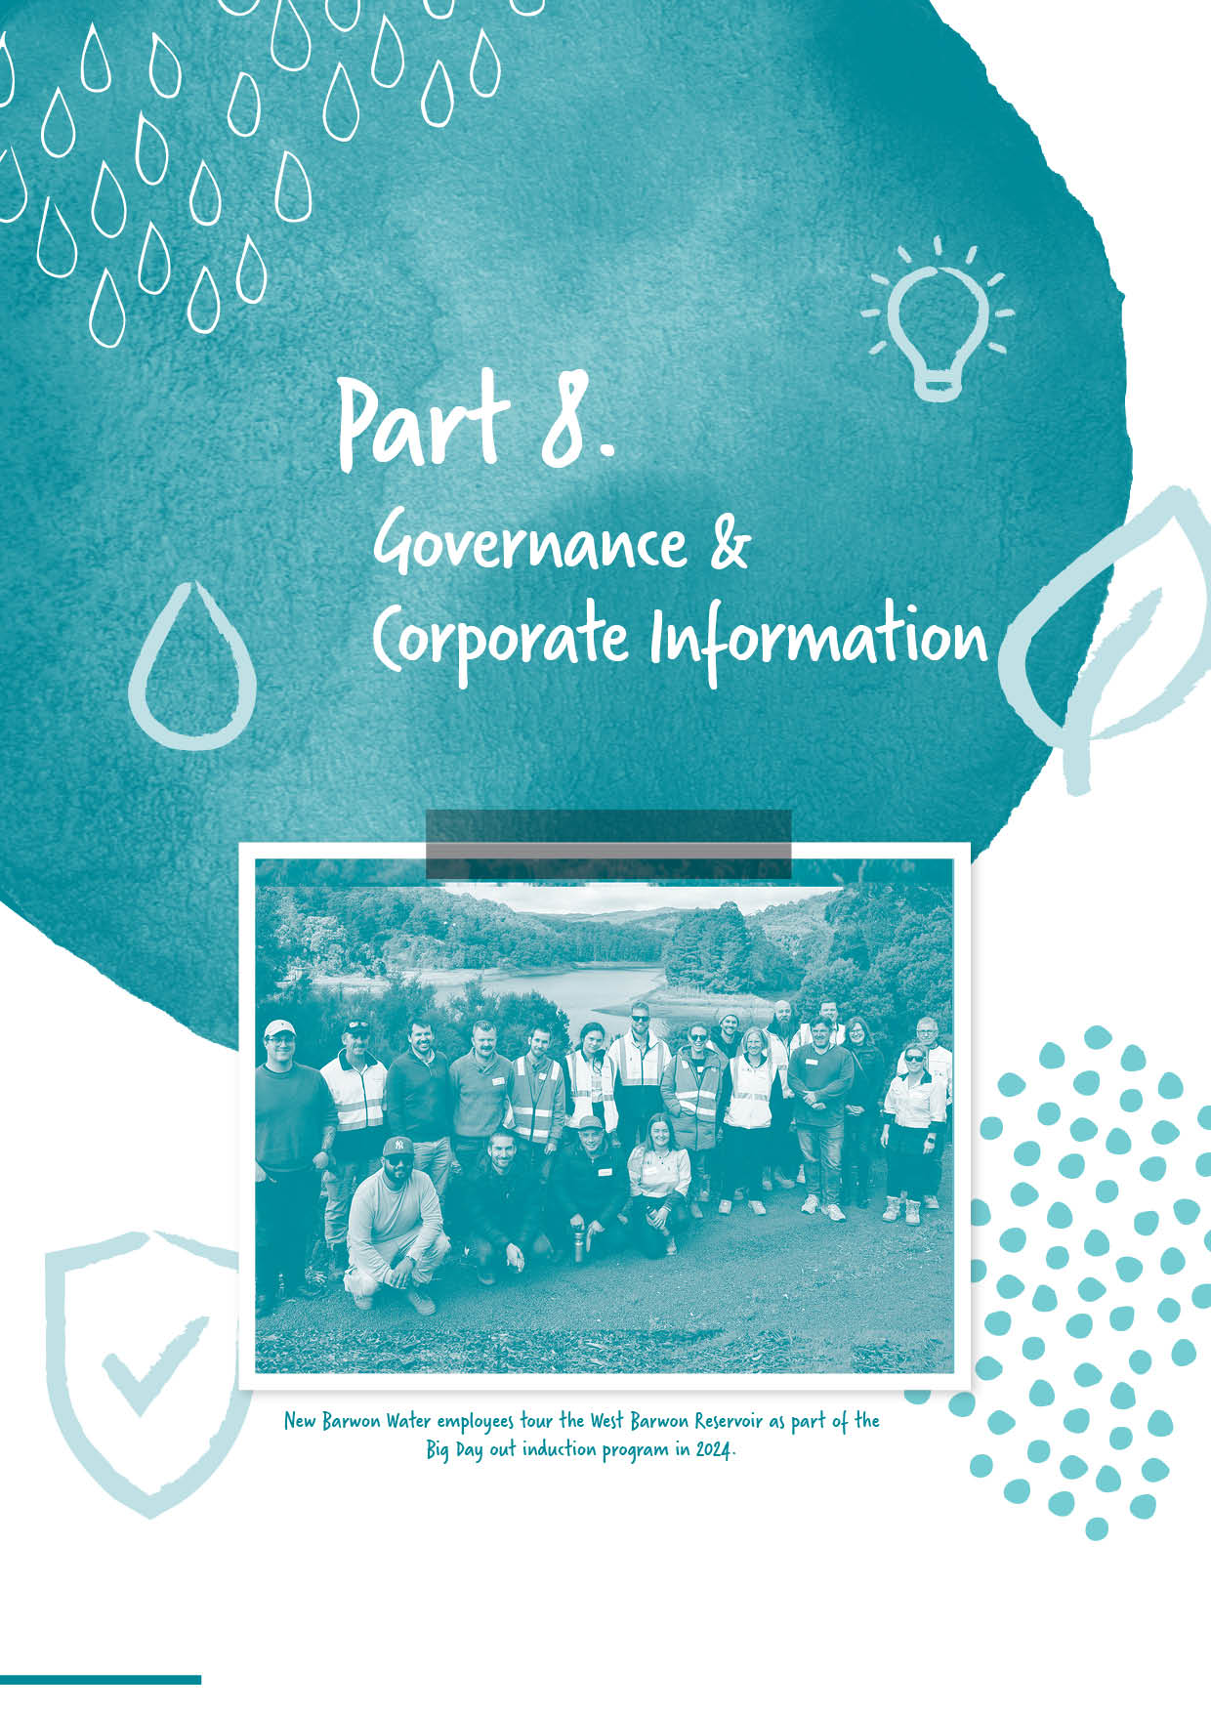

Section divider page
WITH IMAGE

Part 8.
Governance and Corporate information

Organisational structure
As at 30 June 2024

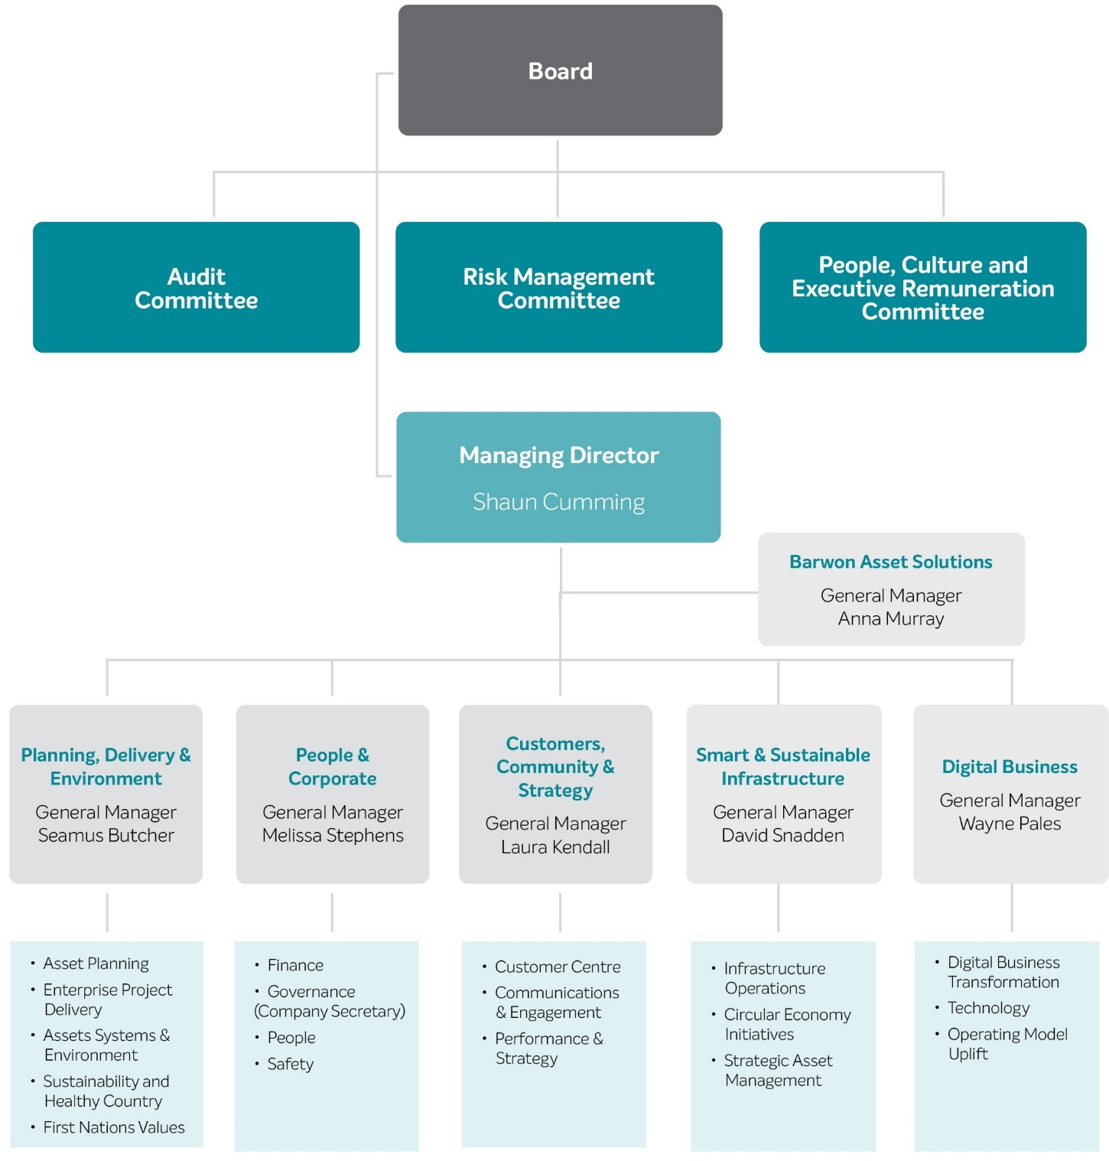

Role of the Board
The Board is responsible for the overall corporate governance of Barwon Water, which includes overseeing strategic direction, establishing performance goals for management and monitoring their achievement.
The Board has a governance framework to ensure compliance with the legal and policy requirements of the Victorian Government, including the Water Act 1989 (Vic), the Public Administration Act 2004 (Vic) and the Financial Management Act 1994 (Vic).
Board composition
The Board comprises a non-executive Chair, eight non-executive directors and a Managing Director. The non-executive Chair and non-executive directors are appointed by the Minister for Water.
The Managing Director is appointed by the Board, in accordance with the Water Act 1989 (Vic).
Board meetings
Board meetings are scheduled 8 times a year with additional meetings being convened as circumstances warrant. Minutes of meetings record Board decisions.
The Managing Director and Executive Leadership Team attend Board meetings. The Company Secretary assists the Board in the conduct of company affairs and advises the Board about their duties and other governance matters.
Board committees
The Board has established a number of committees to provide strategic guidance and assist it in the discharge of its responsibilities. Committee membership is determined by the Board and reviewed at least every two years. Each of the committees is chaired by a non-executive director selected by the Board.

There are currently three committees:
Audit
Risk Management
People, Culture and Executive Remuneration.
Each Board committee has its own charter and reports to the Board after it meets.
Audit Committee
The Audit Committee comprises a non-executive Chair and four non- executive directors. Meetings are held three times per year and at other times, as requested by a member of the committee or the internal or external auditor. The committee liaises with the internal and external auditors to evaluate the adequacy and effectiveness of the overall governance framework.
The Audit Committee members/directors for 2023-24 were:
Jason Kambovski (Chair) from
1 January 2024
Ann Lansberry
Jodie Leonard from 1 January 2024
Peta Maddy ceased as Chair from 31 December 2023
Des Powell
John Gavens ceased 30 September 2024
Bernard Walsh ceased 30 September 2024.

Risk Management Committee
The Risk Management Committee comprises a non-executive Chair and five non-executive directors. Meetings are held three times per year and at any other time, as requested by a member of the committee. The committee takes a lead role in overseeing risk management across the organisation, making sure that risks are identified and adequately addressed by management.

The Risk Management Committee members/directors for 2023-24 were:
Peta Maddy (Chair) from
1 January 2024
Chris Chesterfield from
1 January 2024
Nik Devidas
Jason Kambovski from
1 January 2024
Ann Lansberry ceased as Chair from 31 December 2023
Jo Plummer
Elaine Carbines ceased 30 September 2023.

People, Culture and Executive Remuneration Committee
The People, Culture and Executive Remuneration Committee comprises a non-executive Chair and four non-executive directors. The committee assists the Board to drive a diverse, values- based, high-performing workforce, which supports Barwon Water’s objectives as defined in the organisation’s Strategy 2030. The committee also oversees Barwon Water’s executive employment and remuneration practices, including compliance with government expectations, guidance and directives.
The People, Culture and Executive Remuneration members/directors in 2023–24 were:
Jo Plummer (Chair)
Chris Chesterfield from 1 January 2024
Corrina Eccles
Jodie Leonard from 1 January 2024
Des Powell
Elaine Carbines ceased 30 September 2023.

Barwon Asset Solutions Board
Barwon Asset Solutions is a wholly owned subsidiary of Barwon Water.
The Barwon Asset Solutions (BAS) Board and its Audit and Risk Sub-committee are responsible for ensuring the company fulfills its functions effectively and complies with its governance framework, including compliance with the Corporations Act 2001 (Cth).
The Board presides over all significant strategic, commercial, regulatory, financial and risk-focused elements of BAS. It comprises of four non-executive directors, drawn from Barwon Water’s Board, one executive director, as well as the Managing Director, who performs this role in addition to being the Managing Director of Barwon Water.
The Barwon Asset Solutions Directors for 2023-24 were:
Peta Maddy (Chair)
Nik Devidas (Audit and Risk Committee Chair)
Jason Kambovski from
1 January 2024
Jo Plummer
Shaun Cumming
(Managing Director)
Anna Murray (Executive Director) from 8 March 2024
Bernard Walsh ceased
30 September 2023.

Integrity Framework
The Board’s Integrity Framework consolidates the key standards of conduct and accountabilities that apply to directors at Barwon Water. The key principles of the Integrity Framework include:
Obligations: the Board acts in accordance with its obligations and good public sector governance practices
Public interest: the Board acts in the public interest. Board members comply with the required standards of integrity.
They place the public interest above their own interests when carrying out their official duties
Culture of integrity: the Board models and fosters a culture of integrity. Board members, employees and external stakeholders are supported to raise integrity issues.

Performance evaluation
The Board has established a formal process to review its own performance, as well as that of its committees and individual directors. This process is consistent with the Governance Guidelines issued by DEECA.
Independent advice
Individual directors have access to independent advice from a range of services.
Director’s Code of Conduct
Directors on the Board of Barwon Water are public officials under section 4 of the Public Administration Act 2004. Section 61 of the Act requires that the Victorian Public Sector Commission must prepare and issue codes of conduct based on the public sector values. The Code of Conduct for Directors of Victorian Public Entities is issued to promote adherence to public sector values by the directors of all Victorian public entities. The code expresses the public sector values in terms that are most relevant to the special role and duties of directors. At the same time, it is based on the same set of values (the public sector values) that apply to all public officials, including all employees of Barwon Water.
Board Directors as of 30 June 2024
Jo Plummer
Chair
MBA, FAICD
Appointed to Board: October 2015
With a portfolio of roles, Jo is an experienced Board Chair. Pertinent to the water industry, she first served as non-executive Director for Central
Highlands Water over a four-year term before her appointment to the Barwon Water Chair role in October 2015.
Notably, she was appointed by her peers to Board Chair for the Victorian Water Industry Association in October 2017 until May 2022.
Additionally, Jo's current portfolio includes:
Fellow and Faculty member of the Australian Institute of Company Directors
Director – Barwon Asset Solutions
Chair – Country Fire Authority
Out of the Box Executive - Board Effectiveness/Performance Evaluation & Strategy Facilitation.

She is a highly experienced business strategist and has worked across large commercial corporate, small to medium enterprise, government and not-for-profit environments. Jo is an expert in delivering integrated contemporary Environment, Social, Governance and commercially savvy outcomes to enable organisations to perform at their optimum and achieve outcomes beyond their purpose and value proposition.
Shaun Cumming
Managing Director
BSc BEng MBA GAICD
Appointed October 2023
Over a 20-year career in the water industry, Shaun is committed to making a positive impact to the community and environment in a collaborative, commercial and creative way. Shaun has worked in leadership roles across the public and private sectors and is currently a member of the Water Services Association of Australia Board and Deakin Engineering Advisory Board.
Shaun holds a Bachelor of Science, Bachelor of Engineering, Master of Business Administration and is a Graduate of the Australian Institute of Company Directors.

Ann Lansberry
MEng, DipBA, GAICD
Appointed to Board: October 2017
Ann is a experienced consultant specialising in building community capacity who works for the Traditional Owners the Dja Dja Wurrung.
She has a background in Water Operations, Business Management and Risk management
She holds a Master of Engineering (Chemical Engineering), a Diploma in Business Administration, a Graduate Certificate of Cybersecurity and is a Graduate of the Australian Institute of Company Directors.
Corrina Eccles
Appointed to Board: October 2019
Corrina Eccles, Wadawurrung Woman, lives on Wadawurrung Country, has 25 years of employment experience in Aboriginal organisations and community engagement, and advocacy for Country and First Nations People, recognition and self-determination. She has contributed to various advisory and committee groups including representation on many Boards in the region.
Corrina has undertaken board governance training and brings Aboriginal cultural knowledge, perspective and values relating to water, country and community.
Des Powell
BEcPol, GAICD
Appointed to Board: October 2017
Prior to his appointment to the Barwon Water Board, Des was a Director of Grampians Wimmera Mallee Water Corporation (GWM Water) from October 2015 to September 2017.
Des is currently a Director of Ports Victoria and a Member of the Victorian Skills Authority Advisory Board.
He holds a Bachelor of Economics and Politics and is a Graduate of the Australian Institute of Company Directors.

Peta Maddy
BEng(ChemEng)(Hons), BSc(PharmTox), GAICD
Appointed to Board: October 2021
Peta has more than 25 years of experience in the water and natural resources industries, including ten years in governance roles. Peta is a Commissioner at the Victorian Environmental Water Holder and an independent member of the Audit and Risk Committee for Surf Coast Shire Council.
She has held previous non-executive director roles at Southern Rural Water (Chair Asset Governance Committee) and Grampians Wimmera Mallee Water (Chair Water Resources Committee). She is a past President of the Victorian branch of the Australian Water Association, was a council member of the Victorian Catchment Management Council and chaired the inter- departmental reference group for the Victorian Rural Drainage Strategy. Peta has a Bachelor of Engineering (Chemical) with Honours, a Bachelor of Science (Pharmacology and Toxicology) and is a graduate of the Australian Institute of Company Directors.
Nik Devidas
BBus (BusInfoSys), GAICD
Appointed to Board: October 2021
Nik Devidas is an entrepreneurial leader with extensive experience in technology and cyber security across a broad range of industries. He co-founded and served as Managing Director of Rock IT, established in 2003, a globally ranked managed service provider that helps businesses develop cost-effective, scalable information technology systems without compromising security or performance. Rock IT was acquired in 2023. In the same year, he founded 4walls Cyber Advisory, aiming to simplify cyber resilience by providing comprehensive, easy-to-understand cyber security solutions.
Nik serves on the Board of Directors for both Barwon Water and Barwon Asset Solutions.
In 2013, he was recognised in the MSPmentor 250 List, which identifies the world’s leading managed services provider executives, entrepreneurs, and experts.
Nik holds a Bachelor of Business (Business Information Systems) from RMIT University and is a graduate of the Australian Institute of Company Directors.
Jodie Leonard
BBus FAICD. Member of Chief Executive Women
Appointed to Board: October 2023
Jodie is an experienced Non‐Executive Director of listed, government and high growth companies.
Her portfolio focuses on scaling businesses and digital transformation to drive better customer experiences.
She is currently a Non-Executive Director of Pacific Smiles Group (ASX:PSQ), Barwon Water Corporation and Regis Aged Care.
Jodie previously served on the board of the Great Ocean Road Coast & Parks Authority, RACV, Flexigroup, BWX, Beyond Bank Australia, Racing Victoria and Kinetic Superannuation.
Chris Chesterfield
Appointed to Board: October 2023
Chris is a water sector veteran of over 35 years and is nationally recognized for his leadership in waterway and urban water management and for his contribution to establishing Melbourne as a world leader in water sensitive urban design.
Chris is currently a Professor of Practice at Monash Sustainable Development Institute with a focus on water sector governance and leadership.
He has contributed to advancing water and urban planning practice through a number of recent roles, including as chair of several Ministerial advisory committees that have led to significant planning and legislative reforms in Victoria.
In 2022, Chris received the Paul Jerome award from the Victorian Planning and Environmental Law Association in recognition of his contribution to the sustainable development of cities over the last two decades.
Chris was a Commissioner and the Chairperson of the Victorian Environmental Water Holder until 2023 and in 2019 was appointed by the Minister for Water to chair the Birrarung Council, a bicultural statutory body established under the Yarra River Protection Act (Willip-gin Birrarung murron 2017) as the ‘voice for the Yarra River’.

Jason Kambovski
BCom, LLB, GAICD
Appointed to Board: October 2023
Jason has more than 28 years’ experience in the Financial Services sector, including over 20 years working in the Australian Banking industry covering multiple sectors.
He is currently Westpac Institutional Bank's Global Head of Public Sector and leads a team of specialised banking professionals who service the needs of Commonwealth, State/Territory and Local Governments, including State-Owned Corporations and Government Business Enterprises. Whilst his role is principally focused on the Australasian market, Jason also covers all of Westpac's international

Public Sector activities. Jason has previously worked in the Trustee and Chartered Accounting sectors.
Jason is also a Director for the Board of the National Trust of Australia (Victoria).
Prior to joining the Board of Barwon Water, he was most recently a Non-Executive Director and Deputy Chair of South East Water, Chair of the Finance Assurance and Risk Management Committee, and a Director of Iota Services Pty Ltd. He has previously been a Non-Executive Director and Chair of the Finance and Audit Committee of Lower Murray Urban and Rural Water Authority.

2023–24 Board and committees of the Board attendance
Director | Board  meetings | Audit Committee meetings | Risk Management Committee meetings | People, Culture  & Executive Remuneration Committee meetings | BAS Board meetings | BAS Audit  and Risk Management Committee meetings
J Plummer (Chair)  Term continuing | 8 | 4* | 3 | 2 | 6 | 5
C Chesterfield  (commenced directorship 1/10/23 | 6 |  | 2 | 1
N Devidas  Term continuing | 8 | 5* | 4 |  | 6 | 5
C Eccles  Term continuing | 8 |  |  | 1
J Kambovski  (commenced directorship 1/10/23) | 6 | 2 | 2 |  | 2 | 2
A Lansberry  Term continuing | 5 | 4 | 4
J Leonard  (commenced directorship 1/10/23 | 6 | 2
D Powell  Term continuing | 8 | 5 |  | 2 | 1*
P Maddy  Term continuing | 7 | 4 | 3 |  | 6 | 5
S Cumming  Term continuing | 7 | 3 | 3 | 2 | 5 | 4
E Carbines  (ceased directorship 30/9/23) | 2 | 1 |  | 1 |  | 1*
J Gavens  (ceased directorship 30/9/23) | 2 | 2 |  |  | 1* | 1*
B Walsh  (ceased directorship 30/9/23) | 2 | 2 | 1* | 1 | 3 | 2
Notes: * Only required for a portion of the meeting

Workforce data

People Strategy
Since the creation of Strategy 2030, we have witnessed how swiftly and dramatically our world can change. From the unprecedented challenges of a global pandemic to the relentless impacts of droughts, bushfires, and floods, these events have highlighted the importance of resilience and adaptability in everything we do.
Reflecting on the past, we have much to be proud of. We have navigated through uncertainties, achieved significant milestones, and have continuously strived to deliver on the vision we set forth for Barwon Water – Regional Prosperity. We have taken stock of our achievements and identified areas for further progress as we continue to deliver on the ambitious goals we set for Barwon Water. Our refreshed Strategy 2030 reaffirms our commitment to affordability, water security, environmental stewardship, and reliable services.
Central to the success of Strategy 2030 are our people – the heart and soul of Barwon Water Group. We are making our most significant investment in our people yet, ensuring that we have the talent and capabilities to meet our Strategy 2030 aspirations. To sustain and accelerate this positive change, we are proud to introduce our People Strategy. This strategy is designed to empower our workforce to thrive, engage, and adapt to future challenges. It focuses on five key pillars that are essential to realising our Strategy 2030 goals.
These pillars will guide us in fostering an environment where every team member feels valued, supported, and motivated to contribute their best. Together, we will continue to push boundaries, embrace challenges, and achieve regional prosperity.
The People Strategy is our roadmap for enabling an engaged, inclusive and thriving workplace at Barwon Water and Barwon Asset Solutions. Through this, we are committed to developing
the four “How We Work” elements of Strategy 2030: ‘perform at our best,’ ‘listen and learn,’ ‘partner strategically,’ and ‘find the way.’ Central to this journey is creating a constructive culture, where we support our people in meaningful ways. We inspire each other to achieve ambitious goals, to grow and realise our full potential and to cultivate genuine, caring relationships. In 2018 and 2022, we took a close look and measured our culture at Barwon Water, and we're thrilled to see a positive transformation. We also measured our culture at Barwon Asset Solutions in 2022. As we look ahead, we plan to conduct our next cultural survey in 2026, and we will refine our strategy based on those insights.
Our People Strategy is also designed to keep us progressing in delivering safe and secure water; innovative and reliable services; a healthier environment, and customer value. These are the four “What We Do” elements of Strategy 2030. As we face challenges and opportunities including digital disruption, growing customer expectations, a transition to strategic asset management and generating new sources of revenue, we must ensure we have the right people, with the right skills, at the right time to deliver. Our People Strategy is designed to enable our organisation wide goals through supporting our people to thrive and grow at Barwon Water.
Scholarship program and industry-based internships
Since we started this program, we have provided financial support and paid internships to 17 students. To better support diversity in applicants and disciplines, the scholarship offered each year is allocated specifically to women candidates coming from a science, technology, engineering or mathematics background. This has enabled us to move from a scholarship program largely dominated by men to a gender-balanced one.
Graduate Program
Our two-year graduate program gives graduates an opportunity to perform multiple roles within the organisation through planned rotations. This helps them gain skills and experience in different aspects of the business, supports them to tackle real-world problems, gives them access to a structured leadership development program, and opens opportunities to network more broadly in the water industry. The graduate program forms part of our holistic approach to strategic workforce planning.
Traineeship program
Our traineeship program continues to provide access as an early-career pathway from target communities by providing appropriate education, work, training and support, and achievement of a nationally recognised qualification.
Barwon Asset Solutions also have their own Apprenticeship Program providing career pathways in civil maintenance within the region.
In partnership with Gforce, we have supported 72 trainees in our dynamic program since 2016, which also involves working with Wan-Yaari Aboriginal Consultancy Services. Six trainees joined the 2023 intake: two women – both of whom took up traineeships that traditionally attracted more men – as well as one trainee who identified as Aboriginal. Of those 2023 trainees, all have obtained employment with us. The traineeship program plays an important role in helping us support diversity across cultural and socio- economic demographics, in line with Strategy 2030, and has also helped us attract women trainees into roles that have previously been dominated by men: in particular operations, and construction. The program provides us with a pipeline of skilled resources to support operational needs.

Belonging @ Barwon Water Inclusion Action Plan
We have been working towards creating a diverse and inclusive working environment with a workforce that reflects the community that we serve since we introduced our first diversity and inclusion plan in 2016.
Our current plan, the Belonging @ Barwon Water Inclusion Action Plan 2022–25, includes four key focus areas to help us achieve this goal: Lead, Adjust, Recruit and Promote. Our ‘Belonging @ Barwon Water’ Inclusion

Action Plan provides an outline of the path we will follow to improve diversity and inclusion at Barwon Water and meet the objectives of our Strategy 2030.
The action plan guides our approach to inclusion and diversity with defined targets for gender balance at senior leader level and across the organisation, as well as Aboriginal and Torres Strait Islander inclusion, disability, and cultural and linguistic diversity. The identified actions are also intended to drive inclusion more

broadly by recognising and celebrating difference, while fostering a true sense of belonging for each individual working at Barwon Water.
Annually, we complete a voluntary survey of all employees to collect diversity and inclusion data (see 2023–24 results below). The survey results provide workforce demographic data, as well as qualitative information relating to employees’ sense of belonging. This helps guide our actions for the next 12 months and measures our performance against our targets.

Diversity metrics table
Belonging @ Barwon Water Diversity Metrics  – Focus Areas | Target – June 2024 | Actual progress at  June 2024
Gender balance (Senior Leadership Team) | 40% men  40% women  20% flexible | 40% men  40% women  20% flexible
Gender balance (Organisation) | 60% men  40% women | 58.8% men  41.2% women
Aboriginal & Torres Strait Islander inclusion | 3% Aboriginal and/or Torres Strait islander  peoples employed | 2%
Cultural and linguistic diversity (language other than English or born overseas) | 20% cultural and linguistic diversity employed across the organisation | 13%
People with a disability | 12.5% of employees identify as living with a disability | 7%
Notes: Metrics around Aboriginal & Torres Strait Islander, Cultural and linguistic diverse and people with a disability are reliant on staff identifying through the annual VPSC People Matter Survey.
Prevention of bullying, Equal Opportunity (EEO) and harassment prevention policies

We have an EEO policy, as well as policies for the prevention of bullying and harassment. These policies detail our commitment to addressing bullying, promoting equality of opportunity and maintaining a workplace free of all forms of harassment and discrimination. They also highlight the responsibility of each employee to ensure their behaviour reflects our policy requirements, noting that behaviour contrary to the policies may be subject to disciplinary action, in accordance with our Performance Counselling Policy.
To help improve gender equality, our Belonging @ Barwon Water Inclusion Action Plan 2022–25 incorporates our Gender Equity Action Plan as required under the Gender Equality Act 2020. We measure the effectiveness of these initiatives through key indicators including pay equity, segmentation across departments, and the uptake of flexible working arrangements across all genders.
To provide a safe workplace free from discrimination and harassment, we implemented the following measures:
we maintained policies and procedures that establish clear expectations of behaviour in the workplace and processes for addressing unacceptable behaviours
we continued supporting the #IStandForRespect pledge, demonstrating our commitment to addressing sexual and sex-based harassment, and maintaining a workplace safe for everyone
We are making progress in our gender pay gap, moving down from 11.5% 2021 to 7.8% 2023
we delivered annual training to all employees to ensure they understand the behavioural expectations of Barwon Water including EEO, anti-bullying, harassment and discrimination training, including refresher training
we promoted and celebrated diversity and inclusion events throughout the year to highlight the value of diverse experiences and backgrounds in the workplace
we focused on constructive behaviours and competency uplift as supported by the LEAD2030 and DEVELOP2030 programs
our trained contact officers provided ongoing support to employees about their rights and obligations, as they apply to the prevention of bullying, harassment and discrimination.

Public sector values and employment principles
Barwon Water has policies and practices that are consistent with the Victorian Public Sector Commission (VPSC) employment standards and deliver fair treatment, career opportunities and the early resolution of workplace issues.
We advise our employees on a range of matters including avoiding conflicts of interests, responding to offers of gifts and dealing with misconduct.
We comply with the Public Administration Act 2004 by selecting employees based on ability, knowledge and skills in a fair and open process that ensures equal opportunity. Promotion and advancement of qualified individuals within Barwon Water is based on these same principles. Employees receive fair and equitable treatment and human rights, as set out in the Charter of Human Rights and Responsibilities Act 2006.
In 2023–24, we employed five people in our Talent Development and Inclusion team to provide high-quality, responsive and professional recruitment and selection services, as well as advice and support for managers involved in recruitment and selection processes.

Compliance with the Disability Act
The Disability Act 2006 reaffirms and strengthens the rights of people with a disability and recognises that these rights must be supported across the government sector and within the community.
Our All Abilities Action Plan 2022–25 is a strategic plan that helps us remove barriers preventing people with a disability from using our goods, services and facilities, and from gaining and keeping employment. It also aims to raise awareness of disabilities, which are both invisible and visible to others.
This plan is vital in helping us promote inclusion and participation in the community and achieve changes in attitudes and practices that may result in discrimination. In turn, we believe it will help us drive a safe culture where anyone who chooses to disclose a disability will be treated the same as they were before they disclosed.
Monitoring of activity and measuring outcomes is included as part of the Belonging @ Barwon Water Inclusion Action Plan.

Gifts, Benefits and Hospitality Policy
The Gifts, Benefits and Hospitality Policy establishes standards and procedures for responding to gift, benefit and hospitality offers, as well as offering them, and is consistent with the DEECA model policy. The policy is designed to help employees and directors to avoid conflicts of interest and maintain high levels of integrity and public trust. The policy discourages gift offers and states offers must never be accepted unless there is clear justification, in line with approved conditions in the policy. We continued to deliver training designed to educate all employees about their responsibilities according to the policy, including refresher training.
As part of the training, we made it clear that:
directors and employees are responsible for ensuring their own conduct meets the required standards of integrity
public interest must be placed above own interest when carrying out official duties
all gift offers must be declared in accordance with the policy and prohibited gifts refused.
For further information about our Gifts, Benefits and Hospitality Policy, visit barwonwater.vic.gov.au

Barwon Water employment statistics 2023–24
 |  |  | 2024
 | Casual | Part-time | Full-time | Total (Headcount)  2024 | Total (%)  2024 | FTE 2024
Gender
Women | 1 | 56 | 103 | 160 | 41 | 140.41
Men | 2 | 3 | 223 | 228 | 59 | 224.46
Self-described | 0 | 0 | 0 | 0 | 0 | 0
Prefer not to answer | 0 | 0 | 0 | 0 | 0 | 0
Age
15–24 | 3 | 0 | 8 | 11 | 3 | 7.11
25–34 | 0 | 7 | 70 | 77 | 20 | 74.08
35–44 | 0 | 26 | 97 | 123 | 32 | 115
45–54 | 0 | 14 | 102 | 116 | 30 | 112.03
55–64 | 0 | 11 | 44 | 55 | 14 | 51.26
65+ | 0 | 1 | 5 | 6 | 2 | 5.39
TOTAL | 3 | 59 | 326 | 388 | 100 | 364.87

Previous Barwon Water employment statistics 2022–23
 |  |  | 2023
 | Casual | Part-time | Full-time | Total (Headcount)  2023 | Total (%)  2023 | FTE  2023
Gender
Women | 0 | 54 | 94 | 148 | 41 | 130.4
Men | 4 | 6 | 203 | 213 | 59 | 207.73
Self-described | 0 | 0 | 0 | 0 | 0 | 0
Prefer not to answer | 0 | 0 | 0 | 0 | 0 | 0
Age
15–24 | 4 | 0 | 6 | 10 | 3 | 6.11
25–34 | 0 | 10 | 56 | 66 | 18 | 61.84
35–44 | 0 | 25 | 88 | 113 | 31 | 106.4
45–54 | 0 | 14 | 91 | 105 | 29 | 100.58
55–64 | 0 | 9 | 49 | 58 | 16 | 54.79
65+ | 0 | 2 | 7 | 9 | 2 | 8.42
TOTAL | 4 | 60 | 297 | 361 | 100 | 338.13

ANZSCO – 2024 ANZSCO – 2023
ANZSCO Occupation Classification | Headcount |  | ANZSCO Occupation Classification | Headcount
Managers | 25 |  | Managers | 22
Professionals | 208 |  | Professionals | 181
Technicians and Trade Workers | 45 |  | Technicians and Trade Workers | 41
Clerical and Administrative Workers | 70 |  | Clerical and Administrative Workers | 72
Machinery Operators and Drivers | 40 |  | Machinery Operators and Drivers | 45
TOTAL | 388 |  | TOTAL | 361

Senior Executive Service contracts for the Barwon Water Group in 2023–24 (broken down by gender)
 | All |  | Women |  |  | Men |  |  |  |  | Self-described
Class | Number | Variation | Number | Variation |  |  | Number | Variation |  | Number |  | Variation
SES-3 | 1 | 0 | 0 |  | -1 | 1 |  |  | 1 |  | 0 |  | 0
SES-2 | 8 | 1 | 3 |  | 1 | 5 |  |  | 1 |  | 0 |  | 0
SES-1 | 17 | -1 | 11 |  | -1 | 6 |  |  | 0 |  | 0 |  | 0
TOTAL | 26 | -2 | 14 |  | 1 | 12 |  |  | -2 |  | 0 |  | 0

Reconciliation of executive numbers for the Barwon Water Group
 |  | 2024 | 2023
 | Executives (Financial Statement note x) | 22 | 26
 | Accountable officer | 1 | 1
Less | Separations | -3 | -4
 | Total executive numbers at 30 June | 20 | 23

Health, Safety and Wellbeing (HSW)

HSW management system
We implemented a range of processes and initiatives as part of the 2023–24 HSW management plan to deliver our Beyond Zero Safety Strategy, including:
a detailed review of processes and procedures against Victorian Occupational Health and Safety (OHS) legislation
monthly newsletter that covers safety performance trends, HSW topics relevant to the workplace and upcoming wellbeing events
roll-out of the Contractor Safety Management Framework and the Rapid Global software solution to Barwon Water Group employees and our contractors, to improve how contractor safety is managed.
completing a range of risk assessments including plant and equipment, noise and public safety, with the process including extensive consultation with health and safety representatives
a fit testing program for personnel required to use respiratory protective equipment
maintenance of our lead-paint registers for older assets, which records lead concentration and level of risk exposure associated with its presence in assets
maintenance of our asbestos register, using the AIR System (Asbestos Identification and Rating System), developed by the Victorian Asbestos Eradication Agency
coordinating working groups, including health and safety representatives, to effectively consult and manage health and safety risks and controls impacting the whole organisation.

Health and wellbeing program
As part of our health and wellbeing program, we delivered a range of initiatives in 2023–24, including:
training more employees to become Mental Health First Aiders (MHFA)
coordinating monthly Mental Health First Aider (MHFA) forums and used the discussions to identify trends and inform the health and wellbeing program
a refresh of The Resilience Project and encouraged employees to follow a simple message – Gratitude, Empathy and Mindfulness (GEM) – in the workplace and at home
encouraging employees to donate to Life Blood
a range of webinars covering topics including nutrition, sleep hygiene and mental health
encouraging employees to become physically active with programs such as our weekly yoga program
offering our employees vaccinations and health monitoring, such as flu vaccination and skin checks
recognising awareness events focused on men’s health, diabetes, breast cancer and women’s health
promoting RU OK? Day, which included a topic-specific toolbox
encouraging employees to participate in The Push Up Challenge, which raises mental health awareness through exercise
supporting employees with ergonomics and desk set-up to help prevent posture-related injuries in the office, in vehicles and at home
assessing individuals and provided specialised office equipment to prevent repetitive use and ergonomic- related injuries
engaging local physiotherapists to review and treat employees pre-claim
providing support to employees affected by non-work-related injuries and illness
using the intranet, internal media and articles in the monthly HSW newsletter to promote awareness of health and wellbeing topics including fatigue, sleep, stress, exercise and health checks.

HSW performance
In 2023–24 at Barwon Water there were zero injuries resulting in a WorkCover claim.
Barwon Water Occupational Health and Safety performance
Measure | KPI | 2023-24 | 2022–23 |  |  | 2021–22 | 2020–21 | 2019–20 |  | 2018–19_
Injuries | First aid injuries | 11 |  | 11 | 13 |  | 9 |  | 14 |  | 11
 | Medical treatment only injuries | 1 |  | 0 | 1 |  | 0 |  | 1 |  | 8
 | Lost time injuries | 0 |  | 0 | 0 |  | 0 |  | 1 |  | 1
 | Total injuries | 12 |  | 11 | 14 |  | 9 |  | 16 |  | 20
Incidents | Number of incidents | 24 |  | 38 | 34 |  | 54 |  | 59 |  | 130
 | Rate per 100 FTE | 6.6 |  | 11.9 | 9.4 |  | 16.7 |  | 18.1 |  | 39.5
Claims | Number of standard claims | 0 |  | 0 | 0 |  | 0 |  | 2 |  | 5
 | Number of time lost claims | 0 |  | 0 | 0 |  | 0 |  | 1 |  | 1
 | Rate per 100 FTE | 0 |  | 0 | 0 |  | 0 |  | 0.92 |  | 1.82
 | Average cost per standard claim* | N/A |  | N/A | N/A |  | N/A |  | $1,959 |  | $15,341
Risk Management | Number of OHS meetings held | 36 |  | 36 | 32** |  | 30** |  | 36** |  | 1,453
 | Percentage of internal audits/ inspections conducted as planned | 88% |  | 88% | 89% |  | 88% |  | 89% |  | 91.3%
 | Percentage of reported incidents investigated | 95% |  | 95% | 92% |  | 90% |  | 90% |  | 74.6%
Notes:
* There were no claims in 2023-24, 2022–23, 2021–22 and 2021–22.
** The figures are derived from Corporate HSW Committee meetings and numerous Designated Work Group Committee meetings and does not include meetings held at a functional level.

HSW training
HSW training developed and delivered in 2023–24 covered the following topics:

defensive driving
Incident Cause Analysis Method (ICAM) root cause investigation methodology
using respiratory protective equipment
preventing underground service strikes
working at heights
operating elevated work platforms
chemical safety and management
confined space entry
electrical safety
Fatigue
First aid and CPR
machine guarding
mental health.

We have also continued to refine our training data in the
Learning Management System to support our tracking and reporting.

SQE integrated management system

We maintained our integrated management system via our certification to ISO 45001 Occupational Health and Safety, ISO 9001 Quality and ISO 14001 Environmental. Our certification process is externally audited on an annual basis to ensure our obligations are met and any improvements actions are identified and remediated to support our continuous improvement culture. The annual SQE audit report is presented to the Audit Committee.
Emergency management
We continued to strengthen our emergency management capabilities and capacities throughout 2023–24 by continuously improving frameworks, processes, tools and practices.
To support skills development and maintenance, our corporate and operational response teams were made up of a mixture of experienced and developing response personnel.

This year we participated in activities such as:
annual major exercise for our Incident and Crisis management team members – including skills development workshops
site based incident response exercise scenarios and knowledge workshops
Fire Ready Program toolboxes and training
Warden training and general staff evacuation drills, including increasing our pool of Wardens to support flexible ways of working
after action reviews and debriefs for response events, exercises and training, contributing to continuous improvement
deep dive scenario exploration to improve contingency planning.

We continued to conduct our Fire Ready Program over the summer months, improving on safe ways of working for our on-call personnel and those working from home on high fire risk days. We continued to use these processes to support safety and response to other events likely to require hazard monitoring and early warnings, including severe weather, flood and landslide and other community or industry incidents with potential to impact our people and/or ways of working.
We continue to conduct internal and independent audits of our emergency management preparedness, including its application for many specialist areas in the business. We use what we learn from these to contribute to key activity within our annual Emergency Management Uplift program. designed to further improve our emergency management capability and processes.
We also continued to be actively involved in regional and municipal emergency management committees, industry resilience and community of practice forums. We did this to ensure ongoing learning from others and to enhance cooperation and understanding between agencies and communities. This broad range of connectivity also allows us to rapidly understand emerging issues and respond to these proactively to minimise risk to our organisation and the community we serve.
There was no emergency procurement activated in the 2023-24 financial year.
The key agencies that we interact with include Emergency Management Victoria, emergency services, regulators, infrastructure operators, sector networks, local government and community-led emergency planning groups.




Access to information
Privacy and Data Protection

In 2023–24, we continued to comply with the Information Privacy Principles set out under the Privacy and Data Protection Act 2014. Our Customer Charter and Privacy Charter both explicitly refer to our commitment to protecting the privacy of customers and employees. We ensure the information we hold is protected and actively work to prevent any unauthorised access to, or improper use of, customer and employee information. A copy of our Privacy Charter can be viewed at barwonwater.vic.gov.au.
Freedom of Information
The Freedom of Information Act 1982 (the FOI Act) allows the public a right of access to documents held by Barwon Water. The purpose of the FOI Act is to extend, as far as possible, the right of the community to access information held by government departments, local councils, ministers and other bodies subject to the FOI Act.
An applicant has a right to apply for access to documents held by Barwon Water. This comprises documents both created by Barwon Water or supplied to Barwon Water by an external organisation or individual, and may also include maps, drawings, microfiche, photographs, audio recordings, CCTV footage, emails or any written material in hardcopy or electronic form. Information about the type of material produced by Barwon Water is available on our website under the Part II Information Statement.
The Act allows Barwon Water to refuse access, either fully or partially, to certain documents or information.
Examples of documents that may not be accessed include: cabinet documents; some internal working documents; law enforcement documents; documents covered by legal professional privilege, such as legal advice; personal information about other people; and information provided to us in-confidence.
The Freedom of Information (FOI) processing time for requests received is 30 days. However, when external consultation is required under ss29, 29A, 31, 31A, 33, 34 or 35, the processing time automatically reverts to 45 days. Processing time may also be extended by periods of 30 days in consultation with the applicant. With the applicant’s agreement, this may occur any number of times. However, obtaining an applicant’s agreement for an extension cannot occur after the expiry of the timeframe for deciding a request.
If an applicant is not satisfied by a decision made by Barwon Water, under section 49A of the Act they have the right to seek a review by the Office of the Victorian Information Commissioner (OVIC) within 28 days of receiving a decision letter.
An application fee of $32.70 will apply from 1 July 2024.
Access charges may also be payable if the document pool is large and the search for material time consuming. Access to documents can also be obtained through a written request to our Freedom of Information Officer, as detailed in section 17 of the FOI Act.
When making a request under the FOI Act, applicants should ensure requests are in writing and clearly identify the types of material/documents they are seeking.
Requests for documents in the possession of Barwon Water should be addressed to:
Barwon Water Freedom of Information Officer
Mail: PO Box 659, Geelong VIC 3220
Phone: 1300 656 007
Email: info@barwonwater.vic.gov.au
FOI statistics/timelines
During 2023-24, Barwon Water received three FOI requests. One FOI request became valid under S17 of the Act, and we made the one decision within the statutory time period. Of the other two requests, one was withdrawn and the other remains in progress.
The average time taken to finalise the requests in 2023-24 was 21 days from the request being made. No requests were subject to complaint / internal review by OVIC throughout the period.

Further information
Further information regarding the operation and scope of Freedom of Information can be obtained from the FOI Act, regulations made under the FOI Act, and by visiting ovic.vic.gov.au.

The table below outlines the outcome of each of the requests.
FoI Statistics/timeliness
Full access granted | 0
Partial access granted | 1
Withdrawn / Time elapsed | 1
Not proceeded with / FOI incomplete | 0
No documents | 0
Third party consultation by another agency | 0
Outside the Act / publicly available | 0
Not yet finalised | 1

Other information
Other information as required under the Financial Management Act 1994, but not specifically referred to, has been retained by the Accountable Officer and is available to the Minister, Members of Parliament and the public on request.
This information includes:
pecuniary interests of relevant officers
shares held by a senior officer
details of Barwon Water publications
changes to fees and charges
major external reviews carried out on Barwon Water
research and development activities
overseas visits
major promotional, public relations and marketing activities
assessments and measures to improve the occupational health and safety of employees
major sponsorships.

Compliance with the Building Act

As we own or control two government buildings – located at 55–67 Ryrie Street, Geelong and 18 Kadak Place, Breakwater – we are required to include a statement about how these buildings comply with the building and maintenance provisions of the
Building Act 1993.
We require that appropriately qualified consultants and contractors are engaged for all proposed works on land controlled by Barwon Water, and that their work and services comply with current building standards.
All such consultants and contractors are required to have appropriate mechanisms in place to ensure compliance with the building and maintenance provisions of the Building Act 1993, Building Regulations 2018 and the National Construction Code.
In relation to our existing buildings, the Barwon Water Group’s facilities function is responsible for planned maintenance schedules to maintain building assets in accordance with relevant standards and essential safety measure requirements.
We employ an intranet-based work order system for staff to notify the organisation of maintenance and safety issues.
In addition to this, we also conduct routine site inspections and receive security and failure alerts through a variety of automated alarms.

Building Act compliance
Number of major works projects (greater than $50 000) | 0
Number of building permits, occupancy permits, or certificate of final inspection issued in relation to buildings owned by the entity: | 0 building permits  0 occupancy permits  0 certificates of final inspection
Number of emergency orders and building orders issued in relation to buildings: | 0 emergency orders  0 building orders
Number of buildings that have been brought into conformity with building standards during the reporting period: | 0 buildings brought into conformity

Other Acts
Public Interest Disclosures

The Public Interest Disclosures Act 2012 (the Act) enables people to make disclosures about improper conduct by public officers and public bodies. The Act aims to ensure openness and accountability by encouraging people to make disclosures and protecting them when they do.
What is a public interest disclosure?
A public interest disclosure is a complaint of corrupt or improper conduct by a public officer or a public body. Barwon Water is a ‘public body’ for the purposes of the Act.
What is ‘improper or corrupt conduct’?
Improper or corrupt conduct can include one or more of the following:
substantial corrupt conduct
a criminal offence
serious professional misconduct
dishonest performance of public functions
an intentional or reckless breach of public trust
an intentional or reckless misuse of information
substantial mismanagement of public resources
substantial risk to health or safety of a person
substantial risk to the environment
conduct of any person that adversely affects the honest performance by a public officer of their functions
conduct of any person that is intended to adversely affect the effective performance by a public officer of their functions for the benefit of the other person
conduct that is trivial will not constitute improper conduct for the purpose of the Act.

How do I make a public interest disclosure?
You can make a public interest disclosure about Barwon Water, or its Board members, officers or employees, by contacting the Independent Broad-based Anti-corruption Commission (IBAC), the Victorian Inspectorate (VI) or the Victorian Ombudsman (VO) using the contact details provided below. Barwon Water is not able to receive public interest disclosures.
How can I access Barwon Water’s procedures for the protection of persons from detrimental action?
We have established procedures to protect from anyone who has made a public interest disclosure about Barwon Water or its employees from detrimental action, allowing such disclosures to be made without fear of reprisal. You can access our procedures on our website: barwonwater.vic.gov.au.

Contacts
As noted earlier, the Act does not permit us to receive public interest disclosures.
If you wish to make a disclosure about our organisation or our people, please make that disclosure directly to the IBAC, the VI or the VO.
Independent Broad-Based Anti- Corruption Commission (IBAC) Victoria
Level 1, North Tower, 459 Collins Street, Melbourne Victoria 3000 or
IBAC, GPO Box 24234, Melbourne Victoria 3001
Website: ibac.vic.gov.au.
Phone: 1300 735 135
Email: See the website above for the secure email disclosure process, which also provides for anonymous disclosures.
Victorian Inspectorate
Level 8, 565 Bourke Street
Melbourne Victoria 3000
Website: vicinspectorate.vic.gov.au
Phone: 1800 518 197
Email: info@vicinspectorate.vic.gov.au
Victorian Ombudsman
Level 2, 570 Bourke Street
Melbourne Victoria 3000
Website: ombudsman.vic.gov.au
Online form: ombudsman.vic.gov.au/ complaints
Phone: 1800 806 314.

Local Jobs First

The Local Jobs First Act 2003, introduced in August 2018, brings together the Victorian Industry Participation Policy (VIPP) and Major Project Skills Guarantee (MPSG) Policy, which were previously administered separately.
Barwon Water is required to apply the Local Jobs First policy in all projects valued at $3 million or more for metropolitan Melbourne and for statewide projects, or $1 million or more for projects in regional Victoria.
MPSG applies to all construction projects valued at $20 million or more. The MPSG and VIPP guidelines will continue to apply to MPSG-applicable and VIPP applicable project respectively where contracts have been entered prior to 15 August 2018.
Projects commenced – Local Jobs First Standard
During 2023-24, our organisation commenced four Local Jobs First Standard projects totalling $25,810,457.78 (excluding GST). All projects were located in regional Victoria.



The outcomes expected from the implementation of the Local Jobs First policy to these projects where information was provided are as follows:
an average local content commitment of 96 per cent was made
a total of 42.15 jobs – annualised employee equivalent (AEE) – including creation of 3.10 new jobs and retention of 39.05 existing jobs (AEE)
a total of 4.63 positions for apprentices, trainees and cadets, including the creation of 1.34 new apprenticeships, traineeships, and cadets and retention of 3.29 existing apprenticeships, traineeships, and cadets
we commenced two projects that met requirements of the MPSG and committed to less than one apprentice, trainee, and cadet.

Projects completed – Local Jobs First Standard
During 2023-24, our organisation completed four Local Jobs First Standard projects valued at $9,076,183.48 (excluding GST). All projects were located in regional Victoria. The MSPG did not apply to these projects.
The outcomes reported from the implementation of the Local Jobs First policy to these projects where information was provided, were as follows:
an average local content commitment of 92.16 per cent was made
a total of 34.06 jobs (AEE) were committed – 9.59 new jobs were created and 24.47 existing jobs were retained
for a total of 2.4 positions for apprentices, trainees, and cadets were committed and 1.01 new apprenticeships, traineeships, and cadets were created
we retained 1.39 existing apprenticeships, traineeships, and cadets
MPSG applicable projects provided zero hours to apprentices, trainees, and cadets and engaged no apprentices, trainees and cadets (note there were no MPSG projects completed during the reporting period).

During 2023-24, there were 24 small and medium-sized businesses that prepared a VIPP Plan or LIDP for contracts, with none prepared by large businesses.
Projects commenced - Local Jobs First Strategic
During 2023-24, we commenced no Local Jobs First Strategic projects.

Social Procurement
Our first Social Procurement Strategy was approved by the Department of Treasury and Finance in March 2020. The Strategy was updated most recently in March 2024 and has prioritised the following five objectives from the Victorian Government’s Social Procurement Framework:
opportunities for Victorian Aboriginal people
opportunities for Victorians with disability
women’s equality and safety
sustainable Victorian regions
implementation of the Climate Change Policy objectives.
The Social Procurement Strategy has a range of social procurement priority actions including procurement opportunities, employee capability development and supplier engagement. During 2023-24 we achieved the following:
we spent $2,333,489 (incl GST) with Social Benefit suppliers. This is broken into the following categories, noting that some spend sits across multiple categories:
$2,258,332 with Victorian social enterprises
$335,281 with Victorian social enterprises (disability)
$39,913 with Victorian social enterprises (priority job seekers)
$28,865 with Victorian Aboriginal businesses
we spent $340,527 (incl GST) with First Nations organisations
we continued our nursery services contract with genU, an accredited Australian Disability Enterprise that provides direct economic and social benefit through employment and training of employees with a disability
The contract provides for ongoing full- time employment and training of 4 employees and 16 supported employees. It has also assisted genU to successfully champion five supported employees into open employment during 2023-24
we were an ongoing signatory to GROW Compact, which has a primary objective of addressing long-term, entrenched, placed-based disadvantage in the G21 region
we are a Kinaway Platinum Partner, which enables us to secure the services of a relationship manager who assists with cultural awareness education and training, provides advice on our RAP development and informs us about new Victorian Aboriginal suppliers.
We have also commenced planning on an employment in construction for priority jobseekers initiative. The pilot program will launch in 2024 and place priority jobseekers into Barwon Water and BAS construction projects to provide training, experience and pathways into employment.
Modern Slavery
The first Barwon Water Modern Slavery Statement was approved by the Board in December 2020; this statement was developed in accordance with the Modern Slavery Act 2018.
We are committed to operating our business lawfully and ethically, and working with suppliers that are aligned with our values, as they apply to corporate responsibility, environmental and workplace safety protection, and staff inclusion and diversity. We require our suppliers to operate in accordance with all modern slavery laws.

We are a foundation member of the Water Industry Procurement Working Group (previously known as the VicWater Social Procurement Working Group) and an active member of the Water Services Association of Australia (WSAA) Modern Slavery and Supplier Relationships community of practice. These groups share information across the sector to enhance the sector’s ability to achieve positive Environmental, Social and Governance (ESG) outcomes.
During 2023-24 we have been working with WSAA, a national water sector consortium and a technology provider to assess and address modern slavery risk through our supply chain. A single online platform collects, compares and collates information on suppliers, to inform year on year progress. Since implementation in January 2024 we have engaged with approx. 250 suppliers, of whom 150 have completed or are completing the assessment. Suppliers can opt to share their responses with other consortium members, in turn streamlining reporting and reducing administrative burden from both the supplier and the sector.
Competitive neutrality policy
The principle of competitive neutrality seeks to enable fair competition between government and private sector business. Any advantages or disadvantages that a government business may experience as a result of government ownership should be neutralised. The Barwon Water Group continues to comply with the requirements of the Victorian Government’s Competitive Neutrality Policy.

Asset Management Accountability Framework

Completing an asset management maturity assessment every three years is a requirement of AMAF. We undertook an assessment this 2023-24 financial year, as the previous assessment was in 2021.
Our target rating is 3, shown as the darker teal ring. This denotes a rating of ‘Competence’, meaning that systems and processes are fully in place, consistently applied and systematically meet AMAF requirements.
Leadership and accountability (requirements 1 to 19)
Barwon Water has met the target maturity level for all requirements in this category. The previous reported partial non-compliance (requirement 15 - Asset Management System Performance) reflected that some non-critical assets were not covered by the Asset Management System. A revision of our AM Strategy has addressed this deficit.
Planning (requirements 20 to 23)
Barwon Water has met the target maturity level for all requirements in this category.
Acquisition (requirements 24 and 25)
Barwon Water has met the target maturity level for all requirements in this category.
Operation (requirements 26 to 40)
Barwon Water has met the target maturity level for all requirements in this category. The previously reported partial non-compliance (requirements 34 and 35 - Information Systems and their Establishment) reflected that our Asset Management Information System had not been fully embedded within the organisation. This has improved in the three years since the last report.
Disposal (requirement 41)
Barwon Water has met the target maturity level for the requirement in this category. This was previously reported as a partial non-compliance, which reflected that disposal procedures existed, but a rigorous management procedure was not yet in place. The organisation has strengthened this area through early identification of disposal requirements in the asset planning phase and identification of obsolete assets within the asset management system.
Movement in ratings since 2021
Shifts in compliance ratings have been observed across all asset lifecycle stages. This includes an upswing from competence to optimising for five requirements, and a drop from optimising to competence for eleven requirements. In the latter case, this typically reflects growth in our understanding of what it means to be considered optimising and what type of potential opportunities exist to uplift our rating performance for each requirement.

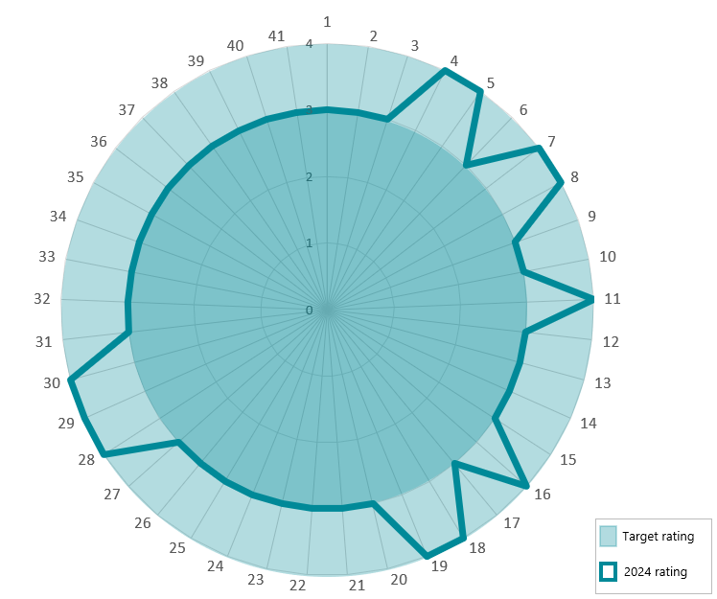
Asset Management Accountability Framework rating
1
1
1
1
2
1
3
1
4
0
Requirements 1 to 41 shown in the outer ring
Status | Scale
Not applicable | n/a
Innocence | 0
Awareness | 1
Developing | 2
Competence | 3
Optimising | 4
Unassessed | u/a

Consultancy and contract expenditure
Details of consultancies (valued at more than $10,000)
In 2023-2024, there were 85 consultancies where the total fees payable to the consultants were $10,000 or greater. The total expenditure incurred during 2023-24 in relation to these consultancies was $10,297,356 (excl. GST). Details of individual consultancies are outlined on our website: barwonwater.vic.gov.au.
Details of consultancies (valued at less than $10,000)
In 2023-24, there were 60 consultancies where the total fees payable to the consultants were less than $10,000. The total expenditure incurred during 2023-24 in relation to these consultancies was $268,653 (excl. GST).
Reviews and studies expenditure
During 2023-24 there were 34 studies and reviews undertaken with a total cost of $1.9 million. Details of individual studies are outlined below.
Name of the  review (portfolio(s)  and output(s)/  agency  responsible) | Reasons for review/study | Terms of reference/scope | Anticipated outcomes | Estimated cost for the year (excl. GST) $ thousand | Final cost if completed (excl. GST) | Publicly available (Y/N)
Large Scale Alternative Water Grid Feasibility Study | Central & Gippsland Sustainable Water Strategy Action. | Feasibility investigation. | Improved understanding of the feasibility of a large-scale alternative water grid to enable productive use of recycled water and stormwater the associated costs and regional benefits. | 600 | To be completed in the 2024-25 financial year | Study still in progress
Enhanced Stormwater Management – Northern and Western Geelong Growth Areas & Bannockburn Growth Areas | Understand the need to keep live stormwater harvesting opportunities in major growth areas. | Feasibility investigation. | Confirmation of need to keep live stormwater harvesting opportunities in major growth areas. | 87.6 | 158.9 | N
Internal Audit Program | Requirement under Standing Directions. | Program for 2023-24 included Procurement, Contract Management, Bulk Water Entitlements, Asset Maintenance and Public Safety. | Improved internal controls | 264 | 273.6 | N
Review of Barwon Water’s Family Violence policy, compliance and practices. | Determine current level of compliance to our policy and identify areas for improvement. | Review strength of the policy and the associated systems, processes, data management, leadership and staff capability. | Identify opportunities to strengthen our management and support of customers who may be impacted by family or domestic violence. | 50 | 50 | N
Boundary Creek and Upper Barwon River Macroinvertebrate Sampling 2023-24 | Required as part of the Boundary Creek, Big Swamp and Surrounding Environment Remediation and Environmental Protection Plan. | s78 Ministerial Notice and feedback received from Southern Rural Water (SRW). | Improved understanding of the health of Boundary Creek and the Upper Barwon River. | 45.2 | 45.2 | Y
Surrounding Environment Investigation | Required as part of the Boundary Creek, Big Swamp and Surrounding Environment Remediation and Environmental Protection Plan. | s78 Ministerial Notice and feedback received from Southern Rural Water (SRW). | Determine whether Barwon Water’s historical management of groundwater pumping activities within the Barwon Downs graben resulted in any other unintended environmentally significant adverse impacts, in addition to those already confirmed within the lower reaches of Boundary Creek. | 7.2 | 240 | Y
Big Swamp Paleoecology Study | Required as part of the Boundary Creek, Big Swamp and Surrounding Environment Remediation and Environmental Protection Plan. | s78 Ministerial Notice and feedback received from Southern Rural Water (SRW). | Establish the paleoenvironmental conditions of the Swamp and potential anthropogenic impacts. | 2.5 | 55 | Y
Ecological Risk Assessment: Boundary Creek, Big Swamp and the Barwon River | Required as part of the Boundary Creek, Big Swamp and Surrounding Environment Remediation and Environmental Protection Plan. | s78 Ministerial Notice and feedback received from Southern Rural Water (SRW). | Quantify the risks associated with the metals and acidity loads to Big Swamp, Boundary Creek and the Barwon River. | 0 | 100 | Y

Name of the review (portfolio(s) and output(s)/  agency responsible) | Reasons for review/  study | Terms of  reference/scope | Anticipated outcomes | Estimated  cost for  the year (excl. GST)  $thousand | Final cost if  completed ( excl. GST) | Publicly  available  (Y/N)
2024 Upper Barwon Fish Survey | To assess the status of native fish populations in the Upper Barwon Region. | Address feedback/ concerns from the Remediation Reference Group. | Better understand the fish species, population and variation within the Upper Barwon River. | 0 | 37.5 | Y
2024 Upper Barwon Fish Survey | To assess the status of native fish populations in the Upper Barwon Region. | Address feedback/ concerns from the Remediation Reference Group. | Better understand the fish species, population and variation within the Upper Barwon River. | 0 | 37.5 | Y
Climate resilience modelling of waterways influenced by former groundwater pumping activities at the Barwon Downs borefield | Required as part of the Boundary Creek, Big Swamp and Surrounding Environment Remediation and Environmental Protection Plan. | s78 Ministerial Notice and feedback received from Southern Rural Water (SRW). | Better understand how these waterways are likely to respond to a changing climate. | 47 | 90 | In progress
Anglesea Groundwater Model Update | Required to inform the Bulk Entitlement (BE) review process outlined in the BE. | Bulk Entitlement (Anglesea Groundwater) Order 2009. | Ensure the groundwater model is adequate to inform the BE review process. | 95 | 350 | N
Bulk Entitlement Review | Required to inform the Bulk Entitlement (BE) review process outlined in the BE. | Bulk Entitlement (Anglesea Groundwater) Order 2009. | Identify any changes and/or improvements that could improve the long-term management of the resource. | 95 | 225 | In progress
Barwon Downs borefield decommissioning plan | Required as part of the Boundary Creek, Big Swamp and Surrounding Environment Remediation and Environmental Protection Plan. | Address feedback /concerns from the Remediation Reference Group. | Outline the approach and methodology Barwon Water intends to apply when decommissioning the former extraction bores. | 2.5 | 26.5 | N
Anglesea Ecological Monitoring | Required as part of the endorsed Monitoring and Assessment Program under the Bulk Entitlement. | Bulk Entitlement (Anglesea Groundwater) Order 2009. | Monitor the environmental values and health of groundwater dependent ecosystems | 57.6 | 73.6 | Y
Callahan’s creek diversion weir remediation assessment | To assess options for remediating willows infestation and harvest of pine plantation at Callahan’s Creek. | To feed into a business case. | The harvest and sale of pine plantation and the remediation of willows. | 27 | 27 | N
Biochar Research (Uni Newcastle, SoilsCRC) | To evaluate biosolids derived biochar on soil health and plant nutrition. | Trials will include open field and greenhouse trials. | Biochar optimisation for soils, better understanding of market potential. | 15 | 45 | Y
Biochar Research (RMIT PYROCO Ph 2, Mk II) | To produce and characterise biosolids derived biochar. | In partnership with Victorian water sector, including RMIT, SEW, GWW, and MW. | Production and characterisation of biosolids derived biochar. | 40 | 40 | Y
Hydogen Research (Deakin University) | To develop deeper understanding of community social licence on hydrogen production in Barwon South West. | PhD research, in partnership with Wannon Water, and Deakin University. | Enhanced understanding of community attitudes to water use and hydrogen production. | 10 | 30 | N.
Hydrogen Research (RMIT) | To understand scalability of oxygen demand in water reclamation plants from hydrogen production. | Post-doctoral study linked with Barwon Water "GreenO2" project, ARENA funded. | Scalability of oxygen demand from hydrogen production. | 40 | 120 | Y
Emerging Contaminant Research (Federation Uni) | To better understand pharmaceutical and personal care products (PPCPs) at Lake Colac. | PhD research of PPCPs at Lake Colac. | Thorough understanding of PPCPs in Lake Colac and their uptake in flora and fauna. | 20 | 60 | N
Emerging Contaminant Research (Federation Uni) | To evaluate sustainable removal methods of PPCPs from effluent discharge. | PhD research that will undertake applied trial and measurements. | Thorough understanding of PPCP removal via use of natural removal processes. | 20 | 60 | N
Emerging Contaminant Research (RMIT) | To evaluate fate of microplastics through waste water treatment plants. | PhD research with focus on three plants at Black Rock, Colac, and NWP. | Thorough understanding of fate of microplastics through selected Barwon Water WWTPs. | 10 | 30 | N
West Barwon dam safety review and risk assessment | To comply with ANCOLD guidelines / DEECA SoO. | Detailed Risk Assessment and Safety Review for Civil Assets; peer review | Compliance with ANCOLD guidelines / DEECA SoO; improved understanding of dam safety risk | 135 | In progress | N

Name of the review  (portfolio(s) and  output(s)/agency  responsible) | Reasons for review/study | Terms of  reference/scope | Anticipated outcomes | Estimated cost for the year (excl. GST) $ thousand | Final cost if completed (excl. GST) | Publicly  available  (Y/N)
Painkalac Reservoir dam break and consequence assessment | To comply with ANCOLD guidelines / DEECA SoO. | Estimate life safety and economic consequences; produce inundation maps. | Compliance with ANCOLD guidelines / DEECA SoO, improved understanding of dam safety risk, emergency response planning. | 39 | 39.02 | N
Painkalac Reservoir dam break and consequence assessment | To comply with ANCOLD guidelines / DEECA SoO. | Estimate life safety and economic consequences; produce inundation maps | Compliance with ANCOLD guidelines / DEECA SoO, improved understanding of dam safety risk, emergency response planning. | 39 | 39.02 | N
Bostock Spillway and Railway Weir special inspection | To comply with ANCOLD guidelines / DEECA SoO. | Assess condition. | Compliance with ANCOLD guidelines / DEECA SoO. | 24 | $24.17 | N
Bungal dam safety review | Joint project with Central Highlands Water. | Design safety review. | Compliance with ANCOLD guidelines / DEECA SoO; improved understanding of dam safety risk. | 48 | In progress | N
2024 Water Reclamation Plants soil sampling and analysis | Environmental Compliance Management. | Assessment of soil condition to inform future irrigation management. | Soil irrigation management recommendations. | 22.5 | 22.5 | N
Class A quality risk management audit and plumbing compliance review | Three yearly external quality audit.  Review of Class A dual pipe cross-connection risk management. | Implementation of Health and Environment Management Plan and associated Recycled Water Quality Risk Management Plans.  Review of risk management practices for prevention of cross-connections in dual pipe networks. | Improvement recommendations. | 53.1 | 53.1 | N
Development of Recycled Water Customer User Site Management Plans | Environmental Risk Management | Development of Customer User Site Management Plans based on site specific risk assessment. | Adoption by customers and improved customer environmental management and irrigation practices. | 22.4 | 22.4 | N
Groundwater review | Environmental Compliance Management | Assessment of groundwater conditions at Water Reclamation Plants. | Understanding of environmental compliance at Water Reclamation Plants. | 42.4 | In progress | N
Interim Human Health and Environmental Risk Assessment Review | Environmental Compliance Management | Update of risk assessment for Black Rock Water Reclamation Plant ocean outfall discharge. | Updated understanding of risk to beneficial uses. | 8.2 | 8.2 | N
2023 Water Reclamation Plants soil sampling and analysis | Environmental Compliance Management | Further assessment of soil conditions to inform future irrigation management. | Soil irrigation management recommendations. | 3.8 | 3.8 | N

Disclosure of major contracts
In 2023–24, we entered into one contract with a value of over $10 million, at a total cost of $12 million. KPMG have been engaged as a strategic delivery partner to lead the delivery of the digital transformation program. Details about this contract are available on the Buying for Victoria Website at: tenders.vic.gov.au.
Disclosure of procurement complaints
Under the Governance Policy of the Victorian Government Purchasing Board (VGPB), we must disclose any formal complaints relating to the procurement of goods and services received through our procurement complaints management system.
We received one formal complaint through our procurement complaints management system in 2023-2024, relating to an open market procurement for a construction project in which the supplier queried Barwon Water’s adherence to its evaluation process. An internal review found that all procurement policies and processes had been adhered to and the complaint has been resolved.

Government Advertising Expenditure
While any government advertising campaign with a total media spend of $100,000 or greater needs to be disclosed, our advertising campaign expenditure in the 2023–24 reporting period did not exceed this amount.
Information and Communications Technology (ICT) expenditure
For the 2023–24 reporting period, we had a total ICT expenditure of $24,525,549 with the details shown below.
All operational ICT expenditure | ICT expenditure relating to projects to create or enhance ICT capabilities
Business As Usual (BAU) ICT expenditure | Non-Business As Usual (non-BAU)  ICT expenditure | Operational expenditure (OPEX) | Capital expenditure (CAPEX)
$11,296,044 | $10,388,285 | $21,684,329 | $2,841,220
Note:
“ICT expenditure” refers to Barwon Water’s costs in providing business enabling ICT services within the current reporting period. It comprises Business As Usual (BAU) ICT expenditure and Non-Business As Usual (Non-BAU) ICT expenditure.
“Non-BAU ICT expenditure” relates to extending or enhancing Barwon Water’s current ICT capabilities.
“BAU ICT expenditure” is all remaining ICT expenditure which primarily relates to ongoing activities to operate and maintain the current ICT capability.

Minister’s Letter of Expectations
Key performance indicators
Priority area | Key Performance Indicator | Measure | Barwon Water activity/response
Climate change  and energy  Undertake activities and provide services that reduce exposure to climate risks, reduce greenhouse gas emissions, increase renewable energy use, adapt to climate change and demonstrate reasonable progress in integrating climate change adaptation into planning and decision making across the business. | CC1 Emission reductions  Demonstration of reasonable progress toward achievement of the entity’s greenhouse gas emission reduction target specified in the Statement of Obligations (Emissions Reduction).  CC2 Electricity use  Demonstrate reasonable progress to sourcing 100 per cent of their electricity from renewable sources by 2025, as is required of all government operations in the Whole of Victorian Government emissions reduction pledge. | E1  Total actual annual reportable greenhouse gas emissions for the Corporation in carbon dioxide equivalent (tCO2-e).  Compliance with all greenhouse gas emissions reporting requirements outlined in Ministerial Reporting Direction 01.  E2  Total actual annual electricity and renewable electricity use for the Corporation, in megawatt hours (MWh).  Compliance with all other electricity reporting requirements outlined in Ministerial Reporting Direction 01. | Our calculated scope 1 and 2 emissions total for 2023-24 was our lowest on record at 19,083 tCO2-e.  This was 22 per cent less than our projected emissions of 24,560 tCO2-e and represents a 19 per cent reduction on last year’s result.  Total electricity consumption for the year was 30,641 MWh.  Our renewable electricity initiatives supplied 57 per cent of our electricity needs for the year, reducing our scope 2 emissions by a total of 13,798 tCO2-e.  More details on our compliance and energy consumption and generation are available on pages 45–49 of this report.
 | CC3 Adaptation to climate change and variability  Application of the Guidelines for Assessing the Impact of Climate Change on Water Suppliers in Victoria for Urban Water Corporations through their application in drought preparedness and urban water strategies.  Demonstration of reasonable progress in integrating climate change adaptation into planning and decision-making across the business (all sources of  water, wastewater, and where relevant drainage and flood management) including in:  - source waters and demand  - built assets  - natural environment  - people and workplace  - interdependencies  - customer and product delivery. | E3  Qualitative description in Corporation’s annual report of how Guidelines for Assessing the Impact of Climate Change on Water Availability in Victoria have been applied.  Qualitative description in Corporation’s annual report of how Guidelines for the Adaptive Management of Wastewater Systems under Climate Change have been applied.  Inclusion of one or more of the following statements in Corporation’s annual report (amended as appropriate for the corporation’s circumstances):  - climate change adaptation plan, strategy or framework  - how corporation is mainstreaming climate change adaptation considerations into all aspects of business decision-making; and/or  - how corporation is addressing climate change adaptation only on an ad-hoc basis as/when required.  AND  Qualitative description and/or case studies on initiatives being planned or implemented by the Corporation to adapt to climate change and variability in line with chosen Statement/s. | Climate change risks are governed by our enterprise risk management framework. The dedicated Climate Change Key Business Risk (KBR) assessment aligns with the Water Services Association of Australia Climate Change Adaptation Guidelines and covers both physical and transition risks. It directly informs our Climate Resilience Plan.  The KBR and progress towards achieving our target risk rating was reviewed by the Risk Management Committee in 2023–24, with an update on our Climate Resilience Plan. As part of this annual update, we measured progress of our actions and collected data across a range of Key Performance Indicators.  We are currently three quarters of the way through implementing our Climate Resilience Plan. Released in 2021 it provides a cohesive vision for building our resilience to climate change.  Our approach to climate resilience includes the five categories of actions – embedding climate resilience, water security, asset resilience, transition to zero net emissions and community resilience.  More information is on pages 50-51 of this report.

Priority area | Key Performance Indicator | Measure | Barwon Water activity/response
Customer,  community and  engagement  Ensure that all aspects of service delivery will be customer and community centred and will continue to build extensive and effective community engagement and partnerships in planning and implementation of service delivery. | C1 Customer Satisfaction  Note this indicator includes both direct and proxy measures.  Overall, reporting on measures identified for this indicator should demonstrate high or improving levels of customer satisfaction over time. | C1.2 Urban bills  C1.2.1 Residential bill – owner occupier  C1.2.2 Residential bill – tenant  C1.2.3 Non-residential bill - business | The latest BoM National Performance Report (2022-23) showed we have the eighth lowest typical bill across Australia among our peers.  While the national average bill for 200kL consumption was $1,362, a Barwon Water bill was only $1,165 and only $33 higher than the lowest bill with the maximum at $1,875.
 |  | C1.3  Customer satisfaction survey.  RWC’s are to report the results from their most recent customer satisfactions survey.  Note DEECA may revisit an approach  to a common survey in the future. | This year Barwon Water consistently ranked either number 1 or 2 amongst Victorian water businesses for Value for Money, Reputation, Trust and Overall Satisfaction in the ESC perception survey.  All parts of our business contribute to this positive result.  External research by WSAA this year identified the driver of trust in particular as the combination of an organisation’s capability to service customers, its culture and contribution to the community. All elements that are central to our Strategy 2030.
 | C2 Customer and community engagement  Stakeholder engagement based on best practice that demonstrates approaches to engagement that are open, honest and occur frequently.  The DEECA Community Charter or IAP2 framework could be considered as a guide. | C2  Development and delivery of an engagement strategy/plan/policy and publication (via the water corporation’s website) of the engagement strategy/plan/policy or equivalent explanation. | Barwon Water has an internal communications and engagement strategy that provides a framework for building customer and community trust.  We integrate a variety of approaches and methods into our community and stakeholder  engagement plans, including referencing and embedding the IAP2 Public Participation Spectrum in all activities.  We use an online community engagement platform (yoursay.barwonwater.vic.gov.au) to share information about engagement processes and outcomes for all major planning, strategic and construction projects.  Examples of these include:  - 2023-28 Price Submission  - Regional Renewable Organics Network  - Lorne: Water, Your Say  - Forrest wastewater  - Porronggitj Karrong and Aqueduct  - Birregurra water supply upgrade.  More information is on pages 37-38.

Priority area | Key Performance Indicator | Measure | Barwon Water activity/response
Deliver Water for  Aboriginal  cultural, spiritual  and economic  values and  support economic  inclusion in the  water sector  Promote self-determination of Traditional Owners, including by supporting the Treaty process as required. Support the implementation of Water is Life: Traditional Owner Access to Water Roadmap by enabling increased access to water entitlements under current frameworks and increased cultural benefits from the way we store, deliver and use water. | AC1 Supporting Aboriginal self- determination  Demonstrate effective and genuine engagement and partnerships with Traditional Owners and Aboriginal Victorians for involvement in business opportunities and access to water  for spiritual, customary, social, and economic purposes, and other self- determined purposes.  Demonstrate there are internal processes, policies and plans in place to support Aboriginal self-determination  /empowerment/employment etc. for Aboriginal community members. | AC1.1  Implementation and reporting on a strategy that demonstrates how the water corporation is providing procurement opportunities to  Aboriginal Enterprises to supply goods and services to water corporations, including addressing any procurement barriers. Aboriginal enterprises to supply goods/services to water corporations and number of Aboriginal enterprises procured in the last year.  AC1.1.2  Total number of tender requests received, total number of Aboriginal enterprise tenders received, and total number of Aboriginal enterprises procured in FY. | Some of the key outcomes relating directly to the creation of opportunities within the water sector for the First Nations community and businesses include:  - revising our Purchasing and Contracting Rules to remove barriers to engage Aboriginal business for engagements <$50k.  - reviewing all tender and quotation documentation to ensure there are no barriers to procuring goods and services from First Nations owned businesses. All our tender and quotation templates include references to purchasing goods and services from Victorian Aboriginal businesses and employment for Victorian Aboriginal people.  - we have embedded Aboriginal procurement within our Procurement Intranet space. Employees can identify accredited Victorian Indigenous businesses through a link to Kinaway.  - Kinaway is an Aboriginal Chamber of Commerce based in Melbourne through which Aboriginal and/or Torres Strait Islander businesses and entrepreneurs have a collective voice both within the Aboriginal and/ or Torres Strait Islander business community and the general business community. Barwon Water is a Platinum member of Kinaway.  - we have numerous commercial relationships with Aboriginal and Torres Strait Islander owned businesses. Some of the goods and services procured through these businesses during 2023-24 include stationery, cultural awareness training, employment, consulting works, graphic design, civil works and artwork.  During 2023-24, Aboriginal-owned business continued to be engaged from previously awarded contracts. Kinaway continued to assist us in identifying potential Aboriginal business that could provide additional goods or services to enhance existing panel contracts.  All Barwon Water tenders were publicly advertised using the Buying for VIC website, allowing Aboriginal businesses to respond to these procurement opportunities.  Our spend with Victorian Aboriginal-owned and certified businesses and corporations during 2023-24 was $28,865; spend with other First Nations businesses was $340,527.  We procured from four new Aboriginal businesses in 2023-24.  Tender data for 1.1.2 was not recorded in 2023-24 and we are reviewing how we collect this data in 2024-25 following a technology upgrade.

Priority area | Key Performance Indicator | Measure | Barwon Water activity/response
 |  | AC1.2  Number and description of  offered and/or active sponsorships of Aboriginal people in relevant study and training courses, including scholarships, vocational education and traineeships initiated in the last year. | We currently have one scholarship student, two trainees and one participant in our LEAD 2030 training program.  We continued to support a university- based internship student through the Career Tracker program.  Our traineeship continues to provide entry-level pathways with two First Nations trainees joining the program in field-based and IT positions.  The First Nation Values department head is undertaking the LEAD 2030 program.
 |  | AC1.3  Number of staff within the water corporation who have undertaken a cross-cultural training course (by  relevant Traditional Owner) in the last year and working towards development of mandatory cultural safety training program/policy. | Forty-two employees completed Connection to Country cultural awareness training.  Teams where Aboriginal or Torres Strait Islander staff will be working have specific training provided to ensure the new employee enters a culturally safe working environment.  To further increase cultural awareness and cultural safety, Yarning Circles have been introduced with significant participation from employees.  Ongoing training developed and facilitated by Traditional Owners through an ‘On Country Connection to Country’ excursion is run throughout the year for all employees, and forms part of the new employee onboarding program. We are also reshaping our capability framework by adding “Caring for Country” as a priority competency.  We continued to provide Cultural Awareness training through an online learning platform, which forms part of the onboarding program for all new employees.
 |  | AC1.4  Number of Aboriginal staff employed | Two per cent of our employees identify as Aboriginal and Torres Strait Islander.  Note: Only proportional data is available (Source: VPSC People Matters survey).

Priority area | Key Performance Indicator | Measure | Barwon Water activity/response
 | AC2 Partnerships with Traditional Owners  Demonstrate effective and genuine partnerships with Traditional Owners for inclusion to enable input into water planning and management decisions related to Aboriginal water values and other self-determined priorities. | AC2.1  Number of effective engagements and partnerships with Traditional Owners in water planning and management, including a number of water projects completed that led to improved outcomes for Aboriginal Communities | Barwon Water and Wadawurrung Traditional Owners Aboriginal Corporation are in a formal partnership (2021 – 2024) that identifies a range of projects and opportunities that helps us walk on our Reconciliation journey, and empowers Wadawurrung to achieve the Cultural objectives set out by its community as represented in their Paleert Tjaara Dja - Wadawurrung Country Plan (2020 -2030) through a well-established relationship guided by trust and enabling self-determination  More information is on pages 28-30. We have co-funded a People and Programs Manager for Wadawurrung’s Caring for Country team with Central Highlands Water, Corangamite Catchment Management Authority, The Great Ocean Road Coast and Parks Authority and Melbourne Water.  Barwon Water and Eastern Maar Aboriginal Corporation have entered into a journey that is centred around developing trust and strengthening our relationship through genuine engagement and helping enable the delivery of Eastern Maar’s Cultural objectives for Country as guided by “Meerreengeeye ngakeepoorryeeyt. – Eastern Maar Country Plan. The relationship with Eastern Maar is in a much earlier stage than Wadawurrung, and therefore more time is being taken to establish a meaningful relationship with the outcome of a formal partnership planned.  Barwon Water along with Wannon Water and Grampians Wimmera Mallee Water have co funded a “Water Corporations Partnerships Officer” position, employed by Eastern Maar Aboriginal Corporation.  We will continue to engage with all Registered Aboriginal Parties in  relation to major water planning and management projects and strategies. This will include our Water for our Future Program, Urban Water Strategy, Water is Life and land/water management opportunities.  There is no specific data available on the number of engagements occurring on a regular basis.
 |  | AC2.2  Demonstrate that Traditional Owners have had the opportunity to review and/ or endorse all sections of the annual report that include specific reference to Traditional Ecological Knowledge, values and wellbeing.  AC2.3  Water corporation can demonstrate it has informed relevant Traditional  Owners of opportunities to access water entitlements or allocation within their Country. | Wadawurrung Traditional Owners Aboriginal Corporation has reviewed and endorsed relevant sections of the annual report.  We commit to continuing to learn from and build relationships with both Wadawurrung and Eastern Maar and engaging early and partnering in the development of all future annual reports.  Three supply by agreement Cultural Water trials were undertaken with Wadawurrung in the Moorabool catchment at Durdidwarrah wetlands, Moorabool East Branch and Moorabool West Branch.  Work also continues on the implementation of the Central and Gippsland Sustainable Water Strategy Action of delivering 3.7GL of water to the Moorabool to be shared between Wadawurrung and the Environment.

Priority area | Key Performance Indicator | Measure | Barwon Water activity/response
 | AC 3 Aboriginal Inclusion Plan/ Reconciliation Action Plan  To be considered in conjunction with AC1 and AC2, taking into account the relevant local context. | AC 3  Implementation of either an Aboriginal Inclusion Plan, Reconciliation Action Plan or a Self Determination Plan, reflecting measures AC1.1 to AC1.3 and AC2.1 as appropriate and report against number of actions achieved and ongoing. | We launched our Stretch Reconciliation Action Plan which continues Barwon Water on its Reconciliation Journey, with key actions including:  - participation and celebration of both National Reconciliation Week and NAIDOC Week  - continuing the partnership with Wadawurrung Traditional Owners Aboriginal Corporation, exploring new opportunities to collaborate with and empower Wadawurrung community  - continuing to build our relationship and trust with Eastern Maar Aboriginal Corporation by walking together to understand what is important to Eastern Maar community  - ongoing Cultural awareness training delivered by First Nation businesses  - implementation of the First Nations Employment and Retention Strategy  - supporting First Nation supplier diversity within our organisation  - working together with Traditional Owners on strategic projects  - implementing a ‘Caring for Country’ approach into our organisation  - continuing to seek opportunities for water return to Traditional Owners  - development of a Culturally Safe language guide and protocols document  - promoting Reconciliation through our sphere of influence.

Priority area |  | Key Performance Indicator |  | Measure |  | Barwon Water activity/response
Recognise  recreational  values  Support the wellbeing of communities by considering recreational values in water management. | Rec1: Recreational values  Consideration of recreational values in carrying out functions and providing services. |  | - Number of site-based projects delivered to improve recreational enjoyment of water storages – for example, projects to improve or maintain access, infrastructure and facilities.  - Efforts taken around the following three themes of Water for Victoria:  - Community engagement processes that identified and considered recreational objectives relating to management of waterways.  - Improvements to information sources (e.g. online) to help recreational users plan their activities.  - Collaboration with other organisations and government agencies (e.g. through membership of working groups or through other means) to explore and progress opportunities to support recreational objectives.  - Number of accessible major water storages with land and recreation management plans in place, as per Water for Victoria action 7.3. |  | We continued to improve the visitor experience at our major water storages, surplus and under-utilised land holdings.  - partnering with Traditional Owners and wider community to identify and develop opportunities.  We provided access to six major water storages – West Barwon, Wurdee Boluc, Painkalac, Bostock and Upper Stony Creek Reservoirs as well as Bolwarrah Weir – for walking, bird watching,  horse riding, mountain biking, dog walking, sightseeing, and picnicking.  We coordinated fish stocking at our reservoirs in collaboration with Fisheries Victoria and community groups. We also supported community events at our reservoirs, such as mountain biking or running festivals.  We continued to progress Murrk Ngubitj Yarram Yaluk (37ha former Bellarine Basin site) and the 66ha Porronggitj Karrong precinct project, as outlined in Part 3.  We contributed to the multi-layered Kitjarra-dja-bul Bullarto langi-ut masterplan (lower Moorabool and lower Barwon River corridors), which has now progressed into the implementation phase.  Along with the City of Greater Geelong, we helped facilitate community groups who are establishing new community gardens on pipe reserves in Armstrong Creek and North Geelong.  We continued to promote these places through our website, social media channels and local radio editorials.

Priority area | Key Performance Indicator | Measure | Barwon Water activity/response
Resilient and  liveable cities and  towns  Contribute to healthy communities by supporting safe, affordable, high- quality services and resilient, liveable environments and recovery from emergency events that builds back with improved resilience against future risks. | L1 Integrated Water Management (IWM) (urban)  In relevant IWM forum(s), actively facilitate and champion water’s contribution to the resilience and liveability of cities and towns of the region consistent with the forum’s objectives.  In the regional context this includes demonstrating reasonable progress towards implementation of priority IWM projects and plans, as identified by the relevant IWM forums. | L1  Progress towards:  - participation in, or establishment of IWM forum(s) in your region  - contribution to development or review, and implementation of Strategic Direction Statement(s) in your region  - implementation of priority IWM projects and plans, as applicable  - delivering IWM outcomes for the region (regional IWM forums) and/ or IWM targets set out in the relevant catchment scale IWM plans (metro IWM forums). | We led and contributed to the functioning of the Barwon IMW Forum by chairing and providing executive support.  In partnership with the Barwon IWM Forum members and DEECA, we continued to implement the priority IWM projects identified in the recently updated Strategic Directions Statement (SDS), the Forum’s key strategic document.  We continued to embed integrated water cycle management early in urban planning for Geelong’s long-term growth areas by working with the City of Greater Geelong to facilitate the implementation of the IWM Plan for the Growth Areas of northern and western Geelong in upcoming Precinct Structure Plans.  We worked with the IWM Forum members and various regional networks, such as the Barwon Regional Partnership, to explain the multiple community-wide benefits of IWM and attract investment for various projects.  We have worked in partnership with our regional partners to develop concept designs and a Business Case for the large scale, staged alternative water (stormwater and recycled water) grid which distributes recycled water and stormwater for beneficial use.  We have led and contributed to significant regional IWM projects and processes, including the delivery of fit-for-purpose recycled water to Deakin University’s Waurn Ponds Campus and the Bellarine Peninsula’s agricultural industry. We also provided strong support to the Surf Coast Shire, which was investigating options to improve the health of the Karaaf Saltmarsh and provide regional IWM outcomes.
 | L2 Water efficiency (urban)  Implement water efficiency initiatives, actions or programs aligned with Target 155 (Metros), Target Your Water Use (Regional Urban), Water for Victoria and relevant sustainable and urban water strategies. | L2a  Continue to collaborate on the Victorian Water Efficiency Strategy delivering  on water efficiency outcomes in Water for Victoria and relevant urban and sustainable water strategies, including:  - water corporations working together to develop statewide initiatives; and  - reporting the number of customers in need assisted by the Community  Rebate Program, and for participating organisations only, the Community Housing Retrofit Program. | We have continued to participate in the Victoria Water Efficiency Network to ensure a coordinated approach to Target Your Water Use and Permanent Water Saving Rules initiatives.  We have assisted 293 customers through the Community Rebate Program (164 customers) and Community Housing Retrofit Program (129 customers) with a combined estimated 24.28 million litres in water savings.
 |  | L2b  Water corporations are required to provide:  - water consumption figures for each district for residential and non- residential water users including drinking water, alternative water sources and non-revenue water  - major non-residential water users, including number of customers who fall within prescribed volume ranges and naming of users and whether they participate in water efficiency program.  - Information must be provided if a water corporation has implemented action under its Drought Preparedness Plan including actions, stage of restrictions, measures and communities affected along with measures to improve future drought response. | Water consumption figures for residential/non-residential and major non-residential users are reported as per L2b measure in Part 3 (pages 21-25) of this report.

Priority area | Key Performance Indicator | Measure |  | Barwon Water activity/response
 | L3 Circular economy outcomes  Reasonable progress towards integrating circular economy principles into business decisions across all aspects of the water cycle.  Measures related to this indicator will highlight the water sector’s contribution towards targets under Recycling Victoria. | L3  Progress towards circular economy might include:  - Qualitative description of projects or initiatives undertaken that adopt circular economy principles and/or contribute towards identified targets in Recycling Victoria.  - Percentage of biosolid mass reused (urban only). |  | Significant projects with circular principles adopted and contributing towards targets under Recycling Victoria include:  The Regional Renewable Organics Network project, which will provide a processing solution for ~60,000 tonnes of municipal food and garden organic waste, commercial and industrial organics and biosolids, continues to be developed and aims to be ready to take waste in 2026. The project will produce renewable energy, biochar (which sequesters carbon) and reduce emissions.  We are investigating further development of a third stage for the Colac Renewable Organics Network project. Barwon Water has placed an order for a hydrogen fuelled prime mover – coordinated via the Viva Energy led New Energies Service Station project. The vehicle will be on road around mid-2025.  We are investigating if there are environmental, operational and financial benefits available through the recovery of cellulose from our wastewater streams.  Other significant projects include reusing 100 per cent of biosolid mass during the financial year.
 | L4 Environmental Statutory Obligations  Water corporations are required to meet statutory obligations and other environmental activities as applicable. | L4  - Regional Catchment Strategy within its region  - Victorian Waterway Management Strategy and regional Waterway Strategy within its region  - State Environment Protection Policy (Waters) clauses referred to in the Environmental Protection Transitional Regulations 2021, where a new legal instrument has been made (e.g. OMLI)  - Port Phillip Bay Environmental Management Plan |  | Barwon Water has continued to update our environmental management and compliance systems in response to changes in the Environment Protection Act and subordinate regulations, reference standards and guidelines.  This has included implementation of new Health and Environmental Management Plans, Recycled Water Quality Management Plans for our recycled water reuse schemes and the preparation of Risk Management and Monitoring Programs for our water reclamation plant operating licence sites. Information on our statutory obligations and compliance are provided in section 7 of this report (pages 43-52).
Leadership,  diversity and  culture  Reflect the needs of our diverse communities and develop strategies and goals that will increase cultural diversity in the  workforce and gender equity in both executive leadership and throughout the organisations, including requirements under the Gender Equality Act 2020. | G1 Diversity and inclusion  Improve gender and cultural diversity in workforce including gender equity in both executive leadership and throughout the organisation.  Diversity Inclusion plans to be based on best practice and include reference to identifying barriers to succession and meeting targets.  The approach of the DEECA Diversity and Inclusion Strategy 2019–2022 could be considered as a guide. |  | G1.1  Development and delivery of a Diversity Inclusion Plan/s, including a Gender Equality Action Plan and publication (via the water corporation’s website)  of progress in relation to the plans or equivalent explanation. | We continued to implement Barwon Water’s Diversity, Inclusion and Gender Equity Strategy through implementing the Belonging @ Barwon Water Action Plan. This current plan aligns to and meets the requirements of the Gender Equality Act 2020. More information is on page 67-68 of this report.  Our 2023–24 progress was reported to the Gender Equality Commission and will be next reported on their website in February 2025.
 |  |  | G1.2  Number of females occupying senior executive positions over projected five-year period. | We aim to maintain a balanced senior leadership team and representation is currently 50 per cent men and 50 per cent women.  As part of the Belonging @ Barwon Water Inclusion Action Plan there are various targets and actions to support gender equality.  The gender balance target for our Senior Leadership Team is 40 per cent women, 40 per cent men and 20 per cent flexible.
 |  |  | G1.3  Adopt strategies and actions to achieve a one per cent target for Aboriginal people in the business, noting the Victorian Public Service has a two per cent target [1] and work to a stretch target of three per cent by 2020 (DELWP policy [2]). | Two per cent of our employees identify as Aboriginal and Torres Strait Islander.  We are working towards a stretch target through various programs, which are driven by our Aboriginal Employment and Retention Strategy, which was recognised at the state and national level for Organisational Excellence by the Australian Water Association.

Priority area | Key Performance Indicator | Measure | Barwon Water activity/response
 |  | G1.4  Actions taken to improve participation by Traditional Owners and Aboriginal Victorians in Board committees and other organisational committees  (e.g. cultural safety training for all Board members and recruiting an Aboriginal delegate to your Board). | Corrina Eccles is on the Barwon Water Board as a non-executive Director.  Corrina, who is a Wadawurrung Traditional Owner and has worked for more than 20 years with Aboriginal organisations, brings a unique insight into Indigenous culture, perspectives and values relating to water.  We have identified a number of opportunities to implement actions and programs that seek to achieve shared benefits with Traditional Owners and Aboriginal communities, including:  - Porronggitj Karrong – Barwon Water and Wadawurrung are working in partnership to transform the land into a new living cultural landscape and community precinct, where traditional land management can be celebrated in practice  - Murk Ngubitj Yarram Yaluk (Bellarine Basin) – We are working in partnership with Wadawurrung, local community, special interest groups and government agencies to restore and provide public access to the Yarram Creek headwaters and surrounding landscape  - We have a Partnership Agreement in place with Wadawurrung Traditional Owners Aboriginal Corporation (2021–24) and have begun planning for its renewal  - We are continuing to build on our relationship with Eastern Maar Aboriginal Corporation, through building trust and deepening our understanding of what’s important to Eastern Maar  - We now have a stand-alone First Nation Values Department with four full time First Nations Staff, that has oversight and gives direction on Barwon Water’s Reconciliation Journey, our partnership with Wadawurrung, relationship Eastern Maar and how we work with First Nation organisations in our region  - We supported the Djilang initiative with the Geelong Advertiser.  We are currently recruiting for a First Nations non-executive Director for the Board of Barwon Asset Solutions. The role aims to improve the board’s decision-making and build a pathway for, and pipeline of, future Aboriginal board members to consider applying for a Ministerial appointed board position in the future.
 |  | G1.5  Number of respondents to the Victorian Public Sector Commission (VPSC) People Matter Survey from each water corporation. | We achieved a participation rate of 83 per cent in the 2024 People Matters survey.
 |  | G2.1 Health and Safety  Performance indicators adopted to monitor occupational health and safety in line with FRD 22, section 5.10. | We have used ‘lead and lag’ performance indicators to inform initiatives and strategies associated with reducing the overall incident frequency rate and severity of injuries.  This has been reflected in a steady decline of our Incident Rate per 100 FTE, which reduced from 11.9 in 2022–23 to 6.6 in 2023–24.

Priority area | Key Performance Indicator | Measure | Barwon Water activity/response
Performance and  Financial  Sustainability  Improve efficiency and consistency  in the reporting of performance while delivering safe  and cost-effective water and wastewater services in a financially sustainable manner. | PF1 Audited statement of performance  Demonstrating a concise statement of performance, financial sustainability and provide a positive picture of a corporation’s financial sustainability over time. | PF1.1 Financial Performance Indicators  PF1.2 Water and Sewerage Network Performance Indicators  PF1.3 Water Service Indicators  PF1.4 Customer Responsiveness Performance Indicators  PF1.5 Water Reuse Indicators  PF1.6 Community Service Obligations | This set of indicators are reported within the Performance Report contained within the Annual Report following  the annual audit process undertaken by VAGO.  DTF undertook a desktop rating in June 2024, which determined that Barwon Water’s credit rating would remain  A- from 1 July,2024.  The FAL rate is increased for 2024–25 to 0.95 per cent.
Compliance and  enforcement  Apply a consistent, transparent and risk-based approach to manage compliance and enforcement of the Water Act 1989 | BE1 Demonstrate bulk entitlements are compliant with individual reporting conditions | Develop and maintain a report for each bulk entitlement, covering all applicable ‘reporting requirements’. | We maintain information on our bulk entitlement compliance.  A full list of all our bulk entitlements is provided within section 7 of this report (page 53 – 58).

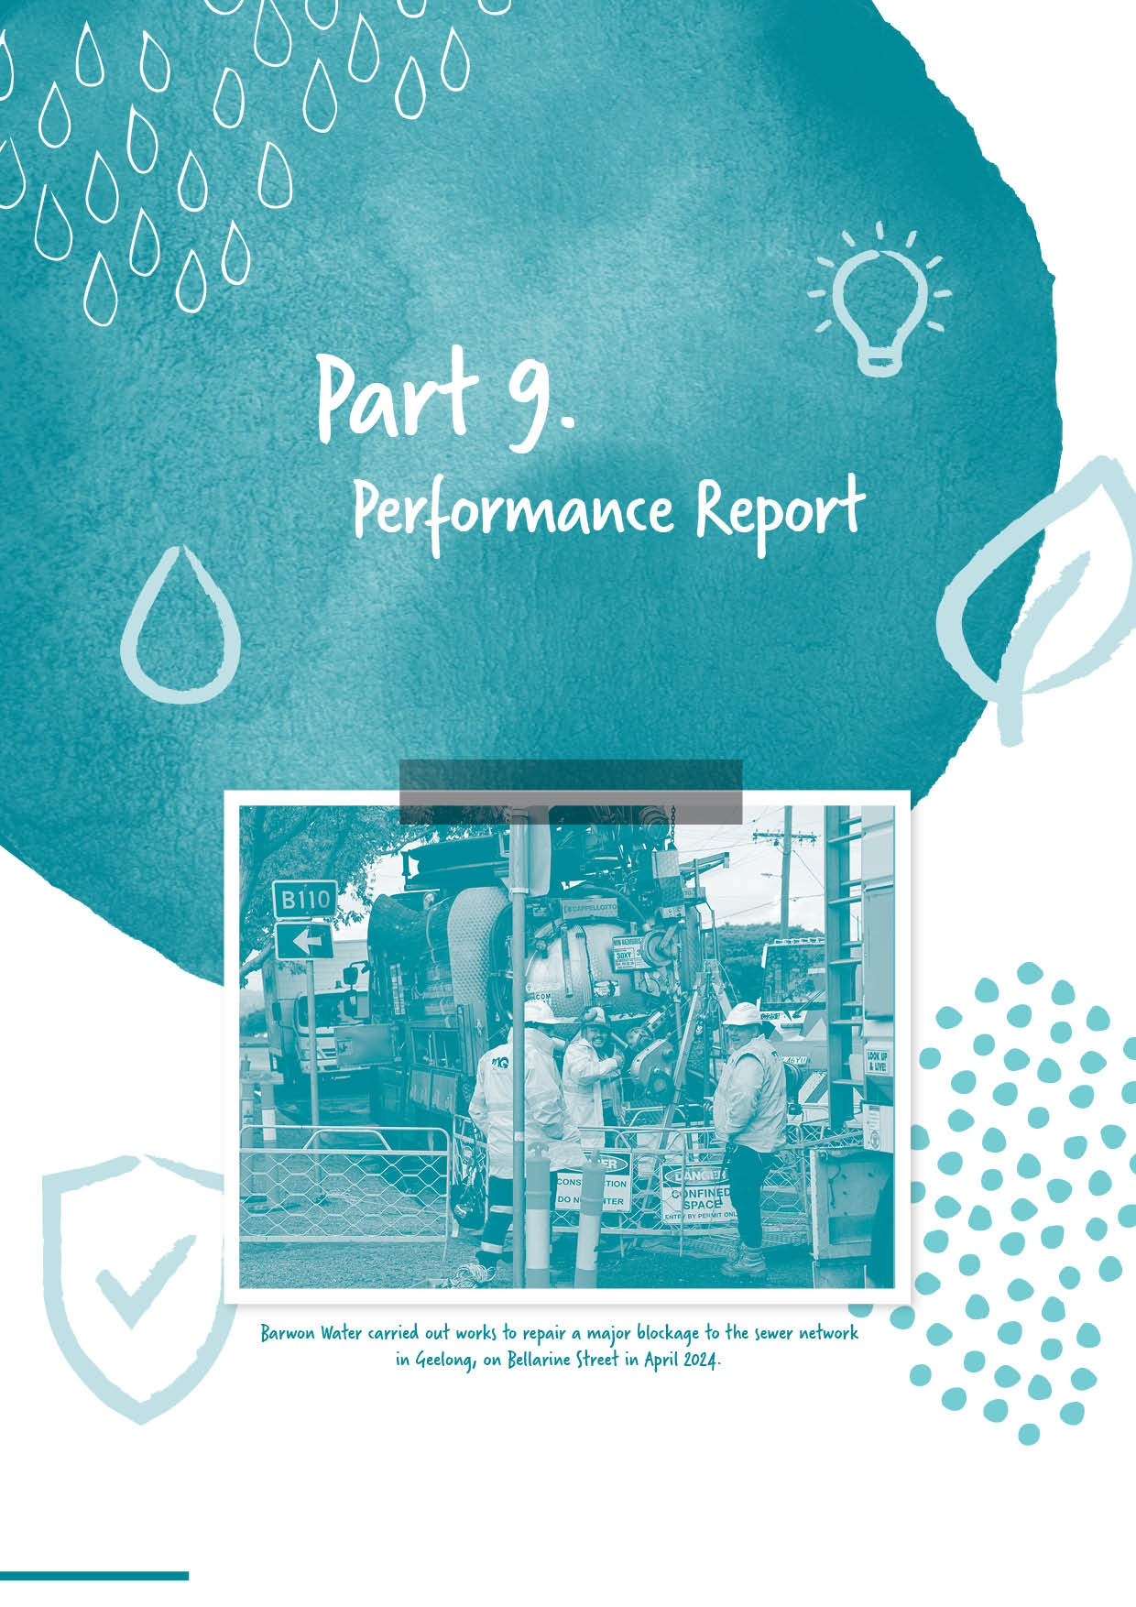
Section divider page
WITH IMAGE

Part 9.
Performance report

Barwon Region Water Corporation (Barwon Water) and Barwon Asset Solutions Pty Ltd (BAS) (collectively ‘the Group).
Consolidated Performance Report 2023-24

- Financial Performance Indicators
Key Performance Indicator | 2022-23  Result | 2023-24  Result | Variance to  2022-23 | 2023-24  Target | Variance to  target
Cash Interest Cover  Net operating cash flows before net interest and tax / net interest payments | 3.30 times | 3.48 times | 5.45% | 3.90 times | ¹ (10.77%)
Gearing Ratio  Total debt (including finance leases) / total assets | 16.20% | 17.13% | 5.74% | 19.60% | ² (12.65%)
Internal Financing Ratio  Net operating cash flow less dividends / net capital expenditure | 65.50% | 64.36% | (1.74%) | 73.00% | ³ (11.84%)
Current Ratio  Current assets / current liabilities (excluding long- term employee provisions and revenue in advance) | 60.00% | 47.10% | ⁴ (21.50%) | 51.00% | (7.65%)
Return on Assets  Earnings before net interest and tax / average assets | 1.20% | 1.29% | 7.50% | 1.40% | (7.86%)
Return on Equity  Net profit after tax / average total equity | 0.30% | 0.39% | ⁵ 30.00% | 0.70% | ⁶ (44.29%)
EBITDA Margin  Earnings before interest, tax, depreciation and amortisation / total revenue | 45.90% | 44.62% | (2.79%) | 47.50% | (6.06%)
Notes:
1. Lower than target cash interest cover due to a combination of non-tariff revenue lower than target, higher than anticipated payments to employees and suppliers and interest payments above target.
2. Lower gearing than target due to lower drawdown of borrowings combined with increased value of water and infrastructure assets compared to target.
3. Lower than target internal financing ratio due to a combination of non-tariff revenue lower than target, higher than anticipated payments to employees and suppliers and interest payments above target.
4. Current ratio lower than prior year due to increased trade payables and increased short term borrowings due to a higher level of capex spend in the last month of the financial year compared to prior year.
5. Return on equity is higher than prior year due to increased tariff revenue related to drier weather conditions and increased inflationary impacts, partially offset by increased costs of external resources, and loss on disposal of assets.
6. Return on equity is lower than target due to increased value of water and sewer infrastructure assets compared to target.

Operational Performance
- Water and Sewerage Network Performance Indicators
Key Performance Indicator | 2022–23  Result | 2023–24  Result | Variance to  2022-23 | 2023–24  Target | Variance to  target
Water Service – minutes off supply (planned and unplanned)  How many minutes on average a customer was without water supply  during a year | 17 | 13 | ⁷ (23.53%) | 30 | ⁸ (56.67%)
Unplanned water supply interruptions  Percentage of customers receiving five unplanned interruptions in the year | 0.3% | 0.3% | 0.00% | 0.40% | ⁹ (25.00%)
Sewerage Service – sewer blockages  Number of sewer blockages reported per 100 kilometres of sewer main | 51 | 57 | ¹⁰ 11.76% | 54 | 5.56%
Sewerage Service – sewer spills  Number of sewer spills reported per 100 kilometres of sewer main | 14 | 13 | (7.14%) | 16 | ¹¹ (18.75%)
Sewerage Service – containment of sewer spills  Sewer spills from reticulation and branch sewers contained within 5 hours | 99.50% | 100.00% | 0.50% | 98.50% | 1.52%
Notes:
7. Favourable performance with little change to the interruption length and the number of unplanned interruptions, it was the number of planned interruptions that decreased greatly in 2023-24. Planned interruption length is nearly twice as long as unplanned, when the number of planned interruptions decreased greatly so did the result.
8. As above.
9. Favourable performance to target is a result of risk-based prioritisation of renewals and upgrade initiatives for water mains, resulting in a reduction in failure rates and corresponding reduction in number of customers affected by multiple unplanned water supply interruptions.
10. Unfavourable performance to prior year. Largest increase was in main sewer blockages with house connection branch blockages also increasing when compared to prior year. However, our programs have been prioritised to reduce sewer spills, which has seen a reduction in the 2023-24 year.
11. Favourable performance to Corporate Plan is a result of continued focus on reducing sewer spills toward zero.

- Water Reuse Indicators
Key Performance Indicator | 2022–23  Result | 2023–24  Result | Variance to  2022-23 | 2023–24  Target | Variance to  target
Recycled water – effluent treatment and reuse  Proportion of water recycled as a percentage of the volume of effluent produced | 10.90% | 13.20% | ¹² 21.10% | 20.00% | ¹³ (34.00%)
Notes:
12. Favourable performance to previous year is a direct result of increased recycled water from Portarlington Water Reclamation Plant.
13. Unfavourable performance to Corporate Plan is a result of ambitious Corporate Plan set, although performance is improving towards Corporate Plan.

- Customer Responsiveness Performance Indicators
Key Performance Indicator | 2022–23  Result | 2023–24  Result | Variance to  2022-23 | 2023–24  Target | Variance to  Target
Water bills - customers on flexible payment plans*  No. of customers with instalment plans | 8,884 | 10,000 | ¹⁴ 12.56% | N/A | N/A
Customers awarded hardship grants ~  No. of customers awarded hardship grants | 3,287 | 5,175 | ¹⁵ 57.44% | N/A | N/A
Customer Responsiveness – water quality complaints  No. of complaints per 100 customers | 0.12 | 0.15 | ¹⁶ 25.00% | 0.20 | ¹⁷ (25.0%)
Customer Responsiveness – number of payment issue complaints  No. of complaints per 100 customers | 0.14 | 0.21 | ¹⁸ 50.00% | 0.12 | ¹⁹ 75.00%
Customer Responsiveness – total complaints  No. of complaints per 100 customers | 0.75 | 1.07 | ²⁰ 42.67% | 0.67 | ²¹ 59.70%
* An increase in customers provided with flexible payment plans has been interpreted to be a favourable variance as this indicator is based on customer focus rather than financial factors and reflects the position that customers consistently support greater help for vulnerable customers, including those in hardship. This is also consistent with government policy.
~ A decrease in customers provided with hardship grants has been interpreted to be an unfavourable variance as this indicator is based on customer focus rather than financial factors and reflects the position that customers consistently support greater help for vulnerable customers, including those in hardship. This is also consistent with government policy.

Notes:
14. Favourable to previous year due to the outcome of an ongoing focus on soft skills training, as well as continual refinement in our proactive outbound communication with customers, encouraging them to engage with support mechanisms. An increased focus on identifying and contacting significantly overdue customers has also helped to lift this result.
15. Favourable to previous year, increased efforts under our Customer Support (hardship) Program to link customers with support or grants appropriate to their circumstances. The sustained success of our customer support offering has been led by an industry-leading Customer Support Program, bolstered by ongoing staff capability uplift. Initiatives include improved customer awareness via bill and reminder inserts, improved direct communication, staff cross-training and recruitment, and data-led outbound calling campaigns to encourage assistance program uptake. These passive and proactive measures are expected to result in ongoing stable growth in these numbers.
16. Unfavourable to target due to operational changes to reduce demand at Wurdee Boluc WTP during Blue Green Algae issues resulted in increased complaints compared to the previous year.
17. Favourable to Corporate Plan due to operational changes to reduce demand at Wurdee Boluc WTP during Blue Green Algae issues resulted in increased complaints compared to the previous year, however the impact of those changes were minimised as much as possible via a proactive communication campaign.
18. Unfavourable performance is a result of increased training effort to encourage complaint reporting behaviour in the organisation, complaints are considered to reflect any degree of dissatisfaction from the customer. There has also been an increase in customers querying bills as a result of cost-of-living pressures.
19. As above.
20. Unfavourable performance to previous year is made up of the above comments surrounding water quality and payment complaints. Also other, wastewater service quality and reliability and flow rate complaints went up. Sewer odour complaints decreased.
21. Unfavourable performance to Corporate Plan. We continue to focus closely on ensuring that complaints undergo root cause analysis and that we take action to mitigate the systemic issues uncovered.

Certification of Performance Report for 2023–24

We certify that the accompanying Performance Report for the Group in respect of the 2023–24 financial year is presented fairly in accordance with the Financial Management Act 1994.
The Performance Report outlines the relevant performance indicators for the financial year as determined by the responsible Minister as set out in the 2023–24 Corporate Plan, the actual and comparative results achieved for the financial year against predetermined performance targets and these indicators, and an explanation of any significant variance between the actual results and performance targets and/or between the actual results in the current year and the previous year.
As at the date of signing, we are not aware of any circumstances which would render any particulars in the Performance Report to be misleading or inaccurate.

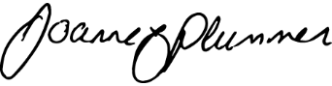
Jo Plummer
Chair

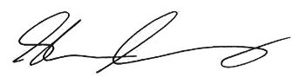
Shaun Cumming
Managing Director
(Accountable Officer)

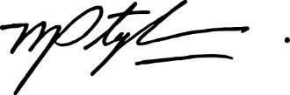
Melissa Stephens
General Manager People and Corporate
(Chief Financial Officer)

Dated this 19th day of September 2024

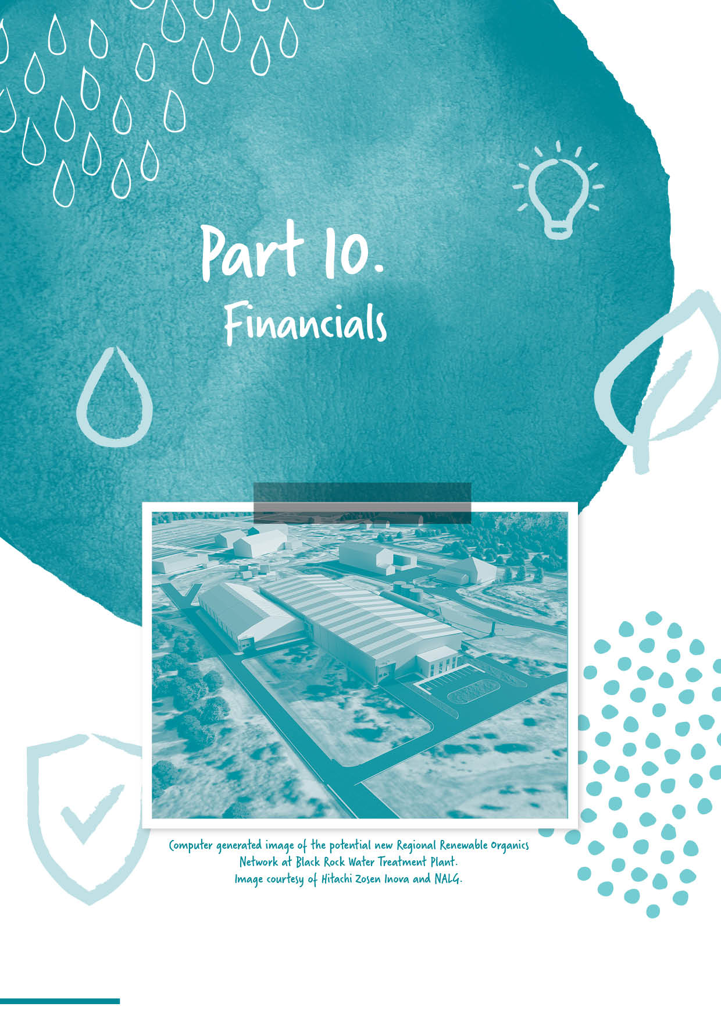

Section divider page
WITH IMAGE

Part 10.
Financials

Will be formatted and inserted here when complete.

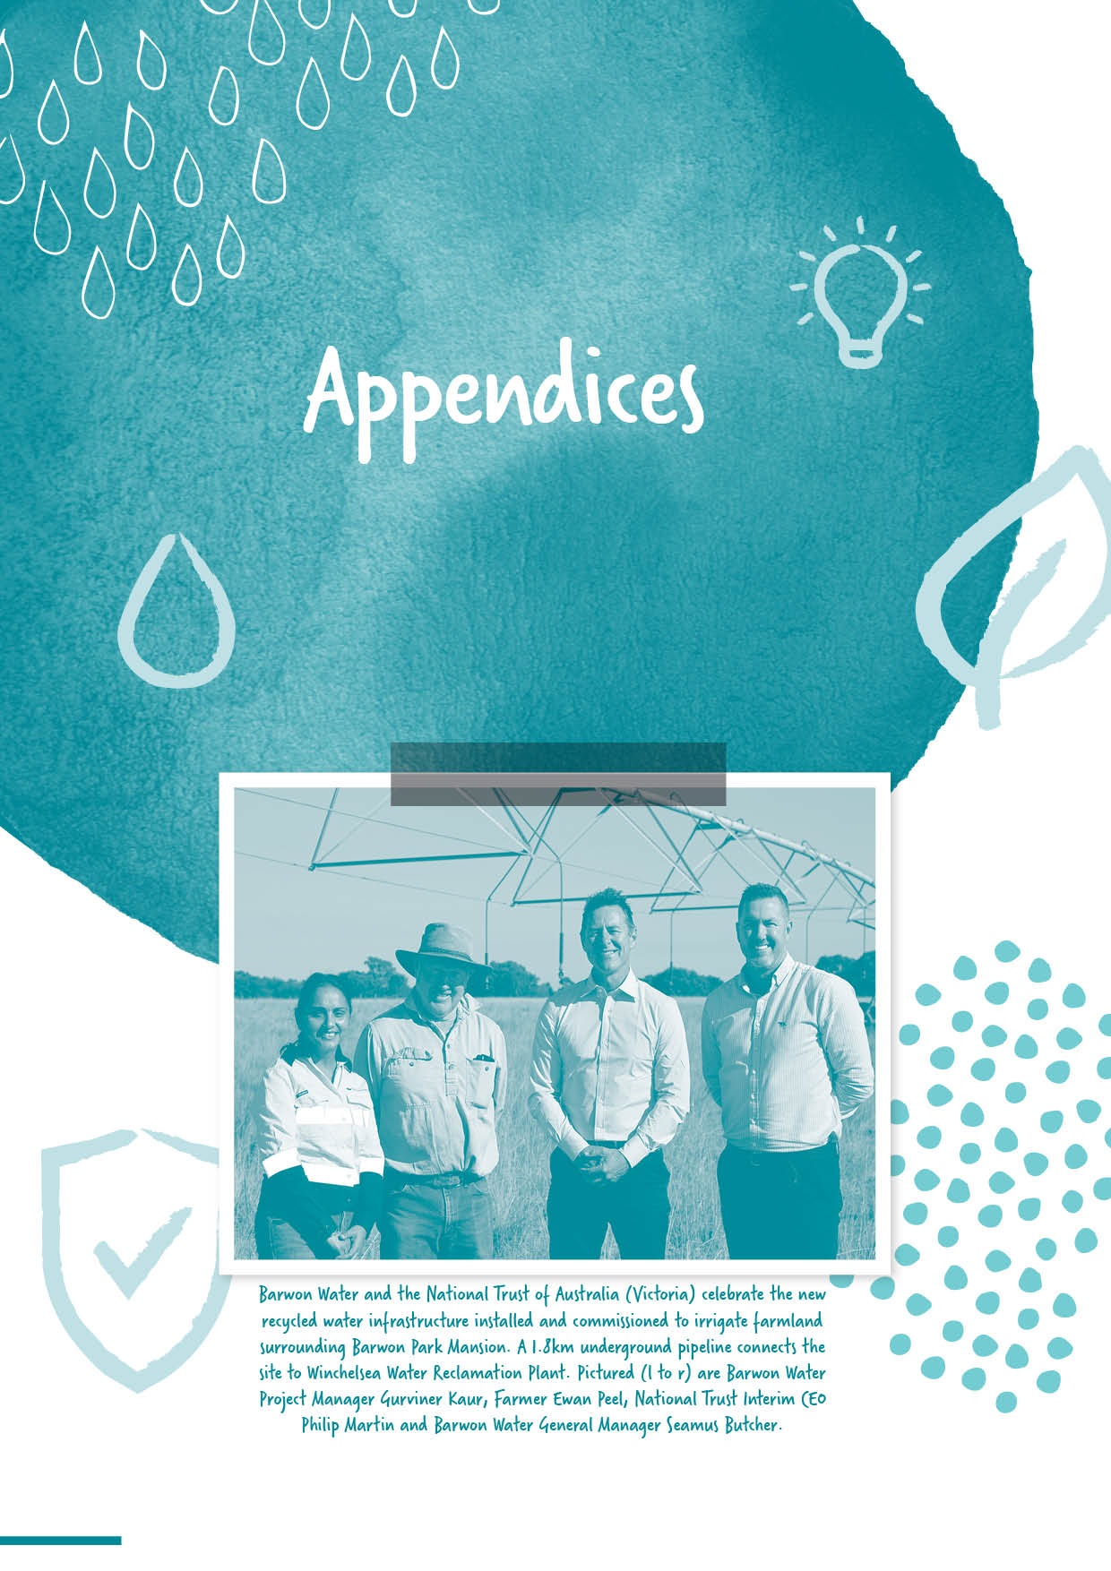

Section divider page
WITH IMAGE

Appendices

Disclosure Index
The 2023-24 Annual Report of Barwon Water Region Water Corporation is prepared in accordance with all relevant Victorian legislation. This index has been prepared to facilitate identification of the authority’s compliance with statutory disclosure requirements.
Legislation | Requirement | Page No.
Charter and purpose
FRD 22 | Manner of establishment and the relevant Ministers | 19
FRD 22 | Purpose, functions, powers and duties | 5, 13, 19
FRD 22 | Key initiatives and projects | 5-11
FRD 22 | Nature and range of services provided | 6,13-15 & 17
Management and structure
FRD 22 | Organisational structure | 60
Financial and other information
FRD 10 | Disclosure index | 161
FRD 12 | Disclosure of major contracts | 80
FRD 15 | Executive Officer disclosure | 68
FRD 22 | Employment and conduct principles | 65-67
FRD 22, 29 | Workforce data | 65-68
FRD 22 | Workforce inclusion policy | 65-66
FRD 22 | Occupational health and safety policy | 69-70
FRD 22 | Summary of the financial results for the year | 8-9
FRD 22 | 5-year financial summary | 8
FRD 22 | Significant changes in financial position during the year | 8
FRD 22 | Major changes or factors affecting performance | 8
FRD 22 | Subsequent events | 8
FRD 22 | Application and operation of Freedom of Information Act 1982 | 72
FRD 22 | Compliance with building and maintenance provisions of Building Act 1993 | 73
FRD 22 | Statement on National Competition Policy (Competitive Neutrality Policy) | 76
FRD 22 | Application and operation of the Public Interest Disclosures Act 2012 | 74
FRD 22 | Application and operation of the Carers Recognition Act 2012 | n/a
FRD 22 | Disclosure of procurement complaints | 80
FRD 22 | Details of consultancies over $10 000 (consultancy expenditure) | 80
FRD 22 | Details of consultancies under $10 000 (consultancy expenditure) | 80
FRD 22 | Disclosure of government advertising expenditure | 83
FRD 22 | Disclosure of ICT expenditure | 81
FRD 22 | Disclosure of review and study expenses | 78-80
FRD 22 | Disclosure of asset maturity assessment | 77

Legislation | Requirement | Page No.
FRD 22 | Disclosure of Emergency Procurement | 71
FRD 22 | Statement of availability of other information | 73
FRD 24 | Reporting of environmental data by government entities | 23, 45-49
FRD 25 | Local Jobs First | 75
FRD 27 | Performance Reporting | 94-97
SPF | Social Procurement Framework | 76
Ministerial Reporting Directions - Letter of Expectation Priority Policy Areas
MRD 01 | Climate Change and Energy | 82
MRD 02 | Customer, Community and Engagement | 83
MRD 03 | Recognise Aboriginal Values | 84-87
MRD 04 | Recognise Recreational Values | 88
MRD 05 | Resilient and Liveable Cities and Towns | 89-90
MRD 06 | Leadership, Diversity and Culture | 90-91
MRD 07 | Performance and Financial Management | 92
MRD 08 | Compliance and Enforcement | 92
Compliance attestation and declaration
SD 5.1.4 | Attestation for Financial Management Compliance or Attestation for Compliance with Ministerial Standing Directions | 8
SD 5.2.3 | Responsible Body Declaration in report of operations or Declaration in report of operations | 5
Legislation
Building Act 1993 |  | 73
Disability Act 2006 |  | 69
Financial Management Act 1994 |  | 5, 8, 61, 73, 97, 106, 128, 150 & 157
Freedom of Information Act 1982 |  | 72
Local Jobs First Act 2003 |  | 75
Public Interest Disclosures Act 2012 |  | 74
Water Act 1989 |  | 19, 41, 44, 53,  61, 82-92 & 107

At a glance – data table
 | 2023-24 | Change  (%) | 2022–23 | Change  (%) | 2021–22 | Change  (%) | 2020–21 | Change  (%) | 2019–20 | Change  (%)
Population served (water) | 379,228 | 2.4 | 370,487 | 5.9 | 349,996 | 2.5 | 341,410 | 3.3 | 330,462 | 2.8
Population served (sewage) | 350,241 | 2.3 | 342,239 | 5.8 | 323,367 | 2.6 | 315,055 | 3.5 | 304,411 | 2.8
Connected properties (water) | 181,844 | 1.9 | 178,505 | 2.3 | 174,511 | 2.2 | 170,759 | 3.0 | 165,804 | 2.5
Connected properties (sewerage) | 165,946 | 2.0 | 162,725 | 2.4 | 158,879 | 2.3 | 155,238 | 3.2 | 150,417 | 2.8
Water treatment plant volumes (megalitres) | 41,821 | 11.7 | 37,454 | 8.2 | 34,624 | -3.3 | 35,807 | -0.8 | 36,104 | -7.0
Water reclamation plant volumes (megalitres) | 33,586 | -5.0 | 35,372 | 6.2 | 33,318 | 2.2 | 32,591 | 15.3 | 30,806 | 8.9
Employee numbers FTE | 365 | 10.0 | 338 | 4.8 | 322 | 0 | 322 | 1.025 | 314 | -0.1
Number of days lost to injury | 0 | 0 | 0 | 0 | 0 | 0 | 0 | -600 | 6 | 500
Total  revenue ($000) | 292,838 | 13.3 | 258,428 | 1.3 | 255,145 | 2.9 | 248,034 | 0.2 | 249,901 | 4.1
Net operating result (before income tax) ($’000) | 13,562 | 58.3 | 8,565 | -65.9 | 25,109 | -8.6 | 27,466 | 4.6 | 26,250 | -2.2
Total assets ($’000) | 3,794,268 | 2.3 | 3,710,564 | 14.7 | 3,236,010 | 0.8 | 3,211,891 | 12.9 | 2,844,693 | 1.7
Capital expenditure ($’000) | 135,828 | 23.8 | 109,696 | 200.1 | 53,174 | -19.2 | 65,840 | -15.0 | 77,438 | -4.4

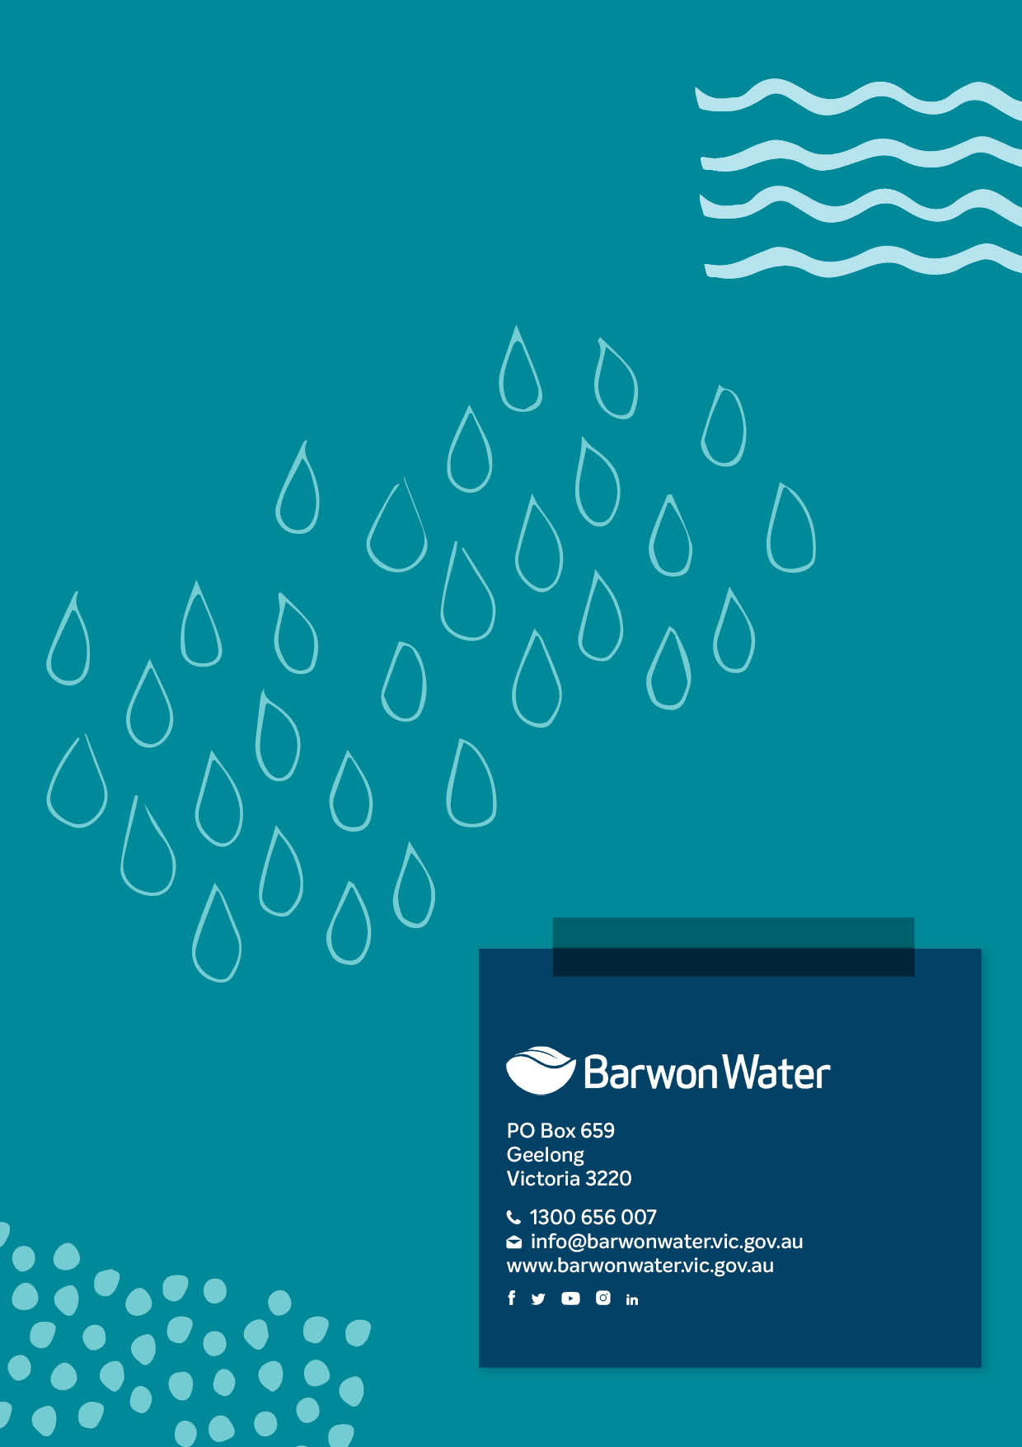

Section divider page
WITH IMAGE

Back Page

ENDS

